French Fascist Turned into "Martyr"
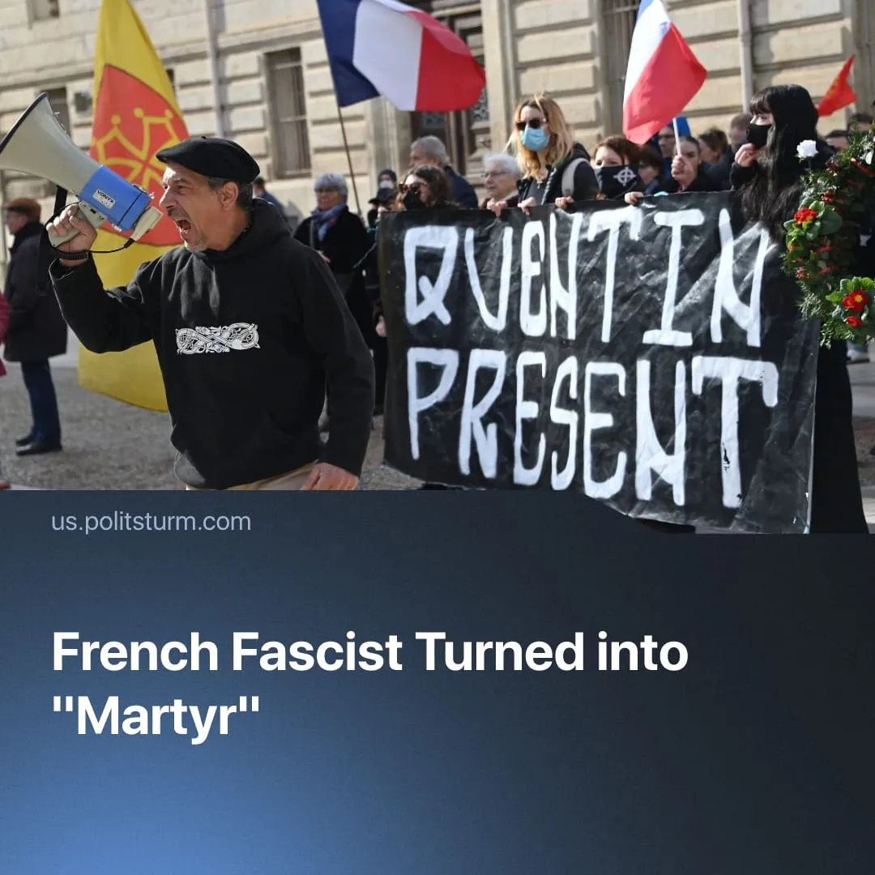

Original article
2026-02-21
2 min read

A French fascist was turned into a “martyr” as a pretext for outlawing communist activity.
Details. French far-right activist Quentin Deranque was killed in a street brawl. He was a trained member of the far-right party Action Française (WW2 Axis collaborators), and worked with the fascist militia Audace/GUD. He participated in the 2025 Paris fascist march, with extensive WW2 German symbolism.
► Capitalist newspapers framed the death as a “lynching” or “ambush,” condemning left-wing “extremists” – despite new footage showing Deranque’s group started the brawl. His far-right background was downplayed: mainstream media portrayed him merely as a “non-violent” student. France’s second-largest news outlet declared Deranque “a martyr for free speech”.
► The French Parliament held one minute of silence to honour the dead brownshirt, by unanimous decision of all parties – including Jean-Luc Mélenchon’s France Unbowed, which called for “compassion” for Deranque. President Macron’s government blamed the killing on the “ultra-left,” whilst the opposition National Rally called for the “far-left” to be designated “terrorist groups.” French police launched an investigation, arresting 11 suspects.
► Fascist groups are building a martyrdom cult around Quentin Deranque’s name and image. Action Française published a poster titled “Quentin? Present!” repeating a fascist slogan, and calling for “eternal memory” for the “hero.” Deranque’s supposed last words, urging further violence, are being used as a new motto.
Context. Far-right activity is being increasingly normalised under capitalism, as fascisation progresses. In 2023, the Canadian Parliament “accidentally” held a standing ovation for a WW2 Axis veteran, declaring him a “hero” for fighting the Soviet Union. In 2025, the US Coast Guard quietly allowed fascist symbols, whilst President Trump launched “Anti-Communism Week.”
► From 1986–2021, over 90% of political killings in France were committed by the far-right, with less than 10% ascribed to the “far-left.” Since 2022, French fascist attacks have been responsible for 11 deaths and 19 heavy injuries.
► In the USA, assassinated right-wing figure Charlie Kirk was similarly made into a martyr, with Trump officials using fascist-style slogans to commemorate him. In 1930s Germany, the Fascists used Horst Wessel – a brownshirt militiaman who died in a brawl – as a political symbol to galvanise support. A march written by Horst Wessel was made the German national anthem.
► Opportunist left-wingers facilitate a widespread capitalist crackdown through adventurist tactics, which provide a pretext to prevent the emergence of real communist activity. The US designated “Antifa” a terrorist group and now has expanded powers to persecute communists. Similar measures were proposed in Europe; France’s largest “antifascist” group, the Young Guard, was banned in 2025. In the same year, adventurist tactics had also provoked counter-terror prosecution by the British state.

Original article

