French Far-right Calls For Snap Elections
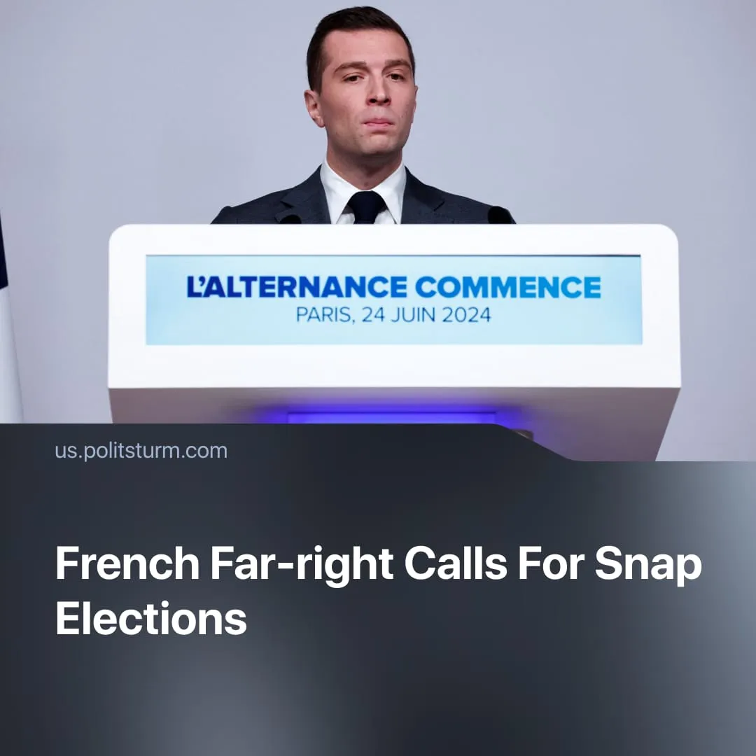

Original article
2025-10-15
1 min read

The far-right National Rally has begun openly calling for snap elections, confident that France’s political chaos will clear its path to power.
Details. Following the recent collapse of the French government, National Rally chief Jordan Bardella asserted that new elections will take place “in the coming weeks” and that his party is “ready to govern.” National Rally MPs stated that “we are accelerating our preparations” and declared that “everything is ready,” with 95% of candidates already nominated.
► October polls from IFOP and OpinionWay show the National Rally leading across multiple election scenarios, winning a plurality with a double-digit lead. The far-right party expects to secure at least 240 seats, doubling its current size in parliament and nearing a majority.
► To reach an absolute majority and form a government, the National Rally has, for the first time, proposed a coalition with the conservatives.
Context. France has faced a parliamentary crisis since the 2024 snap elections. In just two years, six governments have collapsed, with President Macron recently re-appointing a Prime Minister who had resigned only a week earlier.
► With the collapse of Macron’s “presidential camp” in the centre, the main obstacle to a far-right election victory is the broad left NFP coalition. However, the unprincipled nature of the NFP – composed of opportunists, revisionists, and liberals – renders it ineffective and clears the way for the National Rally.
► This is already evident in the personal rivalries and conflicting approaches to the political crisis. The “Socialist” Party seeks to avoid new elections, preferring compromise with Macron to preserve parliamentary stability. France Unbowed calls for snap elections and Macron’s resignation. Smaller member parties remain divided between the two.
► Additionally, the NFP’s previous campaigns opportunistically capitalised on outrage over the Gaza genocide. With the recent ceasefire holding in Gaza, there is now likely to be less voter mobilisation on this issue, weakening the NFP in the face of the National Rally.

Original article

