French Company Dissolved for Treating Workers 'Like Slaves'
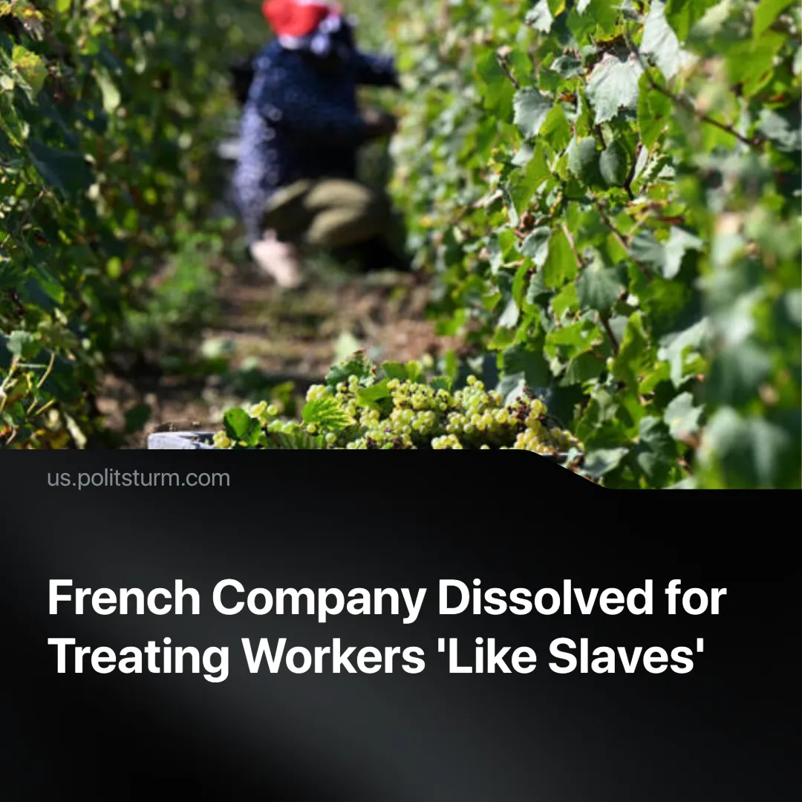

Original article
2025-07-25
1 min read

Dozens of undocumented workers trafficked into France’s champagne industry came from its former colonies in Africa.
Details. In France, a recruiting company was dissolved, and three individuals were imprisoned for human trafficking and labour malpractice.
► During the harvest season in September 2023, over 50 undocumented immigrants were found living in cramped and unhygienic conditions in a building in Nesle-le-Repons, a town southwest of Reims, France.
► The workers, aged between 16 and 65, were from Mali, Mauritania, Ivory Coast, and Senegal—many of them undocumented. They were recruited via WhatsApp with promises of “well-paid work.”
► Upon arrival, they were forced to work 13-hour days and live in overcrowded, unhygienic conditions. One victim described being “crammed into a broken-down house” with no clean water and only “rotten sandwiches” for food. Armed men were used to intimidate the victims.
► The agency behind the operation, Anavim, was run by a Kyrgyz woman and specialised in recruiting cheap labour for the champagne industry. It was formally dissolved by the court. The wine cooperative it supplied, however, was only fined €75,000.
Context. France’s €6 billion champagne industry depends on manual grape-picking every autumn. Around 120,000 seasonal workers are brought in each year, many of whom are recruited via middlemen like Anavim—allowing major firms to avoid direct responsibility and escape with light fines when abuse is exposed.
► The industry’s dependency on cheap labour has led to repeated scandals. In 2023 alone, six grape pickers died from heatstroke. Other employers have faced criminal charges for abusing migrant workers.
► The super-exploited workers in this case came from former French colonies in West Africa. These countries have been structurally impoverished by centuries of French imperialism, creating the very migrant flows European capitalism now profits from.

Original article

