French Prime Minister Proposes Cutting Public Holidays to Curb Debt
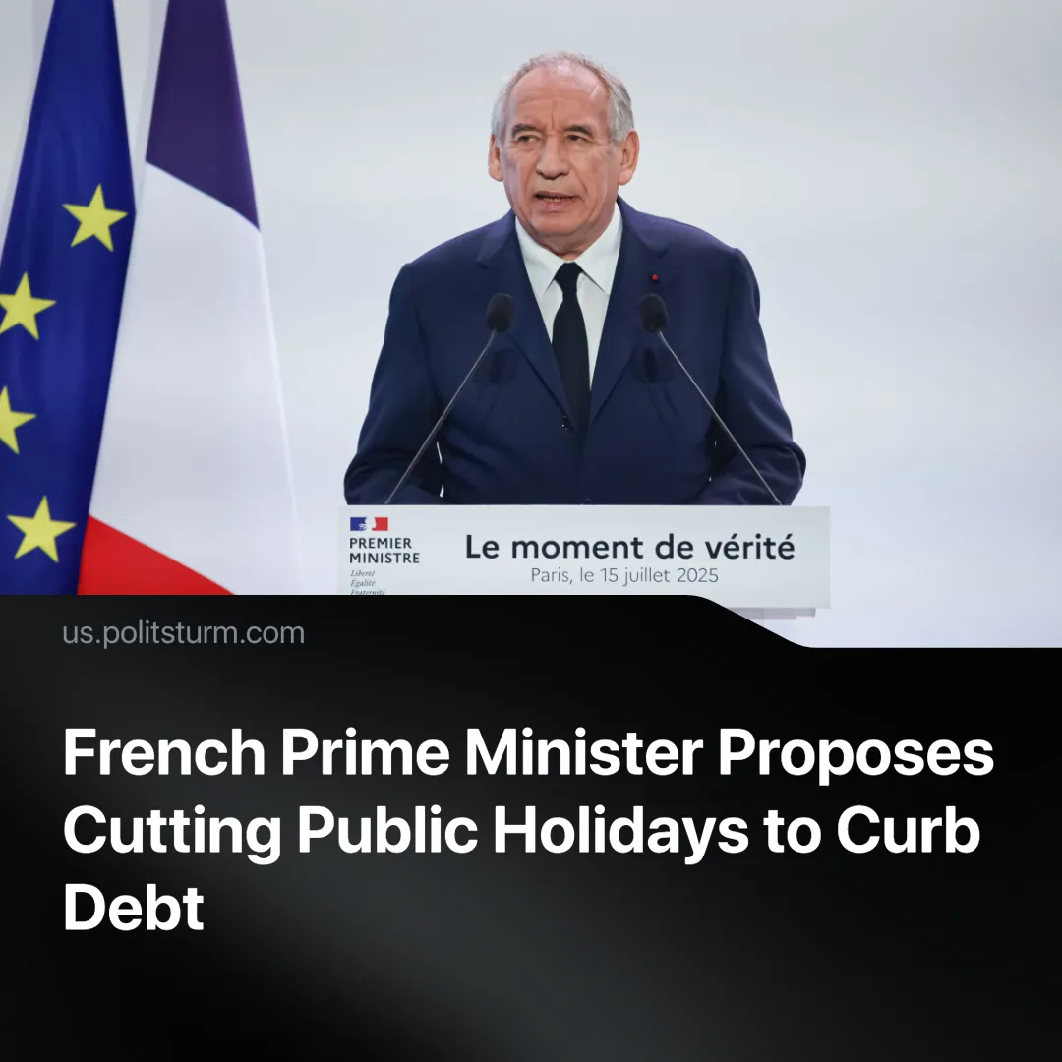

Original article
2025-07-19
1 min read

Despite mass protests against pension cuts in 2023, France's Prime Minister François Bayrou has proposed to scrap two public holidays to reduce the deficit.
Details. The proposal to cut public holidays is part of the 2026 budget plan, which aims to reduce overall spending while increasing defence spending by €3.5 billion next year.
► The targeted holidays are Easter Monday and 8 May (Victory in Europe Day). The PM described May as resembling “gruyère” – a Swiss cheese full of holes – due to its many public holidays. He justified the proposal by saying, “The entire nation must work more – to produce, to increase overall national activity throughout the year, and to improve France's situation”
► If Parliament rejects the budget this autumn, it could trigger a government collapse, forcing Macron to either appoint a successor or form an unelected technocratic government – neither of which is likely to be popular with MPs.
Context. In 2023, the Macron government raised the retirement age from 62 to 64 (to be phased in by 2030) and increased the required contribution period to 43 years. Despite mass protests involving over a million people, the reform was signed into law on 15 April 2023.
► Earlier, in 2017, Macron introduced labour code reforms that reduced trade union power, made labour cheaper, and increased employer control over working conditions. These reforms were passed despite mass protests involving hundreds of thousands.
► Even in Europe’s second most powerful economy – with strong trade unions and a long tradition of social protections – workers’ rights remain concessions: granted or withdrawn according to the balance of class forces and the needs of capital.

Original article

