France expands its nuclear coverage to European allies
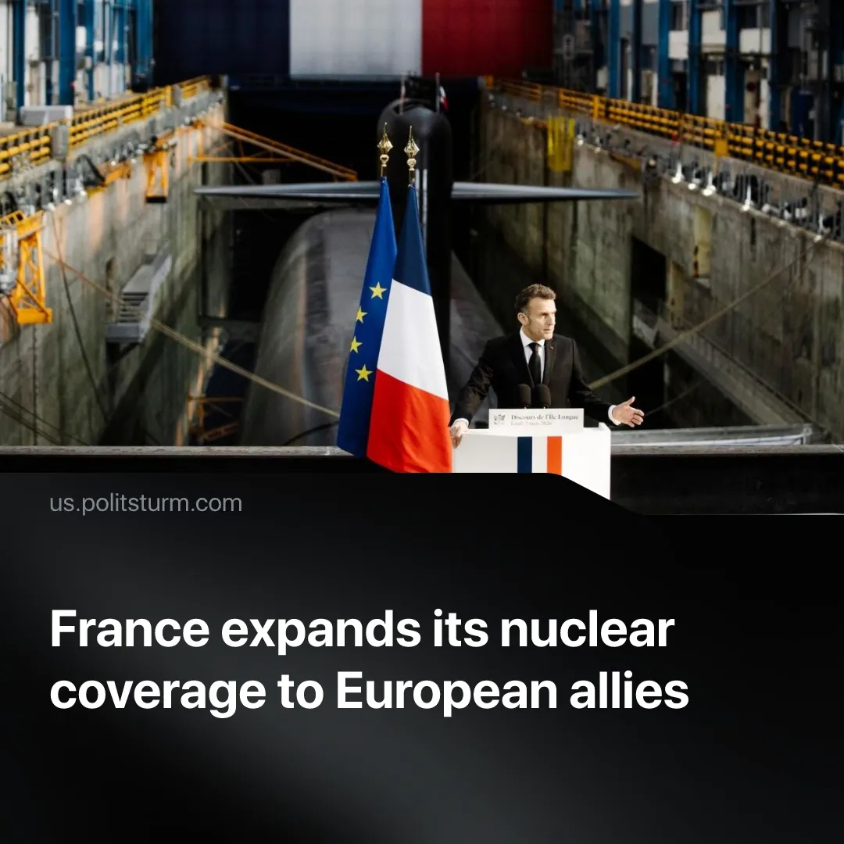

Original article
2026-03-12
1 min read

France expands its nuclear coverage to European allies as the US becomes an unreliable ally.
Details. In a strategy President Macron calls “Advanced Deterrence”, France plans to expand its nuclear arsenal by 300 and declared that the next 50 years will be an “era of nuclear weapons.” Macron also announced a new nuclear submarine scheduled to enter service in 2036, and declared that France will stop publicly disclosing the size of its nuclear arsenal.
► Eight European countries – including the UK, Germany, Poland, the Netherlands, Belgium, Greece, Sweden and Denmark – are participating in this new policy, effectively placing the under France’s nuclear deterrent. The plan allows French nuclear‑capable aircraft to deploy to allied territory and conduct joint exercises, while the decision to use nuclear weapons remains solely with the French president.
► Macron framed the doctrine as a response to shifting alliances, saying Europe must be prepared in case the United States “I want to believe that the United States will remain by our side, but we need to be ready if that were not the case,” and linking the initiative to concerns over Russia
Context. The world is seeing a growing number of escalating conflicts as relations between imperialist powers become more acute. The “Special Military Operation” in Ukraine has entered its fifth year, while the United States has conducted a regime change in Venezuela and carried out numerous strikes in Iran within the first three months of 2026, intensifying pressure on China’s imperialist interests in both regions.
► Diverging imperialist interests between the United States and the EU have pushed the bloc to distance itself from Washington. The US’s threats to take Greenland by force, combined with pressure for Europe to embrace the pro-US far-right, have coincided with EU moves such as the “recognition” of Palestine and rapidly increasing military spending.
► As one of the EU’s dominant economies, France stands to gain from a more consolidated and strategically autonomous European bloc, taking a lead role militarization and joining Germany in imposing “voluntary” conscription on men ages 18–25 to prepare the EU for war.

Original article

