Four Things Stalin Was Right About
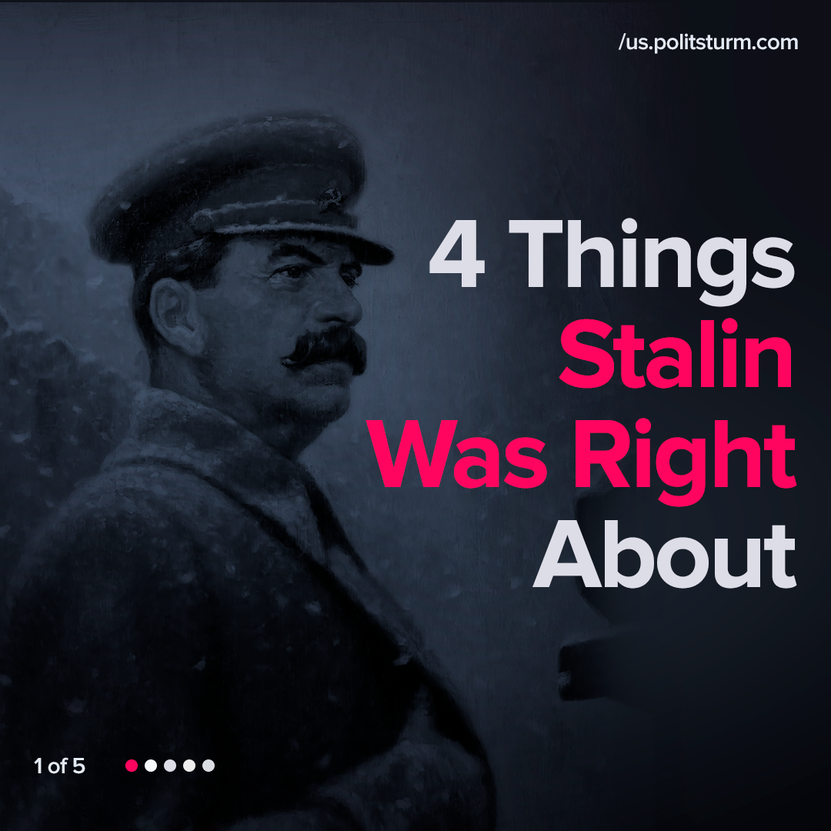

Original article
2021-11-09
1 min read

We selected some quotes from Stalin’s works, showing four problems of the modern capitalist society and his point of view on them, which can be considered clearly as Marxist.
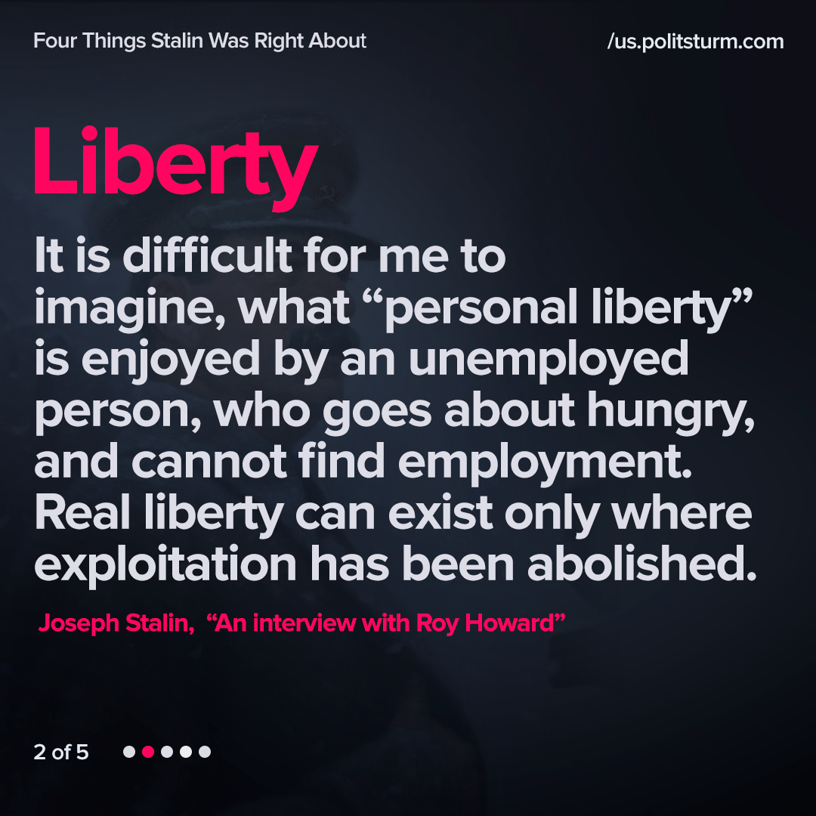
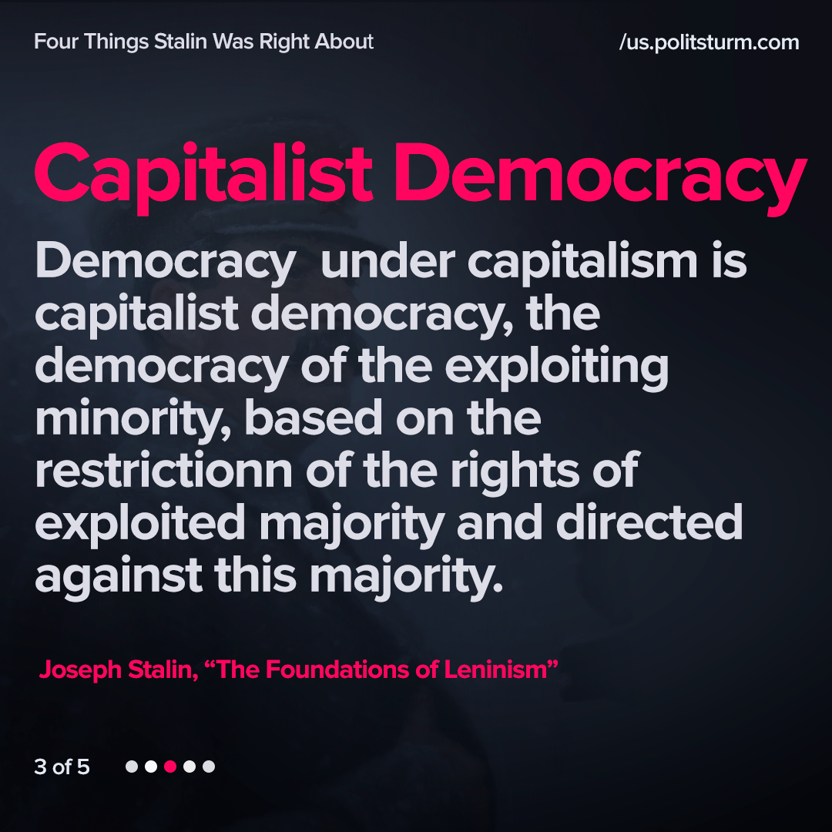
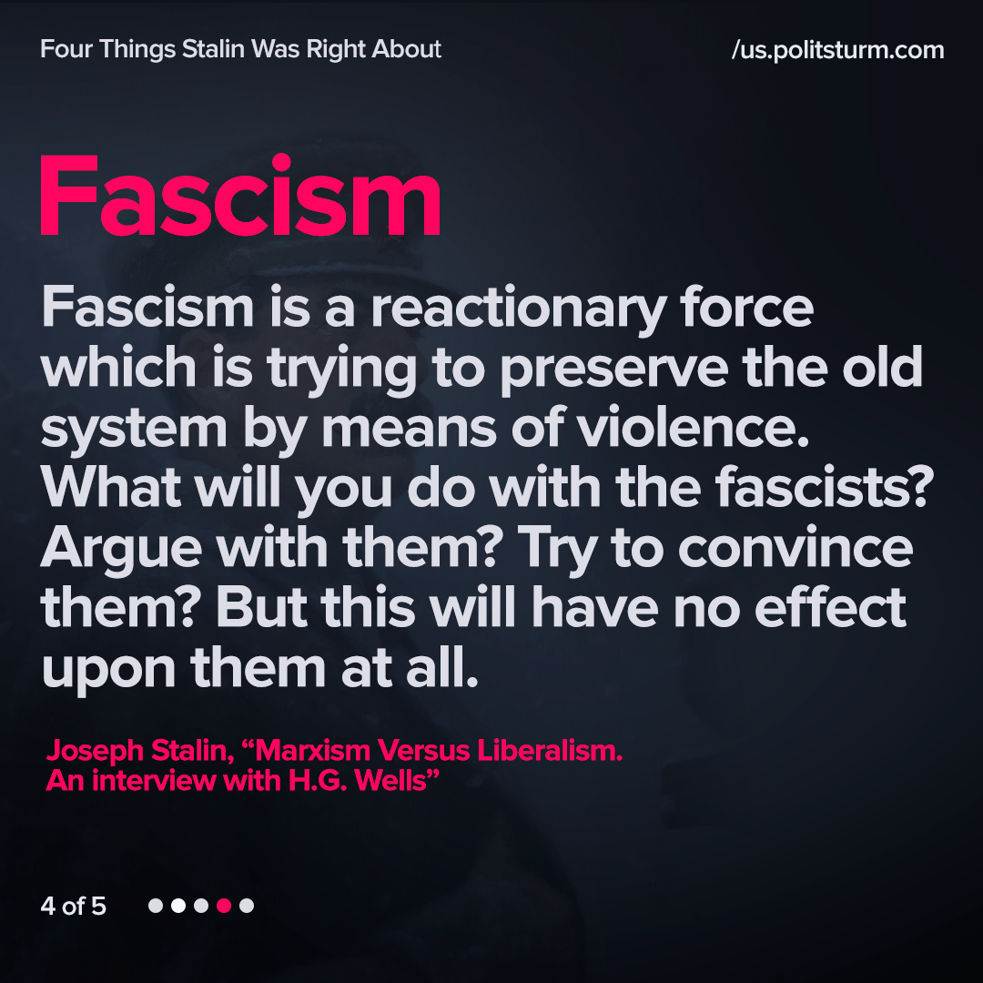
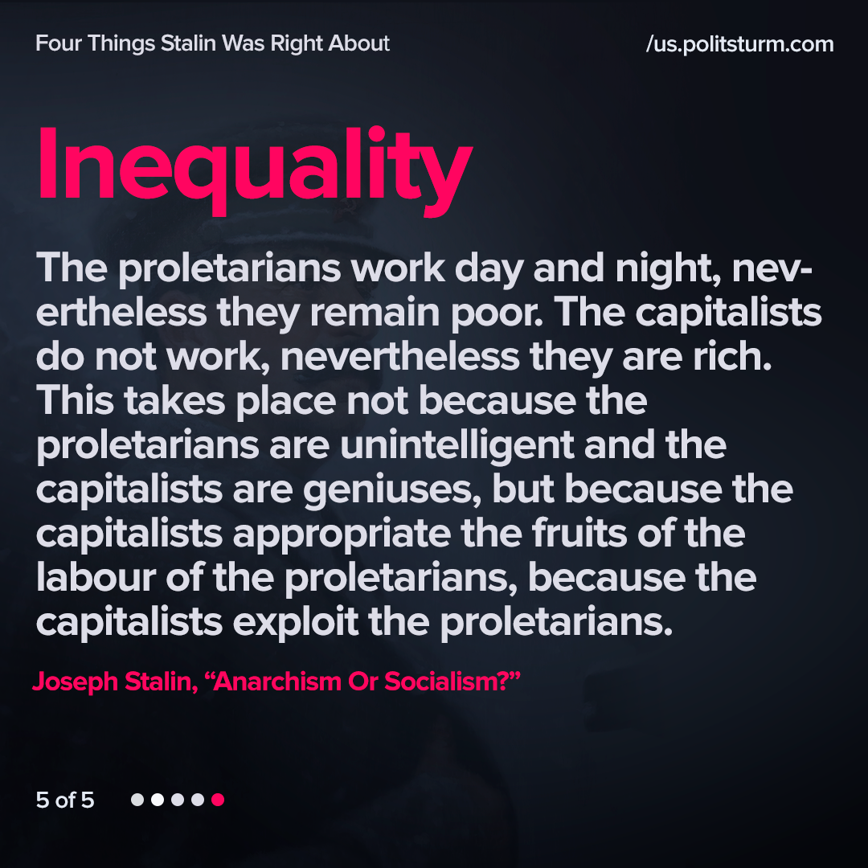

Original article

