Four Theses on American Patriotism
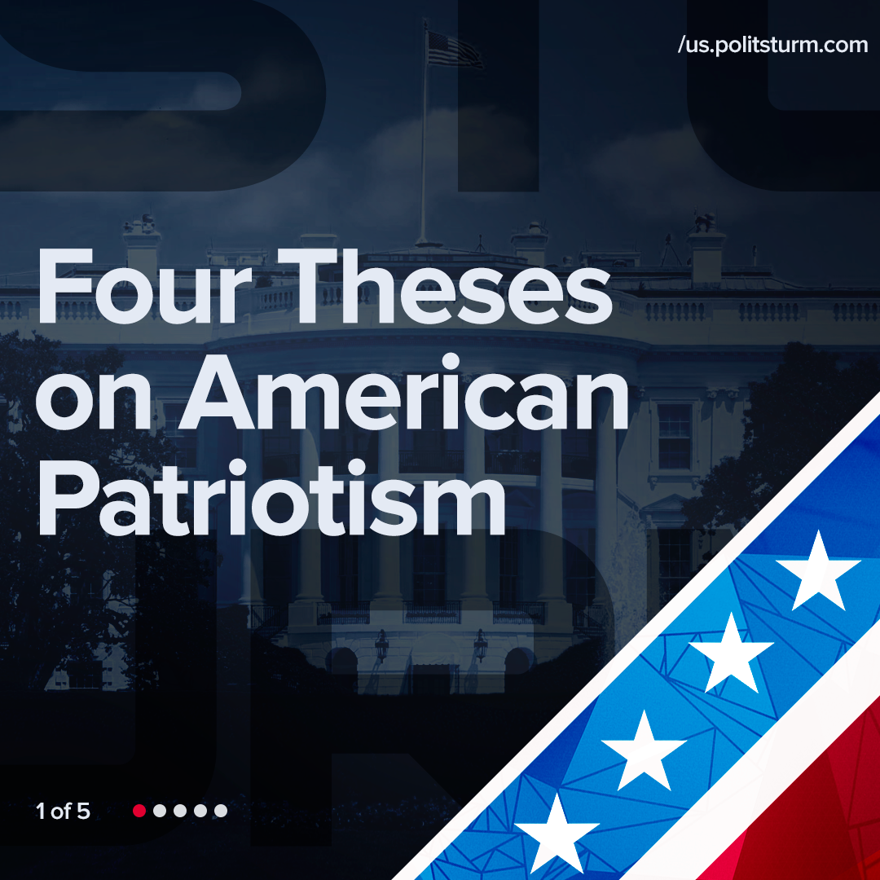

Original article
2021-09-24
1 min read

Error loading image
Error loading image
Error loading image
Error loading image

Original article

