Four Soviet Innovations


Original article
2021-12-29
1 min read

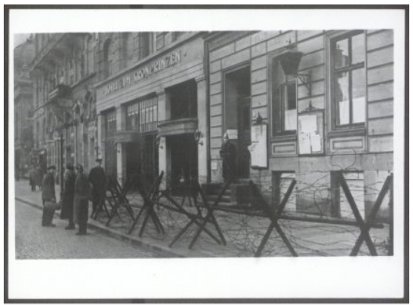

Error loading image

Error loading image

Error loading image

Original article

