Four Reasons Why Capitalism is Bad
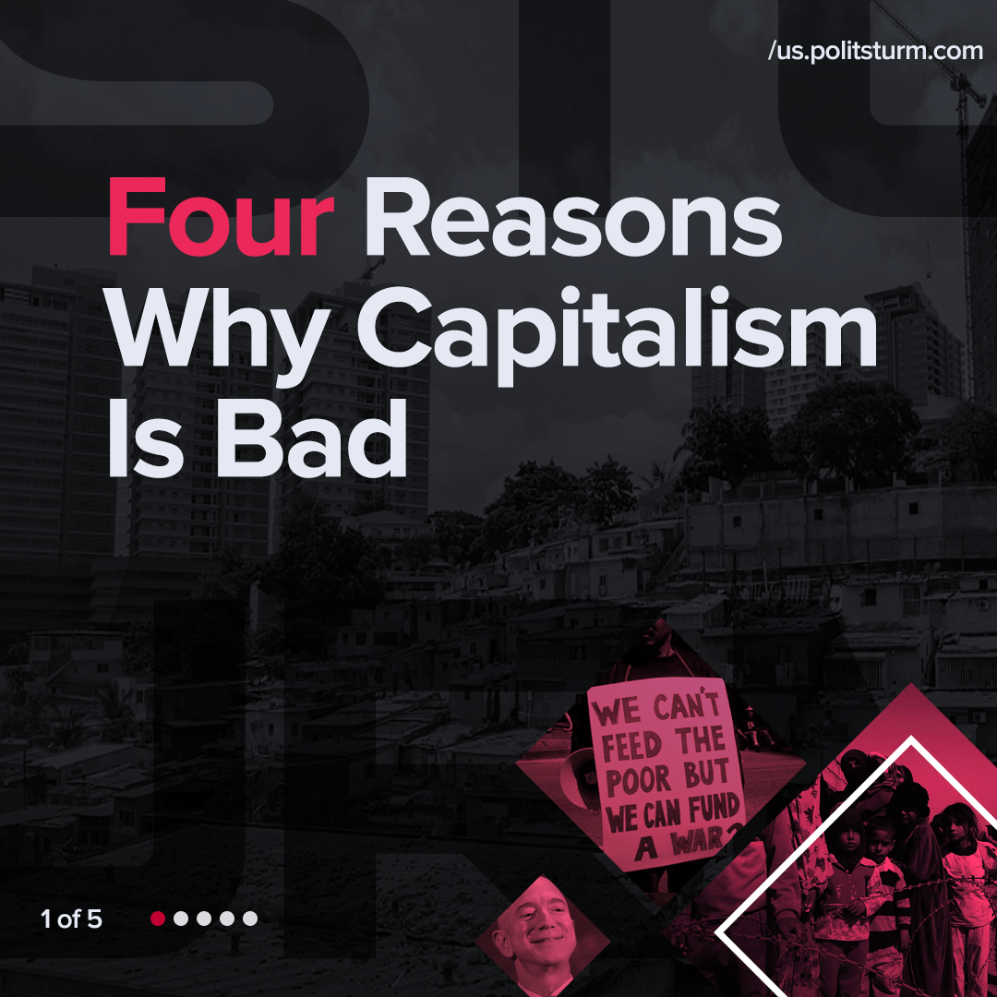

Original article
2022-02-21
1 min read

Error loading image

Error loading image

Error loading image

Error loading image

Original article

