Former Union Leader Caught in £112M Corruption Scandal
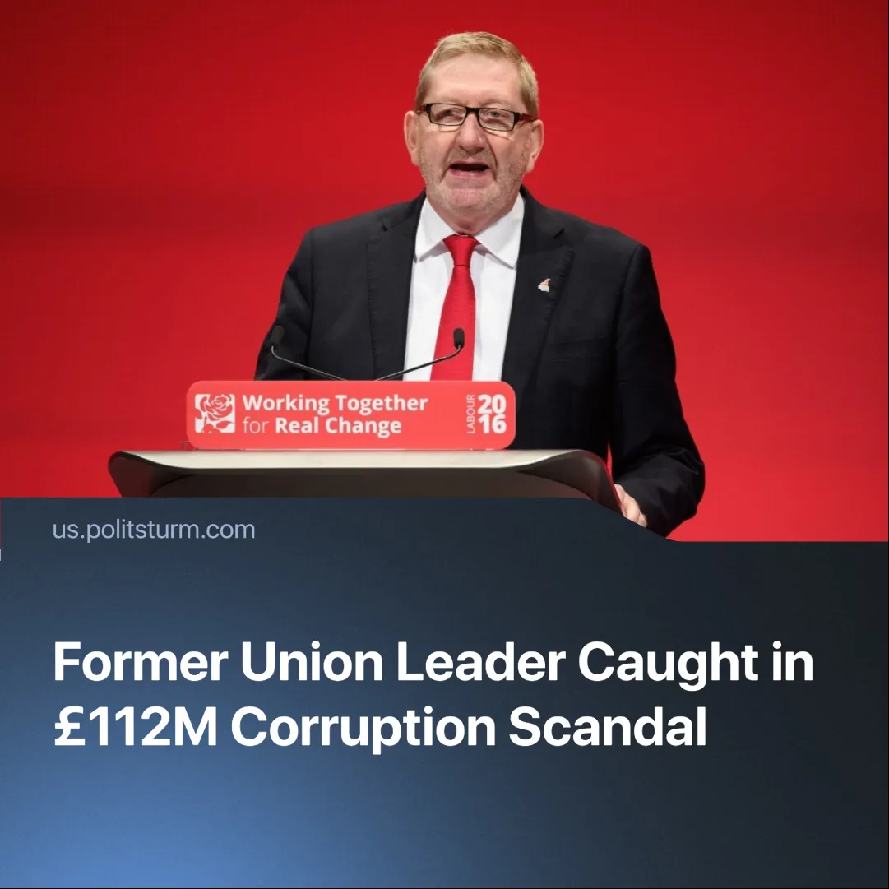

Original article
2025-07-31
2 min read

The former head of the UK’s largest trade union, long linked to the Labour Party, has been accused of accepting bribes in a massive corruption scandal.
Details. Sharon Graham, Unite’s current General Secretary, launched an investigation into the failed hotel project after inheriting both the financial fallout and mounting member outrage over unaccountable leadership. The failure was described as a “total lack of due diligence,” with tens of millions in union funds lost.
►In 2021, former Unite General Secretary Len McCluskey approved a £112 million deal with Flanagan Group, whose owner, Paul Flanagan, is a longtime Labour Party donor. He overruled multiple union lawyers who warned of serious financial and structural risks.
► The £112 million was to be spent on a Unite hotel and conference centre in Birmingham, which failed and was independently valued at just £29 million, implying a £83 million loss.
► McCluskey allegedly received private jet travel and access to a luxury villa arranged by the building firm.
► Unite claimed the project would serve as a centre for organising and events, but no broad member consultation was held before its approval.
Context. This is not the first time McCluskey has been accused of corruption during his tenure. He was also previously accused of wasting union funds on luxury travel, inflated expenses, as well as being accused of bullying, harassment, factional power plays, and mismanagement of other real estate projects.
► Unite has already faced scrutiny over the hotel deal. This failed project has long symbolised the union bureaucracy’s detachment from its base.
► The scandal emerges at a time when union membership in the UK is still declining.
Important to know. Capitalists often exploit the trade union bureaucracy as propaganda, portraying trade unions as corrupt, useless or even harmful to workers, yet they rely on this same layer to contain militancy and keep struggles within legal bounds. Detached from the rank and file, this layer mediates class conflict and shows the limits of trade unionism.
► The development of a privileged trade union bureaucracy is not new. As Lenin warned in State and Revolution, “the functionaries of our political organizations and trade unions are corrupted – or rather tend to be corrupted – by the conditions of capitalism and betray a tendency to become bureaucrats, i.e., privileged persons divorced from the people and standing above the people.”

Original article

