Foreign Worker Quotas Increased by 50% in Russia
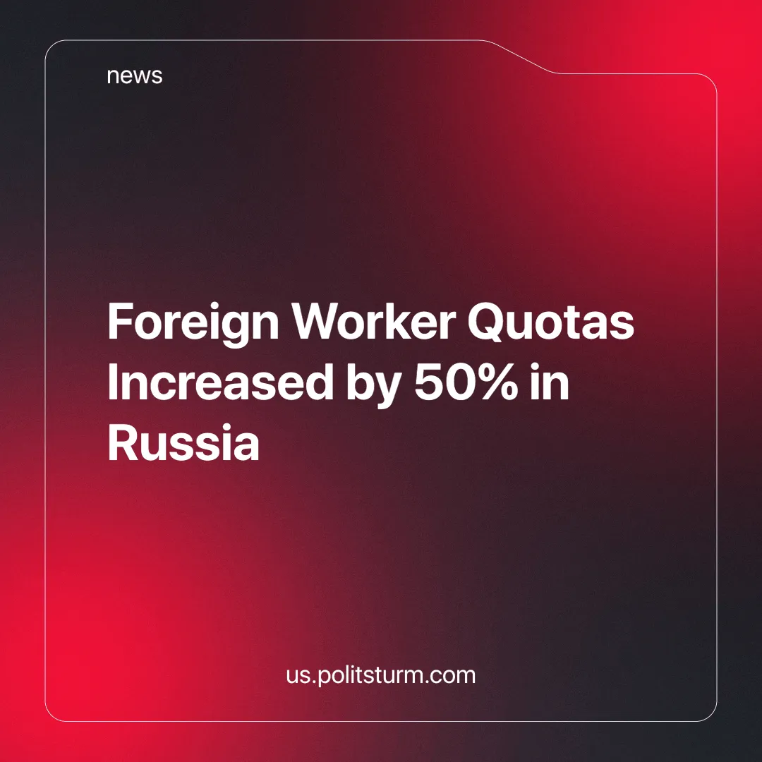

Original article
2025-01-22
4 min read

The Ministry of Labor and Social Protection of Russia plans to hire 235 thousand highly qualified foreign specialists, which is 50% more than in 2024 [1].
They are promised a monthly salary of 380 thousand rubles ($2,300), but half of the employers offer lower wages ranging from 20 to 60 thousand rubles($200 – $600). The other half offers 100 thousand ($1,000) and up but still falls short of the stated amount. The greatest demand for foreign workers is expected in the Amur, Moscow, and Leningrad regions. There are still 78 thousand job vacancies available.
The quotas apply only to foreign citizens who enter Russia with a visa. That said, citizens of EAEU (Eurasian Economic Union) countries and several other states can work in Russia without a visa and are therefore not subject to the quotas. Due to this, it is expected that only about 60% of the established quota for specialists will actually be necessary [1].
The issue of migrants in Russia is not new, but the xenophobic calls to send everyone back to their homeland have come to an end. The president signed a decree that the media already labeled as an "ultimatum". This decree requires migrants to legalize their status in the country by obtaining the necessary documents that grant them the right to stay in Russia legally or leave the country. However, this is just the usual populism, repeated especially loudly after the tragic events of March. It will not change anything substantial: the state needs cheap labor.
There are two ways to solve the problem of the labor shortage: the first is to train and employ the unemployed, and the second is to buy ready-made specialists from abroad. Obviously, the second option will be more profitable – this has been evident for decades, given the situation in the country.
The workforce, like everything else in the world, does not come from nothing. Every employee goes through many stages of education before they start working. A person is born, goes to kindergarten and school, then receives professional education, and, finally, gains experience in a company.
Later, they start a family and work to feed, raise, and educate their children. Each of these stages on a national scale requires substantial material technical resources, a developed educational system, advanced scientific capabilities, and a lot of time. Hiring a foreign worker from the CIS (the Commonwealth of Independent States) would be much cheaper.
In this case, the state does not need to spend money on their upbringing and education because the person is already an educated specialist. At the same time, people do not migrate searching for a good life. On the contrary, people seek to escape from poverty in their own countries and are therefore prepared even for low-paid work.
Businessmen are happy with this situation. They know that the standard of living of these workers in their homeland is much lower than in Russia, and what is considered low wages for Russians is quite a decent salary for migrants, one on which they can survive. That is why there is such a difference between real and declared wage offers.
Unemployment and the growth of migration are common contributions to the reserve worker army that capitalists use to put pressure on the labor market. It is a competition in which a person, regardless of nationality, has to sell his life forces in order to survive. Under such conditions, the winner is the one who offers a greater capacity for work and makes the least demands on the employer.
The advantage of foreigners is obvious, but this does not make them enemies. The workers of the whole world are the same victims of the ruthless "invisible hand" that robs equally the nations of every country with the capitalist economy.
This can be seen in the mass dismissals in Europe where "advanced" capitalism reigns in the so-called "welfare states". In this case, we should not fight against the victims of capitalism but against its representatives – the oligarchs who create such inhuman conditions.
It is possible to defeat rich businessmen only by establishing a new form of economy that avoids the parasitism of labor. The example of a state where every citizen had the right to work is not fiction.
There was a time when foreign specialists came to exchange experience and earn money. No one fought with anyone for jobs or competed with locals for vacancies.
Laborers have no reason for division among themselves when their labor belongs to society and to themselves as part of that society. It is the private ownership of the means of production that divides people into rich and poor, natives and foreign. It is the source of power for all of the big businesses, and the capitalists will go to any length to increase that power, whether it is the expansion of quotas for the import of foreign workers or the risk of ecological disaster. In every situation, they only care about profit.
The building of socialism is a common task of us all, and this goal can be achieved only by working together. People have always defended their rights collectively, together with their comrades. The interests of the laborers in the political arena can only be defended by their own political party. Created by the representatives of the laborers, it will work in the interests of the ordinary people.
Sources:
[1] Solidarity — "Quotas for foreign workers will be increased by 50%" — December 16, 2024.
[2] Politsturm — "The shortage of personnel is growing in the Russian Federation" — November 25, 2024.
[3] EADaily — "VW fires 35 thousand people: how would the Western media react to the same events in the Russian Federation” — December 24, 2024.
[4] mk.ru — “Everything has rotted there”: sailors talk about possible causes of the disaster in the Kerch Strait” — December 16, 2024.
[5] rbc.ru — "Ecologists and tour operators assessed the risks of disruption of the tourist season in Anapa" — December 25, 2024.
[6] gazeta.ru — "Deputies called for an 'urgent audit' of migrant workers in Russia" — March 25, 2024.
[7] rbc.ru — "Putin obliges illegal migrants to regularize their status or leave" — December 30, 2024.
[8] Politsturm — "The Terrorist Attack in Moscow" — March 23, 2024.

Original article

