Food Retailers Profit From Rising Prices
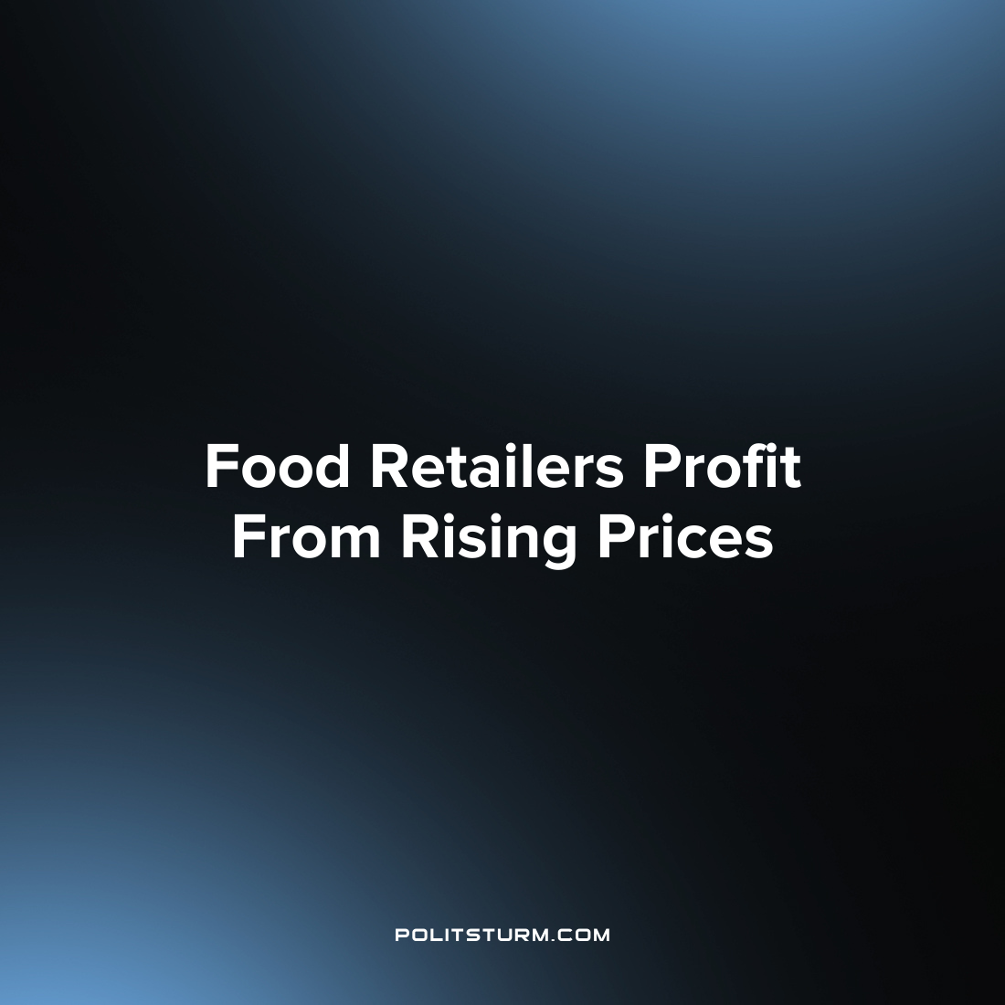

Original article
2022-07-18
1 min read

A new report by Oxfam sought to examine how the companies who sell food have benefitted given the ongoing food price increases. Global food prices have increased by 33.6% over the previous year and are slated to increase by approximately 23% in 2022. Two of the companies that stand to benefit from these rising prices are Walmart and food manufacturer Cargill.
Cargill, which is the largest privately held corporation in the United States in terms of revenue, saw the combined wealth of its owners increase by $14.4 billion since 2020. In 2021 the net income was $5 billion, driven largely by the increase in food prices, especially the increase in grain prices.
Similarly, Walmart has similarly benefitted from the increase in retail food prices. The Walton family owns a large percentage of the company shares and saw their wealth increase by $8.8 billion in real terms from 2020.
While the increase in food prices is a burden on workers and takes up a larger share of their income, the capitalists continue to profit and benefit. The interests of the capitalist class and the workers are diametrically opposed as the capitalists seek only to maximize their private wealth. Only the elimination of capitalist wage slavery can end the inherent exploitation of man by man that occurs regularly under capitalism.

Source: 1

Original article

