Food Prices Set to Rise in Brazil
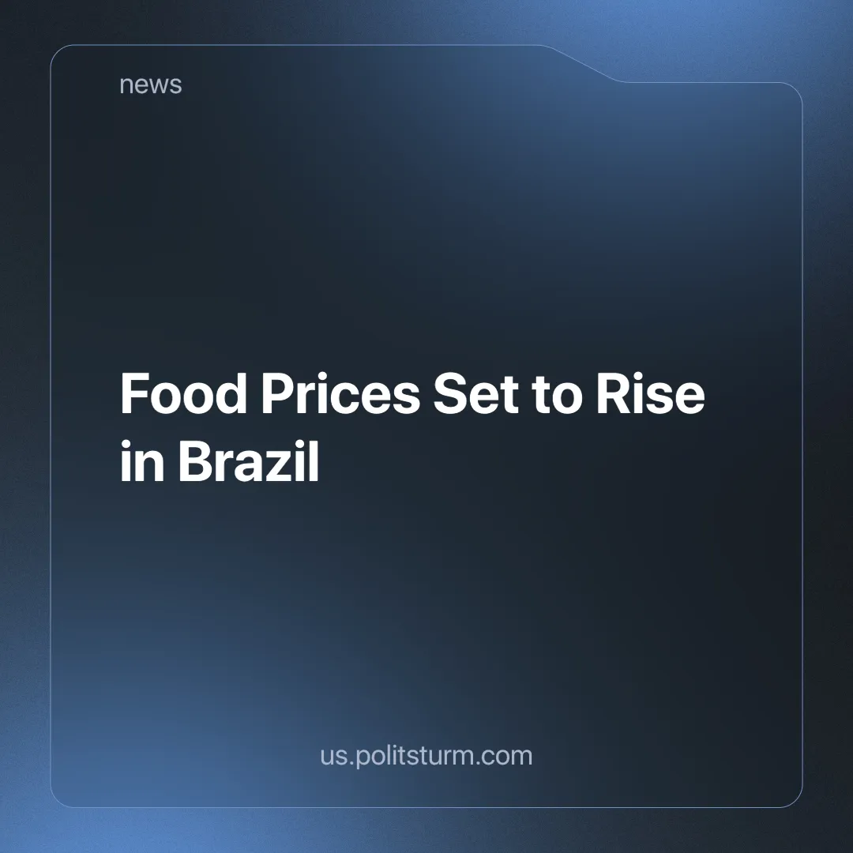

Original article
2024-10-13
3 min read

The prices of general food products, such as meats, fruits and sugar cane, have gone up in Brazil in September and are projected to keep rising in the coming months.
Although August saw a slight decrease in food prices [1], the Broad Consumer Price Index (IPCA) —considered the official measure for inflation in Brazil —for September is projected to have been 0.17% (it is calculated from the 16th of the previous month to the 15th of the following month) [2].
This small fluctuation is notable because it contrasts with the two previous years, all of which saw prices fall in the same month. Some specific products showed a more significant increase. Beef rose by 4.07%, pork by 9.54%, papaya by 27% and orange by 11% [3].
This small increase in prices is expected to be a sign for the coming months. The country has experienced a higher incidence of extreme weather conditions, which has affected food production.
Brazil has experienced prolonged droughts, floods and fires, which we have written about before. This raises the cost of production because it increases the average amount of time it takes to produce food under average conditions (as average conditions worsen).
Under normal conditions, when advances in technology increase labour productivity, prices still rise. This is because, under capitalism, the prices already include a profit component that goes into the pocket of the capitalist. During disasters, this profit margin is maintained (or even increased if prices rise due to scarcity of supply). As a result, during a crisis, the big capitalists can further concentrate their wealth, while food prices soar and living conditions for everyone else deteriorate.
In our previous articles, linked above, we show how a brutal austerity plan is gutting the remaining government agencies that can attempt to fight deforestation and provide disaster relief. But rising prices mean higher profits for capitalists who can afford to ignore the climate crisis around them.
Much of the deforestation in the Amazon, which is greatly accelerating climate change, is ironically being done to clear more land for cattle ranching and agriculture. 2023 saw agricultural land for soy production grow 47 times [4].
The Amazon rainforest, which is important for its large capacity for carbon capture and extreme biodiversity, is being cut down for food production (while food prices continue to rise). Under capitalism, food is produced for profit, not for consumption, and most of it ends up being exported while people starve at home [5].
In addition, mechanisation is often avoided because it is through the exploitation of human labour that profit is generated. Machines don't create new value themselves; they simply transfer their existing value (based on the labour that went into making them) into new products. No surplus value (profit) is added until human labour is involved in operating said machine. In this way, capitalism limits the development of agriculture to protect the interests of the capitalists.
Under a socialist state, the economy is centrally planned to meet human needs because it is a system based not on private ownership and profit, but on public ownership and the common interest of the working class.
Agriculture, freed from the shackles of capitalism, would see major investment to increase production while reducing the amount of labour required, allowing for a reduction in the necessary work day. This would be done while taking into account objective constraints, like possible environmental impacts, sustainability and the requirement to produce enough to feed everyone.
But to achieve socialism, the working class must overthrow capitalism. This cannot be done without the leadership of a genuinely communist party, of which there are none today. A communist party must be able to understand, through Marxist-Leninist theory, the correct strategies and positions that can lead the proletariat in its struggle and ensure victory over capital. Do you want to help us work towards creating this party? Join Politsturm.
Sources:
[1]Brasil de Fato —- Alimentos têm queda suave, mas alta dos combustíveis puxa inflação para perto do teto —- 25/06/2024
[2] CNN Brasil —-Preço dos alimentos deve voltar a subir com estiagem e queimadas —- 15/09/2024
[3]Estadão —-Opinião | Produção de alimentos, afetada por condições climáticas, deve causar subida nos preços —- 01/10/2024
[4]G1 —-Mais de 90% do desmatamento da Amazônia é para abertura de pastagem, diz MapBiomas —- 03/10/2024

Original article

