Food Prices In Russia Went Up By 50-100%
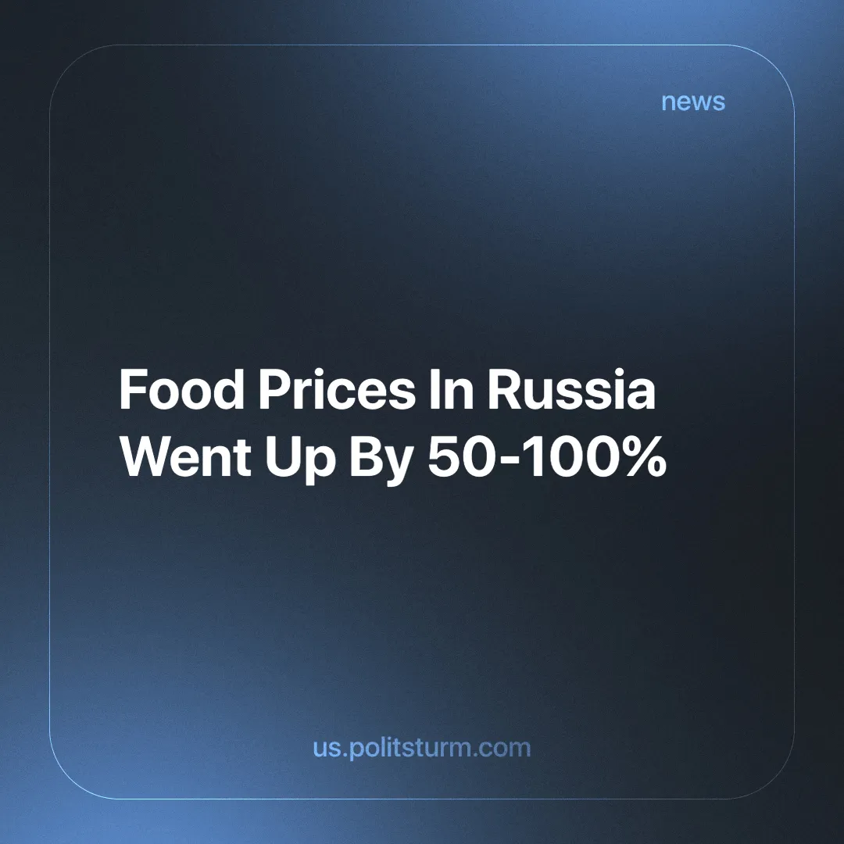

Original article
2024-12-23
3 min read

Every year and every month, the personal budgets of Russian citizens are put to an increasingly severe stress test. The cost of food continues to rise. Official statistics use the term "average check" to calculate inflation, which differs significantly from the real expenses of most Russians.
According to some media reports, the cost of the so-called "average shopping basket" in Russian stores has risen by 8% [1]. However, those who spend their honestly earned money on food and necessities feel the rapid increase in prices. Even official information sources occasionally confirm this [4]. Thus, according to some experts, real inflation may have reached 100% since the beginning of the year [5].
Why have people started to spend more money on food? A rational person, observing the situation in the food market in recent years, will confidently say that the economic crisis, which is worsening all over the world, is to blame. Inflation eats away at the already meager incomes of the majority of Russians, and the indexation of salaries and pensions lags far behind the growth in the prices of goods and services.
That said, the people in power are not among those who benefit from telling the truth under the current circumstances. That is why hired and paid "experts", as well as government proxies , confidently claim that rising citizen incomes are to blame [2]. They say that the salaries of Russians have recently increased significantly, and therefore people immediately rushed to spend extra money in stores. Is this logical? Not at all! But this is the logic of the government propagandists.
What is the reality? An increase in the price of the most essential goods - food - and a decrease in the real income of citizens. The shortage of products produced and grown in the Russian Federation also has a negative impact on price trends. The head of the Russian Ministry of Agriculture Oksana Lut said in her report to the Cabinet of Ministers that as of November 1, 2024, the harvest of major crops has decreased by up to 15% compared to 2023. The harvest of potatoes (15%), grain (12%) and wheat (11%) has decreased the most [3].
This state of affairs does not bode well for the workers of Russia. Sooner or later, the glittering tinsel of stories about rising incomes will crumble to dust, and the real situation will become much worse. The shortage of crops only means that potatoes and other crops will eventually be imported into Russia, and this will inevitably lead to an even steeper rise in their prices.
Inflation will not stop growing, and people's incomes will continue to fall. The worst phase of the overproduction crisis is already looming on the horizon. Russians will not be able to buy expensive goods due to their low incomes and high prices, and businessmen will not be able to sell these goods. And then, in front of the hungry population, the capitalists will destroy the products produced by the labor of these same citizens, as they have done hundreds of times before.
This terrible situation is unavoidable in a market economy with legally established private property. Every business owner wants high demand and high prices for their products. Only a state-planned, socialist economy, an economy without crises and without parasites sitting on the shoulders of the people, can ensure real prosperity and the satisfaction of the needs of society.
Sources:
[1] MKRU "Budget under assault: Russians began to spend more money on food" — November 08, 2024.
[2] MKRUYaroslavl "New version of butter prices rising" — November 07, 2024.
[3] nakanune.ru "The Ministry of Agriculture has warned of a possible shortage of potatoes and vegetables in the country." — November 12, 2024.
[4] gazeta.ru "Products in Russia rise in price by 50-100% in a year" — November 18, 2024.
[5] MKRU "Financial analyst named the real percentage of food price growth in Russia" — November 18, 2024.

Original article

