Florida’s Oldest Black University Dissolves Teachers’ Union for “Religious Freedom”
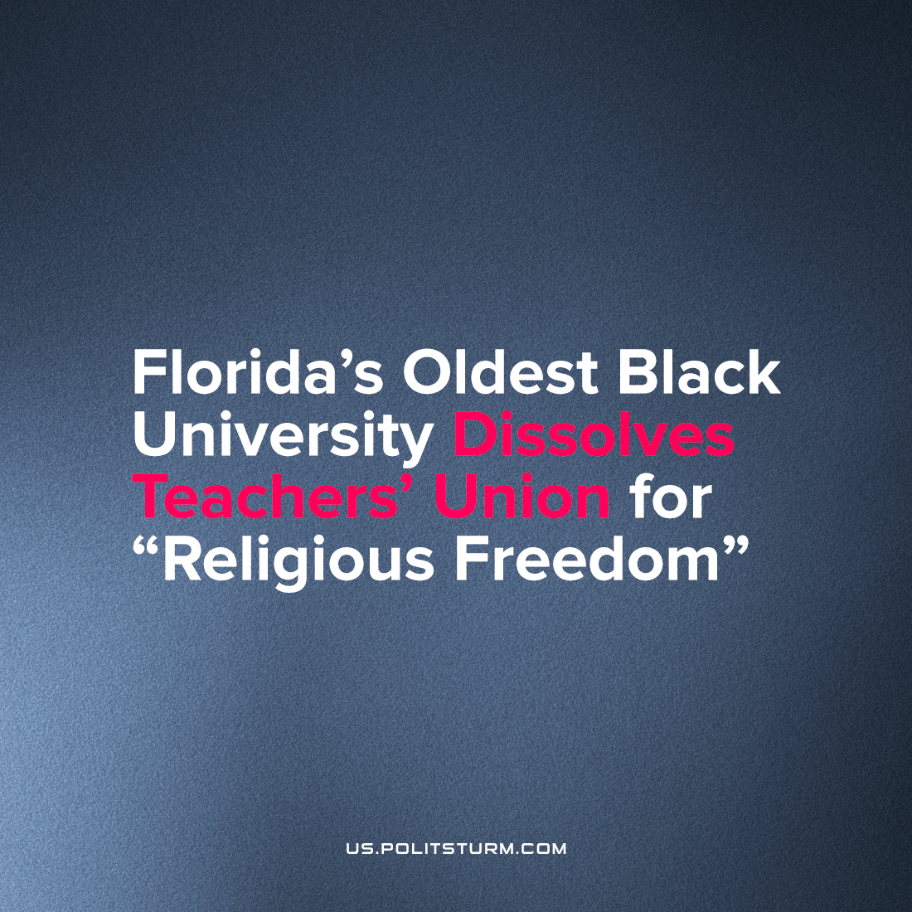

Original article
2022-12-16
2 min read

Edward Waters University has 'un-recognized' the chapter of AAUP which represented the school's faculty, on the basis of a 2020 National Labor Relations Board decision which empowered them on the grounds of the "Religion Clauses of the First Amendment of the Constitution".
“The assertion of the University’s rights as a religious educational institution, acknowledged by the Supreme Court of the United States and the National Labor Relations Board, will also allow EWU to be driven by its faith-based Christian mission, rather than the political agendas often associated with federal labor policies,”
Luckily for the nation's private Christian universities, federal labor policies now support their political agenda, with both the NLRB and federal judge ruling that a "self-identified religious institution of higher education" cannot be ordered to follow federal labor law, since;
"jurisdiction over religious schools in matters involving faculty members will inevitably involve inquiry into the religious tenets of these institutions."
This example demonstrates the principle motivation why religious rights have been given precedence by federal authorities over the past 40 years. We cannot fall into hysteric fears of Christian dictatorship, as many compare the abolition of abortion rights with the dystopian novel Handmaid's Tale, but instead recognize that the legal rights of Christians and powerful religious organizations are merely used to enact the political and economic goals of the whole ruling class.
In order to preserve the institutions of private education during economic crisis, which sprang up in the 1950's to allow parents to avoid mandatory desegregation, while public schools are gradually de-funded and under-serve their students, federal law approves greater legal privileges to maintain services for the children of the wealthy. If these schools were not exempt from taxation, a huge number of them would go bankrupt and disappear forever - possibly forcing wealthy parents to either support increased funding for local charter schools, or join the growing (largely Christian) home-school movement.
Private schools pay their teachers much less, and with far fewer rights to basic services and pensions, than their public counterparts. This should be seen in the comparative unionization rates between the two, where public school teachers were organized at nearly 70% in 2016.
This profession, like the public university system, is one of the nation's few remaining hold-outs of labor union presence in any American institution. As the role of public education diminishes along with its funding, private schools gain more and more leeway to break the rules as it rises to the place of replacing public service.
Even the most open bigots and reactionaries use the cause of "rights for minorities" as a publicity campaign for the advancing the legal position of the rich, using Black and Christian faces to deflect criticism. Using liberal cliches, like the historically black identity of EWU, or the "oppression" of religious communities (in this case, the dominant evangelical Christian denomination), they can shamelessly call for the most direct attacks on American workers.
We must reject these falsities and fight to organize workers behind the backs of the fat-cats who laugh and say they've won with a flick of the pen and a few words in front of the camera. No employer, and no anti-worker law will be able to abolish the class struggle. Attacks on teachers and education as a whole are the vanguard assault of the American fascists, as we see elsewhere, precisely because this is one of the last hold-outs of a higher standard for workers rights.
Sources: 1, 2.

Original article

