Five Workers Killed At Sewage Treatment Plant In Italy
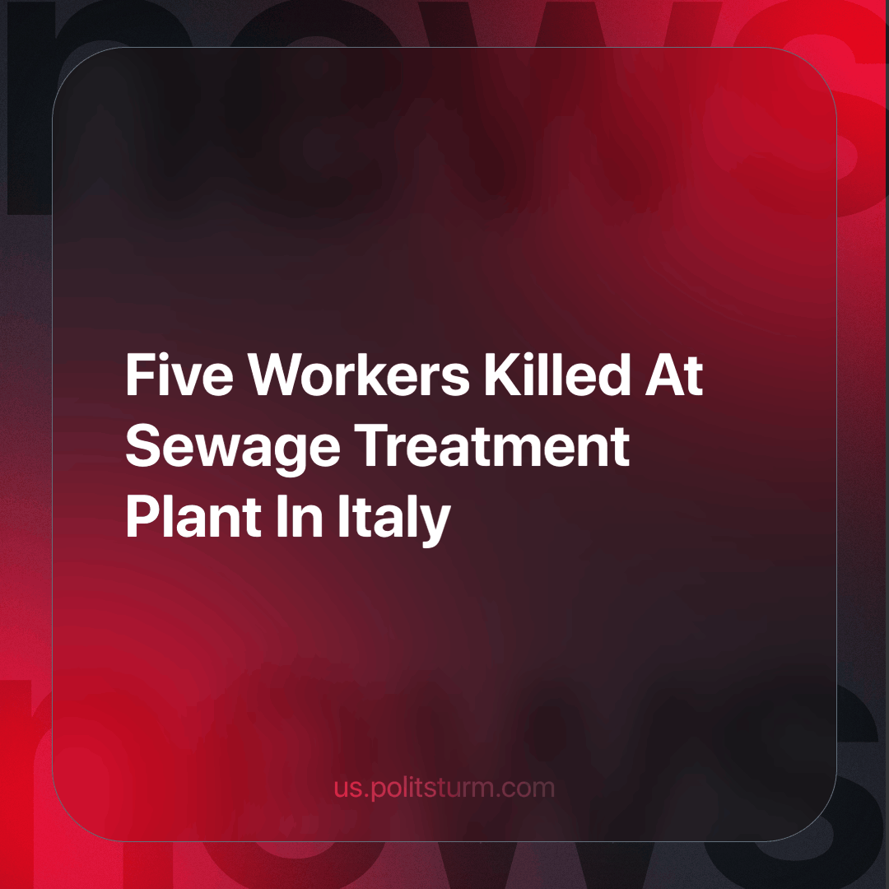

Original article
2024-05-23
3 min read

At the beginning of the month, five workers were killed at a sewage treatment plant near Palermo, Sicily while another was found unconscious and taken to hospital. They were not wearing any masks and succumbed to toxic gas poisoning.
The tragic deaths are a glaring example of the deep contradictions and injustices of the capitalist system. This incident is not an isolated one but represents a widespread reality in which workers' lives are constantly put at risk for the sake of maximising profits.
First, capitalism is based on the exploitation of labour. Workers are seen as mere resources, and objects, often disposable, whose value is measured only in terms of productivity and the produce profit for the owners of capital. This approach inevitably leads to precarious and unsafe working conditions, with safety measures often seen as an unnecessary cost. The fact that an army of workers are forced to remain unemployed by capitalism, aggravates the situation by also lowering the price of labour power in favour of private capitalist profit. The accident in Palermo, where workers were not wearing protective masks and were exposed to toxic gases at ten times the safety limit, highlights the lack of investment in adequate safety measures. This shows that the protection of workers is being sacrificed on the altar of profit.
The negligence and irresponsibility of the institutions make the situation even worse. Statements by politicians such as Prime Minister Giorgia Meloni and President Sergio Mattarella, calling for clarity on the accident, are mere formal acts without any real commitment to changing the structural conditions that allow such tragedies to occur. This attitude reflects the fact that de jure, the state seems committed to protecting workers through laws and regulations. De facto, however, these commitments never really meet the interests of the oppressed class. Workplace safety regulations exist on paper, but they are often poorly enforced, and inspections and penalties for violations are inadequate.
The power imbalance between workers and employers is a fundamental feature of capitalism. Workers have no power to decide on their working conditions and accept whatever conditions are necessary to survive. This imbalance of power is evident in the inability to prevent accidents like the one in Palermo, despite repeated calls for better safety conditions by the workers' unions and the workers themselves.
From a Marxist perspective, the solution to these problems lies in collective struggle. Only through unity and mobilisation can workers hope to win significant improvements in their working conditions, and eventually the change to a system that guarantees these things. The growing anger and frustration among workers and trade unions in Italy shows the potential for a wider and more organised mobilisation. This incident could be a turning point, leading to greater solidarity and pressure on the institutions to bring about real change.
Finally, Politsturm expresses its deep solidarity with the new victims of capitalism whose lives have been tragically cut short by greed and negligence. These workers are not just numbers in a statistic, but human beings with families, dreams and aspirations. Their loss is a painful reminder of the systemic injustices that plague our society. These victims must be an example to all workers: it is time to wake up. It is time to recognise that their lives and well-being are being systematically sacrificed for profit. To honour the memory of these workers and to prevent future tragedies, it is essential that the working class unite in a communist party, the vanguard of the working class, to fight for its common interests in an organised and determined way. Only through solidarity and collective action can workers hope to overthrow the oppressive structures of capitalism and build a new, more advanced society based on social equality and dignity for all.
It is time to turn pain into strength and despair into hope, for a future where every worker is valued and protected.
Source:
BBC - “Five dead in new Italian workplace tragedy” dated May 7, 2024.

Original article

