First Croatian Conscripts Begin Training
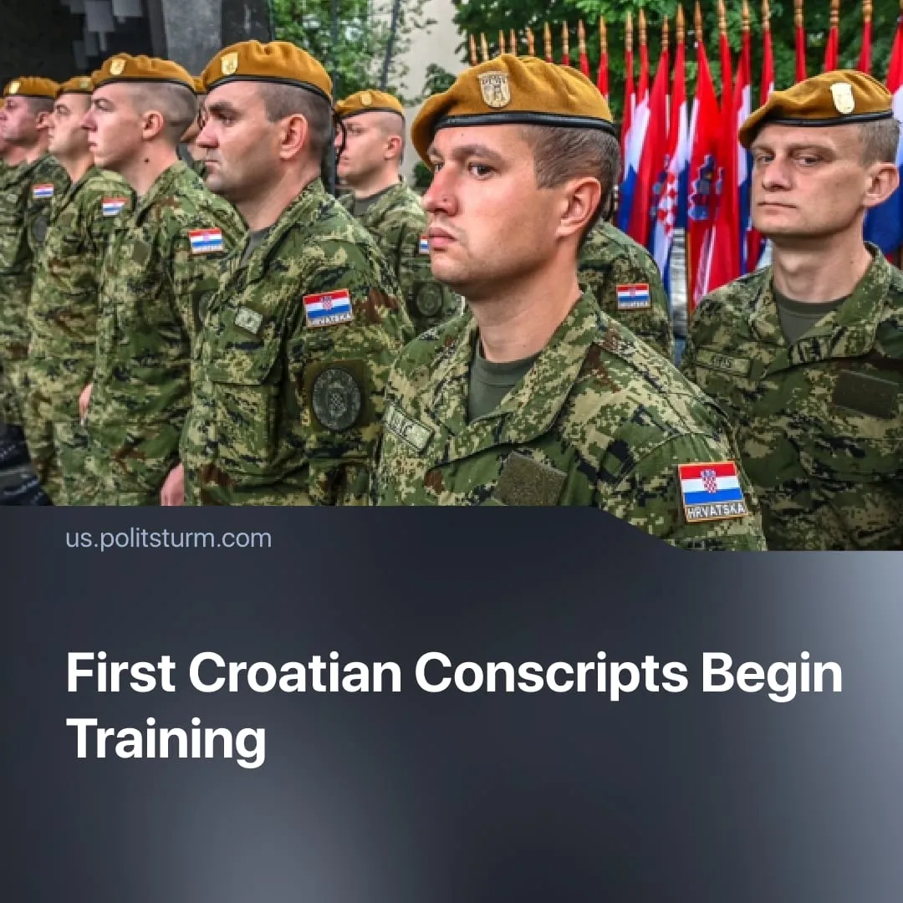

Original article
2026-03-18
1 min read

Croatian men begin new military conscription, following a trend seen across Europe.
Details. In October 2025, the Croatian Parliament reintroduced two months of compulsory military training by amending the Defence and Armed Forces Service Acts. Implementation began when the first conscripts entered basic training at army barracks nationwide.
► Mandatory service mainly applies to male Croatian citizens aged 18–27 (with a possible extension until the age of 30). The first group affected will be men born in 2007, who will be called up throughout 2026. Around 4000 recruits are expected each year, while women may serve voluntarily.
► Typical of capitalist propaganda, the Croatian government justified the introduction of compulsory military service and increased militarisation by presenting it as a means of "defence", particularly in the context of the Russian “SMO”. Officials stated that the measure is intended to strengthen national preparedness and expand the pool of trained reserve forces.
Context. Across Europe, governments are rapidly expanding military spending and rebuilding their armed forces after decades of post-Cold War reductions. Germany, France, Poland, and several Nordic countries have launched major rearmament programmes, as NATO pushes members to increase military spending toward 5% of GDP by 2035.
► Across Europe, governments are cutting social programmes and development aid to fund rearmament. In some cases, new borrowing or financial measures are being employed to fund this rapid growth in military spending, making smaller EU countries that want to increase their spending more dependent.
► Several European states are moving toward conscription to expand their armed forces. Latvia has reintroduced mandatory service, Denmark has expanded its draft, while major powers such as Germany and France are advancing “voluntary” conscription schemes.

Original article

