Intense Fires in Brazilian Wetlands
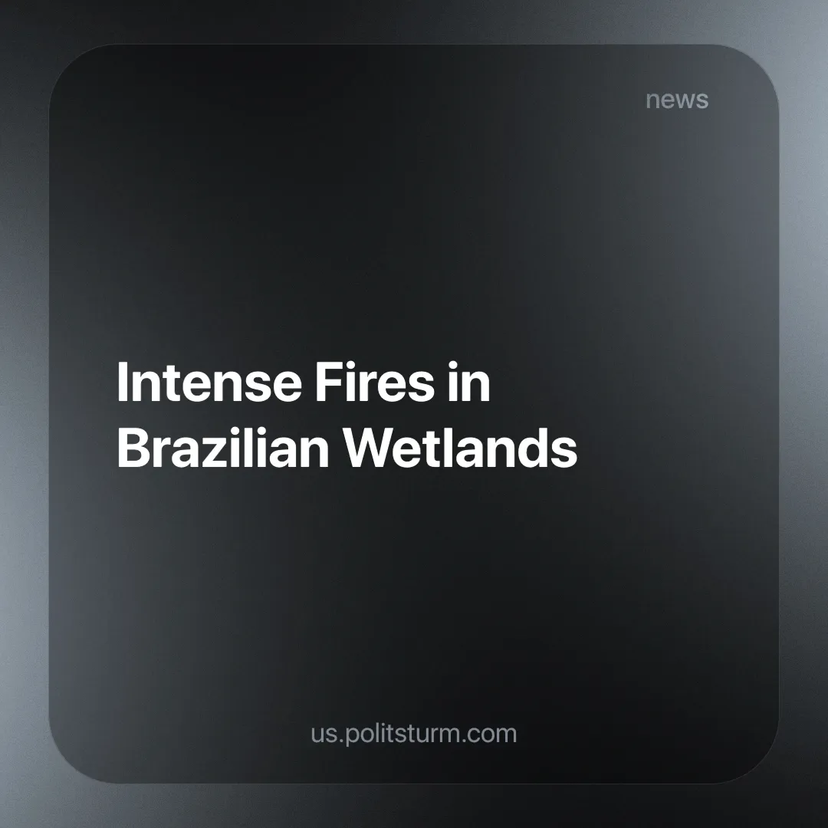

Original article
2024-07-04
2 min read

Massive fires have been recorded in the Brazilian wetlands biome, with at least 3,000 cases being recorded since the beginning of the year. The biome is shrinking and is likely to disappear if immediate action isn't taken.
Known as the Pantanal, it is the largest floodplain in the world and is located in the Centre-West region of Brazil. It is naturally prone to fires during the dry season because large amounts of flammable organic material accumulate during the flood season. Fires usually occur due to natural causes, such as lightning, but nowadays they are mostly caused artificially by big landowners clearing land for agriculture. This endangers the local population who, generally speaking, have no influence or culpability in these disasters, but suffer the most because of them.
Climate change is also making fires more widespread and the dry seasons longer. It is the biome that has lost the most water relative to its size in the country, with 61% of its water surface drying up in the last 38 years [1].
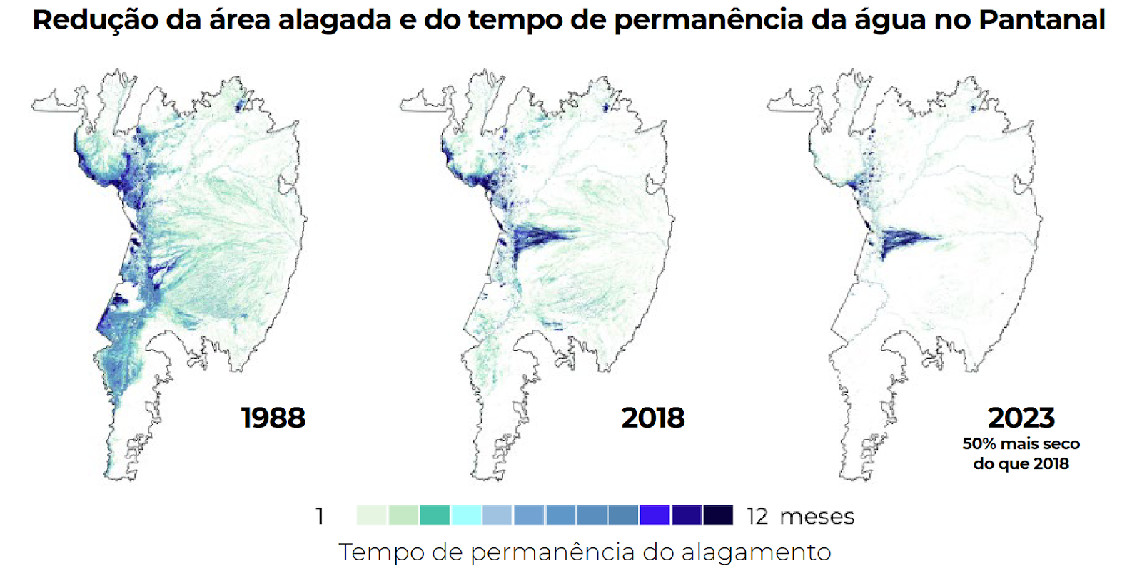
Earlier this year, the Brazilian state of Rio Grande do Sul suffered severe flooding, which we wrote about previously. In that article, we mentioned the government's austerity measures, led by President Lula da Silva of the Workers' Party (PT).
In the wake of the floods, Lindbergh Farias, a member of parliament also from the PT, has proposed a complementary bill to lift the austerity measures on projects aimed at preventing natural disasters [2], but this proposal would need popular support and a concentrated effort from leftist parties to pass against a government made up mainly of conservatives. But it has received little attention from the so-called "progressive media" and isn't brought into the debate by most of the supposedly leftist government officials, making it largely unknown to the average person. This is because the PT has shown that its priority is to implement its zero-deficit plan rather than invest in vital areas of society.
Earlier this year, for example, the country's teachers went on strike due to the lack of funding and salary adjustments caused by the Zero Deficit Programme [3]. An organ of society that is supposed to have a constitutional minimum of spending.
A government that serves capital will always protect the profits of big business, whether it is a right-wing government or a supposedly left-wing government like Brazil's Workers' Party. The prevention of natural disasters and the preservation of human life are an afterthought. Only a truly communist party, working to establish socialism, where human life, not profit, is the prime consideration, is capable of truly solving these problems.
Sources: 1,2,3

Original article

