The Finnish Workers' Strike is Extended
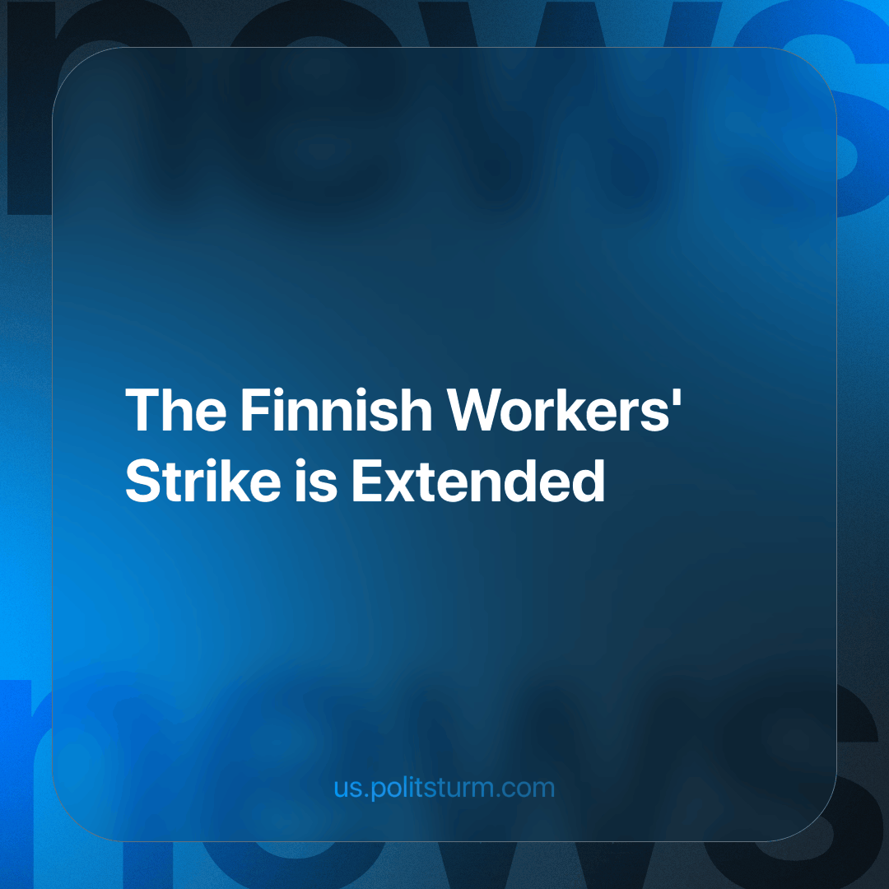

Original article
2024-03-29
1 min read

The Finnish trade union JHL has announced the extension of the strike in the export sector for another week. This follows a strike of 100,000 last month that we covered. The strike is directed against the policy of the Finnish Government, which includes:
- Reducing housing allowances and unemployment security
- Limiting the right to strike
- Complicating the procedure for concluding collective agreements.
The strike, which originally began on March 11 and will now last until March 31, effectively halts the country's exports, demonstrating the seriousness of the workers' intentions not to deviate from their demands.
About a thousand members of the Trade Union for the Public and Welfare Sectors (JHL), as well as members of other trade unions belonging to the Central Organization of Finnish Trade Unions (SAK), are actively participating in this strike. Key industries that have been affected include rail freight transport and several major ports throughout Finland.
The extension follows unsuccessful discussions between SAK President Jarkko Eloranta and Finland's Minister of Employment Arto Satonen. The capitalist government of Finland has once again shown that it does not intend to negotiate and make any compromises with the workers. The president of JHL even expressed the idea that the government is “aligning too closely with business interests” [1].
At the same time, the capitalists begin to feel the damage from the strike.
There is a shortage of steel and chemical products in the Finnish industry [2]. Buses in Helsinki may run out of fuel due to ongoing strikes, as about 60% of buses run on diesel fuel [3].
At the moment, it is unclear whether the Finnish workers will be able to convince the bourgeois government with their actions. In any case, we wish them more strength and patience in the fight. For protest activities to have the desired effect, the Finnish working class needs a workers' party that will unite and coordinate many trade unions and public organizations. At the moment, there is no such party, and it is the primary task of the Communists to build such a party.
Sources: 1, 2, 3

Original article

