Finland Lifts Arms Export Ban to Turkey
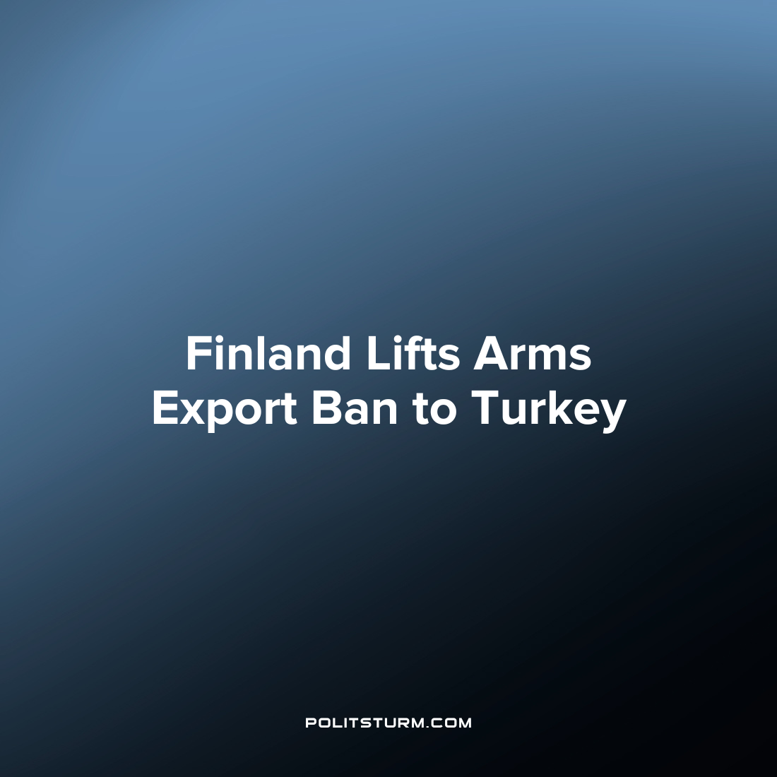

Original article
2022-12-31
2 min read

On December 8th, Finland announced its readiness to lift the ban on arms exports to Turkey. According to Defense Minister Antti Kaikkonen, the Finnish government may in the near future renew licenses to sell weapons to Ankara.
“At the moment, there is no categorical ban on the supply of weapons to Turkey in Finland,” the minister concluded.
A message about the possibility of renewing the license for the sale of weapons to Turkey was received at a meeting of Finnish and Turkish diplomats in Ankara on December 8th. There, representatives of the two states discussed the conditions for Finland to join NATO. Likely one of Finland's arms embargo claims, the Finnish government immediately after the meeting rushed to re-establish arms trade with Turkey.
An embargo on arms exports to Turkey was imposed by Finland in 2019 in response to Turkish airstrikes on North Syria. However, at the present time - with Turkey opening up a new phase of bombing of North Syria and Iraq, and is threatening to send ground troops into these areas - Finland no longer considers a ban necessary.
In 2018, before the embargo, arms exports from Finland to Turkey amounted to about 17 million euros.
Not only Finland, but Sweden has also completely changed their arms trade policy with Turkey recently. Just like Finland, Sweden imposed an arms embargo on Turkey in 2019 in connection with Turkey's military operation in Syria. However, in September 2022, the Swedish government officially lifted the ban on the sale of weapons and other military supplies to Turkey. To fulfill Turkey's conditions for joining NATO, Sweden has also begun extraditing "political criminals" from the Kurdistan Workers Party to Turkey, where they face many years in prison.
The decision of Finland and Sweden to change their attitude towards the sale of weapons to Turkey because of the desire to join NATO shows the hypocrisy and unscrupulousness of the bourgeois states. They change their policies based on momentary benefits, subordinated to the interests of the capitalists. Only a socialist state comes forward with a consistent political line that puts the workers in the first place.
Source:
Dagens Nyheter – “Finland kan snart bevilja vapenlicenser till Turkiet” Date: December 8
Dagens Nyheter – “Sverige öppnar officiellt för vapenexport till Turkiet” Date: September 30
ТАСС – «Финляндия оформит лицензии на экспорт оружия в Турцию» Date: December 8Газета – «Министр обороны: Финляндия может снять эмбарго на продажу оружия в Турцию» Date: December 13

Original article

