Lenin on Financial Collapse and Measures To Combat It
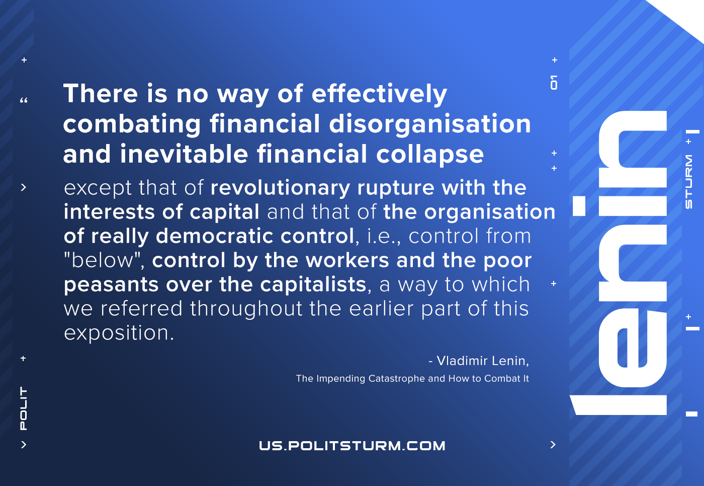

Original article
2021-01-06

There is no way of effectively combating financial disorganisation and inevitable financial collapse except that of revolutionary rupture with the interests of capital and that of the organisation of really democratic control, i.e., control from “below”, control by the workers and the poor peasants over the capitalists, a way to which we referred throughout the earlier part of this exposition.
V. I. Lenin
The Impending Catastrophe and How to Combat It

Original article

