Why Has Fentanyl Become America's Deadliest Drug?
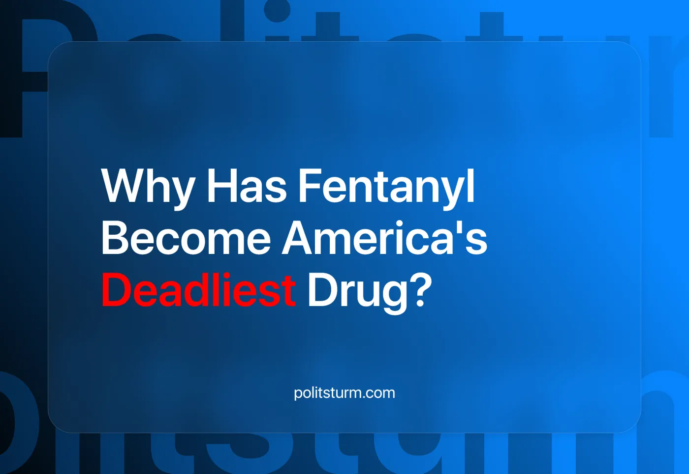

Original article
2024-07-27
8 min read

In recent years, a new drug called fentanyl has come to the forefront in the United States. This highly potent opioid has risen to become one of the largest leading causes of death in the country, being the leading cause of death for people under the age of 40 [12]. What is this drug, why are capitalists powerless to resolve the issue, and how do we deal with it? We delve into the crisis in this material.

1. The Fentanyl Crisis
Fentanyl is a synthetic opioid used in medical applications such as anesthesia. Its usage outside of professional and medical settings is due to its recreational experience, potency, and addictive properties. What distinguishes fentanyl from similar drugs such as morphine is its newer and more potent synthesis. Fentanyl and its derivatives, unlike its other opioid counterpart, account for 70% [3] of all overdose deaths in the United States. We previously covered the ‘fourth wave’ of overdose fatalities.
Approximately 599,255 people died from drug overdoses in the United States between 1979 and 2016 [1], which contrasts with the recent staggering number of fentanyl overdose deaths alone, which accounted for 297,115 deaths [4] in the six years from 2016 to 2022. Compared to natural opioids, fentanyl is obscenely easy to manufacture. It takes about 1,000 square meters of poppy fields to produce one kilogram of heroin, and about 18 meters of space to produce one kilogram of fentanyl. This, combined with the higher potency of fentanyl, about 20 times that of heroin, makes synthetic opiates extremely profitable for drug traffickers and pharmaceutical companies.
The ease of manufacture that allows for the widespread use of such substances, and the profit motive and competition that drive drug traffickers and pharmaceutical companies to produce cheaper (but more dangerous) drugs, have inevitably led to the extreme and growing crisis we face today. These economic laws that govern capitalism created an epidemic in the U.S. because of its position in the world market. As one of the richest countries with the greatest access to both illegal and legal drug markets, as well as more extreme social inequality compared to other richer countries, America's conditions have been the foundation for higher levels of drug use than comparable countries.
Rather than being the exception, America is a prelude to the rise of fentanyl globally. Fentanyl is now appearing in several different countries, such as Germany [3], signaling an alarming increase in its popularity around the world. In order to grow profits, the current system (capitalism) has to expand its markets to sell its most profitable drugs no matter the consequences. This will lead to the present US epidemic inevitably expanding to a global one.
Error loading image
Error loading image

2. Causes of the Crisis
These tumultuous social conditions under the current system of economic production create pressures on all working people and the ever-present market forces that imprint themselves on all spheres of society. Competition and profit incentives ultimately create worker alienation (as the worker’s ability to labor is too freely bought and sold in a market). Whether outside or inside the law, the ruling capitalists must maintain their social relations (i.e., ownership of the means of production) in order to continue making their profits. In this case, the legal capitalists, such as the monopoly pharmaceutical companies, started the crisis by over-prescribing highly profitable opioid painkillers like OxyContin in the 1990s.
To make such blatantly false prescriptions, the big corporations paid doctors to market their drugs, forcing them to lie directly to patients about the expensive opioids and their effects [8]. This allowed the illegal capitalists to step in and sell stronger, more dangerous substances for cheaper [7]. The competition between capitalists in this new market has also increased the misery of the workers, as the capitalist class must undercut each other in order to compete and sell goods to “consumers”. In undercutting, they must maintain profit levels, so they must find a way to cheapen the cost of producing their product - often creating an incentive to sell products that are more dangerous than before, as in the present case of selling fentanyl instead of heroin or morphine, cutting fentanyl into other products or adding other filler impurities. The new wave of fentanyl overdoses that these capitalist forces are creating through their actions is already straining an already failing medical system.
Recently, medical errors have become the third leading cause of death in America, with 200,000 people dying annually and another 400,000 suffering preventable harm from the current medical system [11]. In order to increase profits, legal capitalists like their counterparts in the drug cartels (illegal capitalists) must find a resource that is most easily exploitable for profit and in the market. Fentanyl was therefore used by said cartels and large corporations as its profitability outweighs its potential harm to users, ultimately leading to more deadly drug overdoses [12]. The reason for this lies in the despair and meaninglessness that result from alienation in a capitalist society. Marx's formulation of the capitalist creation of alienation for working people is refreshingly eloquent in his manuscript Estranged Labor [4]:
"This fact merely expresses that the object which labor produces-the product of labor-is confronted with it as something alien, as a force independent of the producer. The product of labor is labor embodied in an object, which has become material: it is the objectification of labor. The realization of labor is its objectification. Under these economic conditions, this realization of labor appears to the workers as a loss of realization; objectification is a loss of the object and bondage to it; appropriation is estrangement, as alienation. So much does the realization of labor appear as a loss of realization that the worker loses realization to the point of starvation."
Inevitably, workers become alienated from the realities and conditions they face and use various coping mechanisms, such as drugs, to distract themselves from the current realities that the capitalist system imposes on them.

3. How does the government deal with it?
Modern capitalist solutions to the current crisis include a variety of different, contradictory perspectives. To date, the UN (United Nations), has enacted the "War on Drugs", led by the United States, which has completely failed in the task of reducing drug-related crime [6], and on the contrary, has increased the level of violence in minority communities through police brutality [5]; policies enacted under many different administrations create programs that harshly and arbitrarily incarcerate people who have possessed or used drugs. It is further escalated by laws giving police and other institutions more power to enforce drug-related crimes designed to punish working people for their understandable alienation and escape from the harsh realities they face. According to other liberal scholars, restrictions on drugs rather than outright prohibition will limit the amount of drug use and overdoses compared to current projections [7]. Still, while helpful in treating the symptoms, these measures do not stop the underlying contradictions of capitalism that create the conditions conducive to drug abuse or the proliferation of drugs available to the masses. These laws of capitalism leading to crisis are not a new phenomenon, and we have covered this topic before on why capitalism has caused a crisis of drug abuse.

4. The Real Solution
To eradicate the drug crisis, we must attack it at the root, not at the branch of addiction that has formed. Drugs and our use of them in their current form have their origins in capitalism, alienation, the profit motive, and competition, creating a system in which people seek to alleviate their suffering through the use of substances that will lead to the end of their lives. And without the definitive destruction of this outdated socio-economic system that is at the root of the issue, the fights against drug addiction, drug trafficking and the drug rings of legal and illegal capitalists are doomed to fail. To do this, we must overthrow the old capitalist system and firmly establish a new socialist system. The new socialist construction must be led by the vanguard of the working class, the genuinely communist party, however, no such party currently exists in the US. Join us in building such a party, to effectively lead the fight against capitalism.
Sources:
[1] https://www.ncbi.nlm.nih.gov/pmc/articles/PMC6848196/
[2] https://www.reuters.com/graphics/MEXICO-DRUGS/FENTANYL/dwvkadblovm/
[3] https://www.dw.com/en/germany-battles-growing-crack-and-fentanyl-crisis/a-68512680
[4] https://www.statista.com/statistics/895945/fentanyl-overdose-deaths-us/
[5] https://www.ncbi.nlm.nih.gov/pmc/articles/PMC4800748/
[6] https://www.globalcommissionondrugs.org/reports/the-war-on-drugs
[7] https://jied.lse.ac.uk/articles/10.31389/jied.22
[8] https://www.propublica.org/article/double-dip-doctors-paid-to-advise-promote-drug-companies-that-fund-research
[9] https://pubmed.ncbi.nlm.nih.gov/29763131/
[10] https://pubmed.ncbi.nlm.nih.gov/29763131/
[11] https://www.statnews.com/2016/11/16/illegal-drugs-price-potency/
[12] https://missouriindependent.com/2023/09/05/death-rates-for-people-under-40-have-skyrocketed-blame-fentanyl/

Original article

