Feed The Hungry Or Burn The Food?
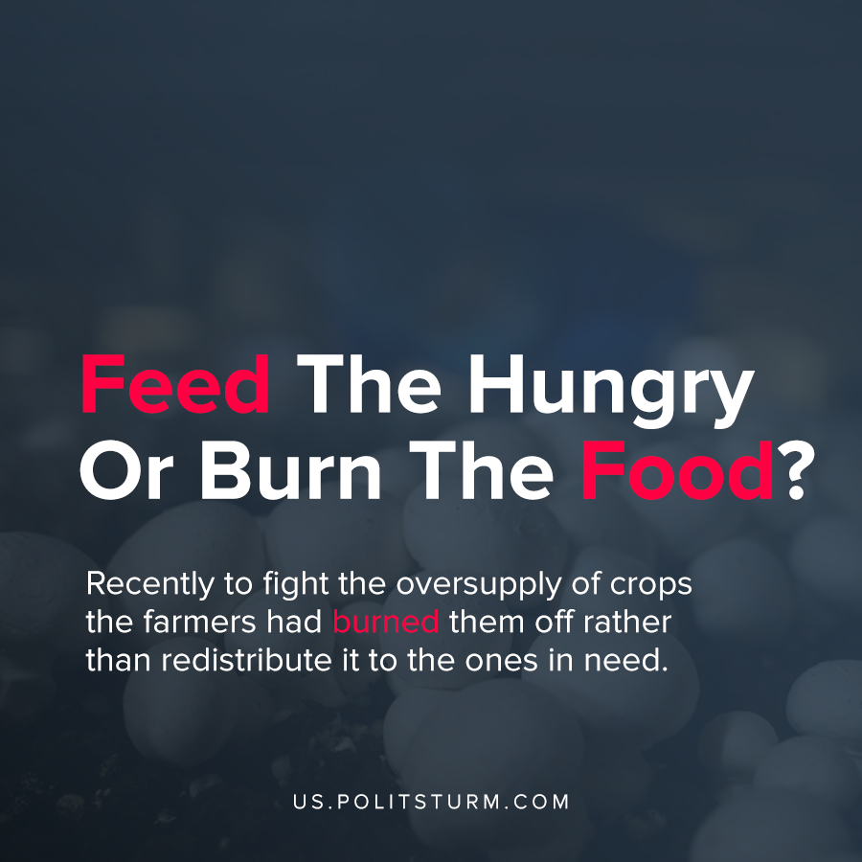

Original article
2020-04-18
1 min read

Recently to fight the oversupply of crops the farmers had burned them off rather than redistribute it to the ones in need.
“Mushroom farmers across Canada have been struggling for weeks with an oversupply, according to Mushrooms Canada.
The association said changes in the industry have been happening too quickly to fully quantify how much oversupply is currently in the system, which produced more than 133,000 tons of mushrooms and $1 billion in sales last year. But it said the drop in demand, on top of shortages in farm labour, has some mushroom operations considering closure.”
“The demand for pork bellies has dipped, too, in part because bacon is so ubiquitous on fast-food menus, one pork processor said this week. And, of course, dairy farmers have been dumping raw milk now that coffee chains and school programs need less dairy, if any”
This is an example of what occurs during a crisis of overproduction, where the supply overcomes the demand. The capitalist basis enforced the producers to destroy their goods to reduce supply, with the goal of restoring profitability. The capitalist system inherently makes these people behave in self-interest as while they collectively produce food. Hence we see that the capitalist system cannot be reformed as the system inherently forces people to be greedy in order to survive.
Only a socialist system will be able to fix these issues as it will to fulfil peoples needs rather work for a profit. We will no longer see similar actions done like during past crises of overproduction, such as the more notable great depression, where to fight similar issues, producers would burn their supply. Once more, only socialism can fix these issues as crises of overproduction would cease to exist, and there will never be situations where we have millions of hungry people while having enough food to feed 10 billion people, and these are only stats from 2018. (1)
https://business.financialpost.com/commodities/agriculture/the-mushroom-problem
https://www.nytimes.com/2020/04/11/business/coronavirus-destroying-food.html
https://medium.com/@jeremyerdman/we-produce-enough-food-to-feed-10-billion-people-so-why-does-hunger-still-exist-8086d2657539 (1)

Original article

