Federal Reserve to Increase Interest Rates
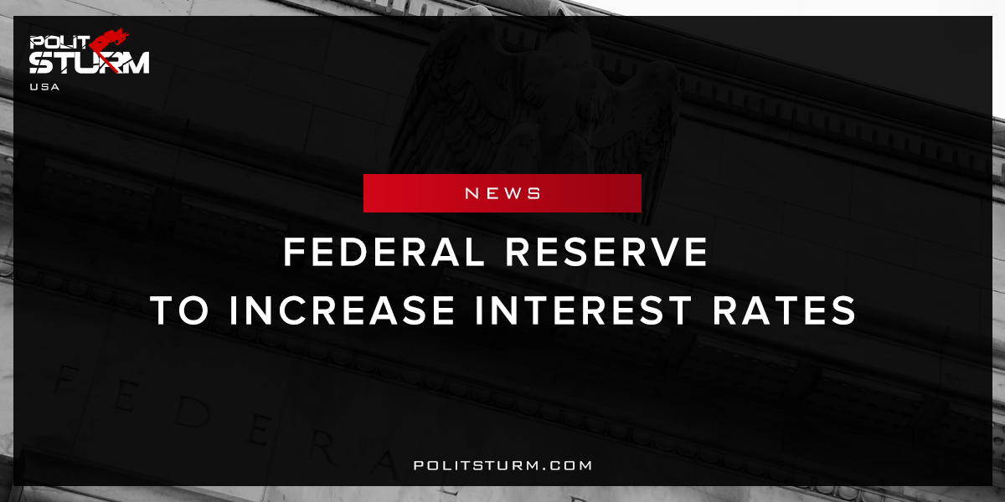

Original article
2017-10-08
2 min read

The Federal Reserve must respond to “very tight” U.S. labor markets by gradually raising interest rates or risk halting the economic recovery, a hawkish Fed official said on Saturday.
In prepared remarks that largely restated his views, Boston Fed President Eric Rosengren said he expects the labor market to improve further after U.S. unemployment dropped to 4.2 percent last month, its lowest level since 2001.

Prudent risk management would argue for the continued gradual removal of monetary policy accommodation in order to minimize the risk of outcomes that might prematurely shorten the current economic recovery
– said Rosengren, who was speaking at the International Atlantic Economic Conference in Montreal, adding he expects the U.S. economy will likely continue to grow above its potential.
Politsturm: U.S Federal reserve officials argued that interest rates are likely to rise and the economy will grow “above it’s potential”. It is claimed that the increase of wages is forcing the monetary authorities to raise interest rates in an effort to halt inflation pressures. It is worth noting the tacit implication made by the Federal Reserve is that wage inflation leads to price inflation. Since unemployment figures are low, according to this theory, the laborers have the greatest bargaining power are are driving up wages and prices. The fact that Karl Marx disproved this argument well over a century ago is either unknown or unacknowledged. Marx empirically proved that a rise in wages leads to no change in prices of production for the capital of an average composition.
American economists such as Eric Rosengren are propagating false information that is supportive of the profits of capital and in opposition to the general working population. The Federal Reserve bank has taken its usual stance of blaming labor’s demands for increased wages for slowing down the “economic recovery”. The interest rates are rising because we are nearing another crisis of overproduction in the typical industrial cycle of capitalism. As commodities are overproduced relative to the money needed to circulate them interest rates rise late in the cycle as money becomes more scarce. This is merely an attempt to associate unemployment figures with increasing inflation rather than examining the cyclical nature of capitalist business cycles. Economic crises occur regardless of the monetary policy of the Federal Reserve and merely serves the interest of the capitalist class in suppressing the working class..
Sourses: 1, 2, 3, 4

Original article

