Federal Budget Deficit of Russia Almost Reached the Annual Plan Within 2 Months
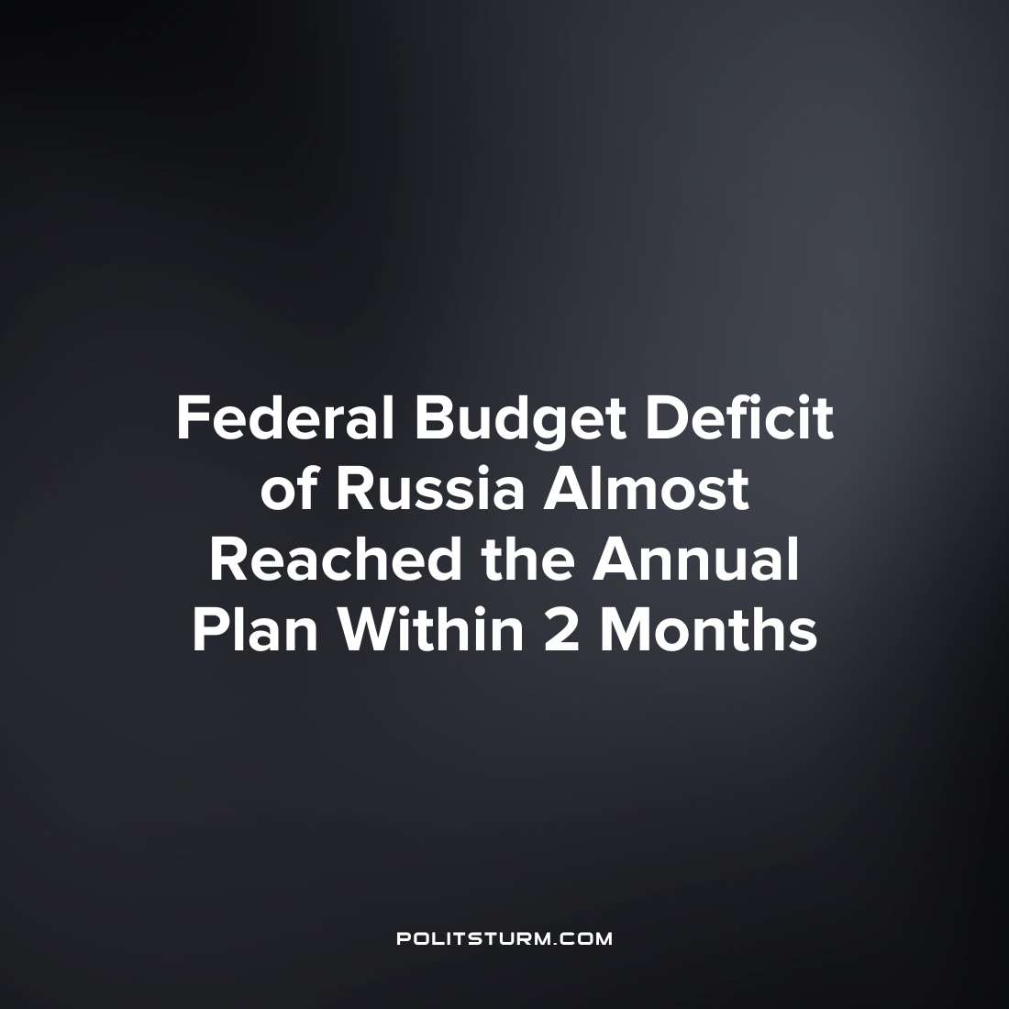

Original article
2023-05-23
3 min read

According to preliminary data from the Ministry of Finance the federal budget deficit of the Russian Federation reached 2.581 trillion rubles in January-February 2023, approaching the annual plan of 2.925 trillion rubles.
In February 2023 the federal budget ended with a large deficit but not as shocking as in January. In the first month of the year revenues lagged behind expenditures by 1.76 trillion rubles, in the second they lagged by 820 billion rubles, which follows from the data released by the Ministry of Finance.
In general, between January-February the deficit amounted to 2.581 trillion rubles. This is 88% of the plan for the whole year (2.925 trillion rubles). A year earlier, following the results of the first two months, a surplus of 415 billion rubles was recorded. Comparative dynamics in terms of expenses and income can be seen in the following chart:
Federal Budget in January-February for the Years 2018-2023 (Trillions of Rubles) Revenue vs. Expenditures
Error loading image
Source: Ministry of Finance of the Russian Federation
Indicators of revenues and expenditures of the federal budget for 2018-2023
This year, the Ministry of Finance further limited the disclosure of information on taxpayer money collection and spending. In May 2022, sections on the structure of expenditures, on sources of financing the deficit and figures on the state of the state treasury in the past month disappeared from the reporting. Since February 2023, there is no longer a breakdown of income by the Federal Tax Service (Federal Tax Service) and FCS (Federal Customs Service) in the reports of the Ministry of Finance as well as the fact that there is no data on payments for imports, excises and primary deficit.
From the remaining data it follows that the income of the first two months amounted to 3.163 trillion rubles. This means that in February the budget received 1.807 trillion rubles after receiving in January 1.356 trillion rubles. The Income over these two months is a trillion less than last year (by 24.8%). Oil and gas revenues fell year-on-year by 46.4%, while other revenues fell by 9.1%. The latter, as the Ministry of Finance explains, is mainly due to the reimbursement of income tax overpayment, while VAT collection was in positive territory by 5.4%.
January-February expenses amounted to 5.744 trillion rubles (which is by 52%, or almost 2 trillion rubles more than a year earlier). As before, the Ministry of Finance explains such high costs by the prompt conclusion of contracts and advance payments, further spending should become more even.
Earlier, the state authorities discussed with businessmen a one-time contribution to the budget in the amount of 250 billion rubles, which is less than 10% of the current budget deficit. The size of the NWF (National Wealth Fund) at the beginning of February was 10.807 trillion rubles.
Judging by the data of the Ministry of Finance, another economic crisis is brewing in the Russian Federation. So far, funds are being withdrawn from the NWF, but it is not endless. The bourgeois state is not capable of resisting Western capital, which systematically imposes sanctions and directly affects the budget of the Russian Federation, since the resource-based economy is highly dependent on energy resources consumers. The Ministry of Finance almost does not even report how the tax money taken from workers is being used. The government will try by any means to compensate for the budget deficit. These measures, most likely, will be the reduction of "less important" sectors of the economy: education, medicine and science, which previously were also financed on a residual basis.
Sources: Kommersant — “The deficit is growing, but at a slower pace” from March 07, 2023.
Banki.ru - "Contribution of 250 billion. The authorities are discussing with companies a one-time payment to the budget" from February 08, 2023
The Ministry of Finance of Russia - "The volume of the National Welfare Fund" from February 20, 2023

Original article

