Farmers' protest in Germany
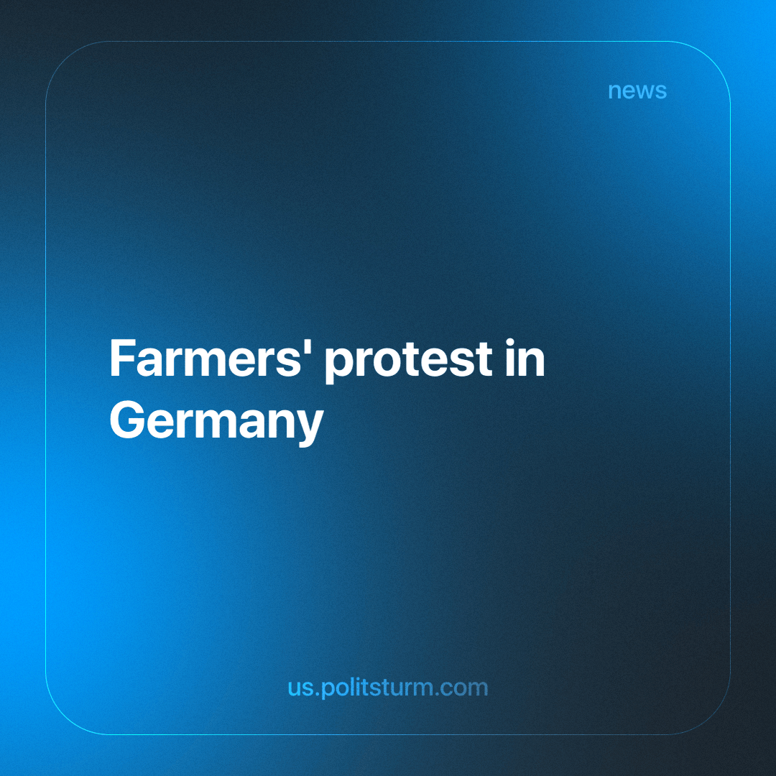

Original article
2024-01-20
4 min read

German farmers have blocked roads with tractors since January 8th, as part of a week of protests against government plans to completely eliminate agricultural subsidies. At least 5,000 tractors and other agricultural machinery have entered the centre of Berlin. According to police estimates, more than 10,000 people took part in the protest at the Brandenburg Gate in Berlin on January 15th — about three times more than law enforcement officials expected.
As often happens, bourgeois authorities normally get out of their crises at the expense of the working class, but in this case, they did not forget about the petty bourgeoisie either.
The government plans to cancel two tax breaks that currently save farmers about €900 million ($980 million) a year, threatening their existence as small-holders. The coalition government was forced to find billions in savings in its 2024 budget after a court ruling in November derailed its previous spending plans. [1]
After a week of protests and the blocking of several roads and even the Volkswagen factory, the German Chancellor, Olaf Scholz, agreed only to a phased reduction in subsidies, and not to their immediate termination — which does not suit the protesters’ demands. [2]
An interesting addition is the fact that while the German bourgeoisie has not found money for its small owners and the working class, it has very deep pockets for military spending.
Germany will provide military assistance to Ukraine worth more than 7 billion euros in 2024, according to a statement by the German government. This is 7 times more than they recently tried to take from farmers. [3]
This contradiction cannot but spur chauvinistic sentiments in Germany itself, especially against the background of a decline in support for Zelensky and an increase in social problems in Germany itself.
A spokesman for the German Interior Ministry said that members of far-right groups are trying to infiltrate these protests and divert them for their own purposes. The police believe that right-wing extremists are planning to provoke a general strike or even mass riots in order to overthrow the current government. Similar cases, they said, took place in anti-vaccination protests or demonstrations against military aid to Ukraine. [4]
An incident where the German Economic Minister Robert Habeck was accosted by farmers last week prompted the police to postulate similar things would continue to happen. Then about 100 farmers tried to prevent him from getting off a ferry in northern Germany, which the police assessed as very tense. The president of the Association of German Farmers managed to disown these farmers and asked the members of the organization to distance themselves from extremist groups.
It is worth noting that in recent years, the German far-right has indeed been flirting with a social agenda and trying to lead it. However, such accusations can be considered as an attempt by the authorities to discredit the farmers’ protest in the eyes of German citizens.
According to a survey conducted by the German INSA institute, 69% of German residents support protests against cuts in benefits and subsidies. Only 22% of the population are against them [5]. It is worth noting that the largest percentage of support (88%) is observed among voters of the “Alternative for Germany”.
At the same time, analysts note that in the next regional elections in September this year, the far-right chauvinist Alternative for Germany party has a real chance of winning in several regions. [6]
Amid this unabashed celebration of resurgent German chauvinism, the coalition government comprising Social Democrats, liberals, and Greens is actively provoking additional protests with their policies and actions. In doing so, they are discrediting themselves in the eyes of society, severing connections with the people, and compelling individuals to seek alternatives due to their anti-social policies.
The small-holding farmers cannot compete with the efficiency of the large agro-industrial monopolies, and as such are reliant on government subsidies to maintain their class position and livelihoods. As these subsidies dry up, they will inevitably be ruined and forced to join the ranks of the proletariat, as the centralization of capital is an inevitable tendency of capitalism.
As a consequence, yielding to spontaneity, small-scale proprietors, in general, will inevitably gravitate towards reactionary positions, harking back to a time when their class was more numerous and prosperous, akin to the politics espoused by movements such as the “Alternative for Germany”. However, embracing such politics would not resolve their predicaments. The pursuit of their interests, focused on fortifying their property rights and privileges, inadvertently fortifies and bestows advantages upon their aforementioned monopolistic competitors. They operate as if reverting capitalism to a prior, non-monopolistic stage is either possible or desirable. The authentic remedy for the precarious position and declining standard of living of small-scale farmers lies in forsaking their current interests and aligning with their future interests by joining forces with the workers - the proletariat. Our thoughts and aspirations should not be clouded by nostalgic and idealised memories of a bygone era; instead, we must steadfastly look ahead to the future - to socialism.
History has already shown us what happens when the labor movement is blinded by the ideology of the far right. Social democracy has once again been reduced to the most blatant betrayal of the workers, and the enabler of the fascists. The only sensible and most genuine alternative for Germany is the path to socialism. To do this, Germany needs a workers' party that will organize various trade unions and other public organizations. It will lead the working class to the conquest of power and socialist transformations. It will permanently destroy the exploitation of man by man and move forward towards communism. All the other “alternatives” have shown their inconsistency, unscientific nature, dead-end development, misanthropy and bestial nature that they cover up for the time being.
Sources: 1, 2, 3, 4, 5, 6

Original article

