Far-Right Riots Erupt in the UK
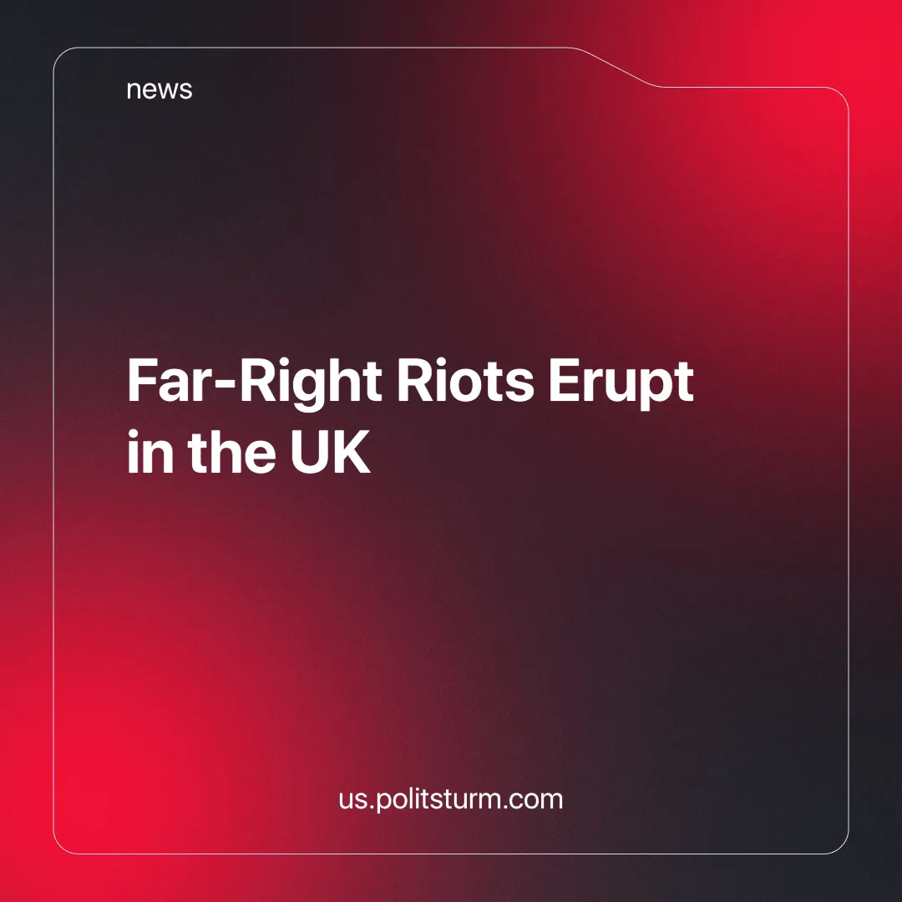

Original article
2024-08-14
6 min read

Far-right, anti-immigrant riots erupted across the UK after a mass knife attack on a children's dance workshop in Southport on 29 July, which tragically left three children dead and several others seriously injured. A 17-year-old suspect was arrested at the scene. The suspect's identity wasn't immediately revealed due to UK laws on confidentiality.
The three children were Bebe King, 6, Elsie Dot Stancombe, 7, and Alice Dasilva Aguiar, 9. There is no doubt that this attack and the subsequent riots have been devastating for the families and the local community [1].
Shortly after the horrific attack, an article on the crime news website Channel3NOW gave the suspect a false name, "Ali Al-Shakati", and claimed that the attacker was an asylum seeker who had arrived in the UK by boat last year [2].
This disinformation about the attacker's identity began to spread rapidly online, mainly through well-known far-right accounts.
While lying on a sunbed in Cyprus, evading arrest in the UK [3], Tommy Robinson, who we have previously written about leading a far-right march in June and his links to billionaires and think tanks, played a major role in fuelling the disinformation. Posting on his social media accounts, on Twitter, where he has 984,000 followers, and on his Telegram channel 'Tommyrobinsonnews' with 106,000 followers.
For example, at 6pm on 30 July, the day after the attack, Tommy Robinson, without knowing the identity of the suspect, uploaded a rant in which he first described the horror of the attack and then suggested that Islam is a mental health issue.
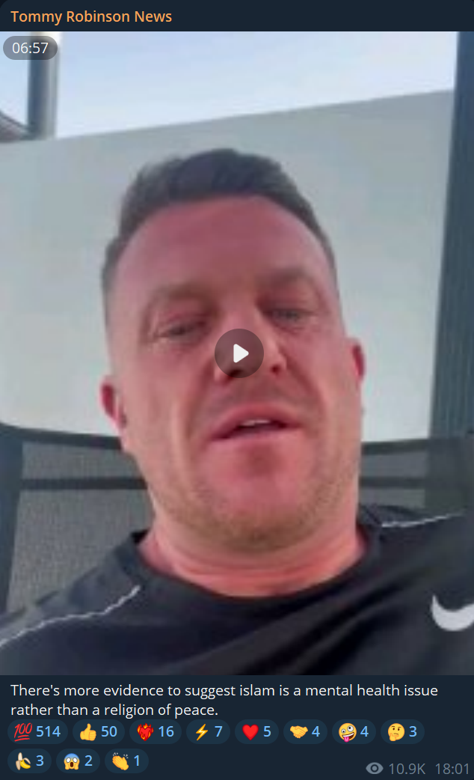
Image of the Tommy Robinson post
A telegram channel called 'Southport Wake up', and later a Tiktok account set up by the same group on the day of the attack, quickly began advertising a planned demonstration in St Lukes Road, Southport. Some of the videos garnered over 15,000 views [4].
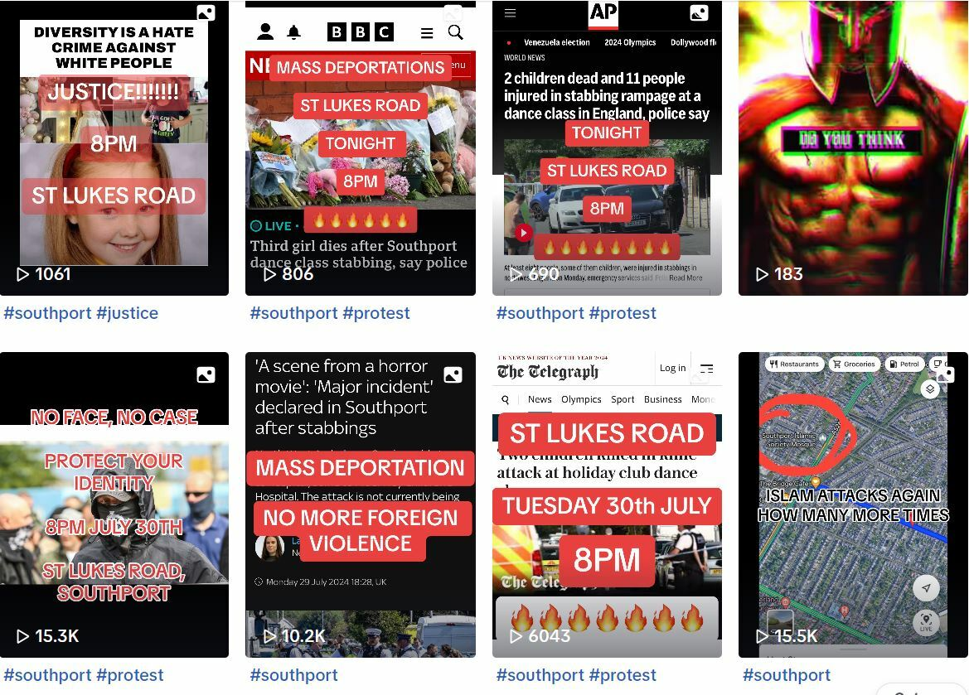
Picture of some of the Tiktok posts
Most of those present at the event were not formally associated with any particular organisation, these riots were largely organised through decentralised social media networks, but the 'protest' was attended by some well-known figures/groups on the far right, such as members of 'Patriotic Alternative' (PA), members of the fascist 'British Movement' and a PA splinter group called the 'Independent Nationalist Network' [4].
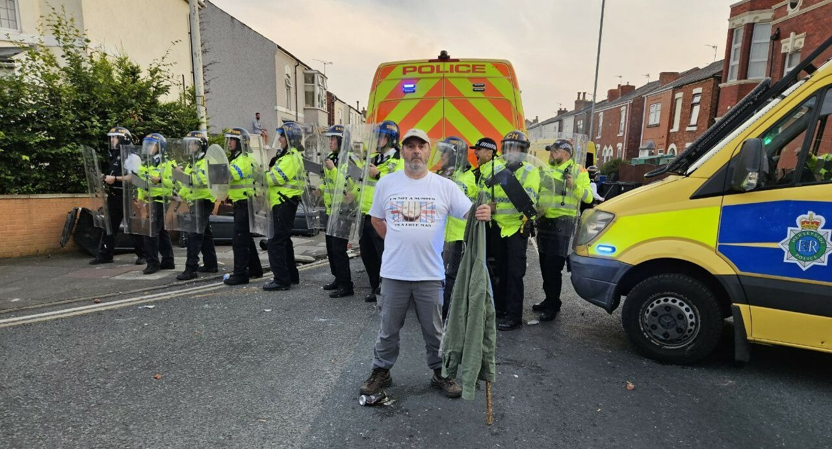
‘The English Wanderer’ or David Miles, a core member of ‘Patriotic Alternative’ uploaded a picture of himself at the riot.
This riot included an attack on the local mosque, with a petrol bomb and with rioters breaking and throwing bricks from people's houses, resulting in significant damages to the neighbourhood, and injuries to 53 police officers and a police van being set on fire. The next day many locals volunteered to repair the damages [1][5][6].
Although the court broke with convention and released information about the suspect, revealing that he was in fact born in Cardiff to a Christian family who had emigrated from Rwanda, over the next few days similar riots, organised through the same decentralised social media networks, spread across the UK, starting with a protest in London the following day and spreading to several cities and towns over the next week, most of them in the Midlands and the North of England, which is notoriously underdeveloped and poverty-stricken [1].
Events began to escalate: in Sunderland, a Citizens Advice Bureau used by struggling families was set on fire [7]; in Liverpool, a public library was burnt down [8]; in Belfast, far-right rioters attacked immigrant-owned businesses, setting fire to a cafe and a supermarket [9]; in Middlesbrough, homes and cars were attacked and windows smashed indiscriminately [10]. Mosques have been repeatedly targeted and Asian people brutally beaten and stabbed [11]. In Rotherham, a hotel housing asylum seekers was deliberately set alight while residents and staff were still inside [12].
British prime minister, Keir Starmer, made a speech condemning the ‘far-right thuggary’ and vowed that those who participated will ‘face the full force of the law’ both ‘online and offline’ [13]. Under this cover of far-right riots and pogroms, the British state introduced new vague anti-protest measures, including: increased surveillance measures such as AI facial recognition and tracking [14] and harsher, longer sentences for rioting. There is no doubt that these measures will be used against the communist and broad left opposition movements in the face of the ongoing capitalist crisis.
In response to the escalating far-right violence, people tried to organise counter-demonstrations, some of which were successful, but most of which were not, being severely outnumbered by the far-right.
In a major success, on 7 August, when a large number of far-right demonstrations were planned across the country, 'anti-racist' and 'anti-fascist' counter-protests were hastily organised by trade unions, local communities of concern and broad left organisations such as Stand Up to Racism and Unite Against Fascism. It is important to note that both Stand Up to Racism and Unite Against Fascism have strong links with the Trotskyist group, the Socialist Workers Party, which is often criticised for inserting themselves in grassroots movements.
These counter-protests appear to have been successful, with thousands of people taking part despite the police telling people to stay at home, and the night passing peacefully, with only a handful of far-right supporters showing up at the planned locations, humiliating them and proving the effectiveness of community organisation, but this is by no means a decisive blow to the growing fascist movement, far more is needed [15].
The capitalist media attempted to abstract away the far-right escalation by simply laying blame on the disinformation spread online, we are not so naive. The root of the matter lies within British society and the capitalist economy as a whole.
We have written before about mass migration in Britain. For years the British capitalist media and politicians have scapegoated migrants, particularly Muslims. They have done this while systematically dismantling social services in the interests of profit.
The ruling class has no interest in genuinely stopping or integrating migrants into Britain because it profits from a vulnerable, easily exploitable section of the population, while it can also divert workers' attention away from the class struggle and towards chauvinism and reaction. Nationalism is a capitalist slogan, the working class slogan is of internationalism, anyone who obscures this fact, is an enemy to socialism.
As explained, the mobilisations that have slowed the current wave of far-right violence are by no means a significant victory. Sections of the capitalist class have already begun to reconcile and justify the seriousness of this violence, with Elon Musk asking Keir Starmer on Twitter, "Shouldn't you be concerned about attacks on *all* communities?" [16] and former Prime Minister Boris Johnson accusing Keir Starmer of being “deaf” to concerns about immigration, while the Labour government continues to focus on the negative aspects of immigration.
The capitalist system is decaying, finance capitalists have completely divided the world into different blocs and are struggling to find sources of profit and ways to survive, they are turning their expansion inwards. Even under the banner of "social reform" or "Labour", the capitalists continue to lay siege to the concessions won by previous workers' movements in order to find profit. In the process they wreck whole sections of the working class leaving them destitute and disillusioned.
In the absence of a genuine communist movement, these disillusioned workers, cut off from the "reforms" and slogans of a "Labour" Party that does not represent them, have nowhere to turn, they become ripe for reaction. To be used, if necessary, by the capitalist class to maintain its rule. This is the very basis of fascism.
Nothing short of the establishment of socialism, with a workers' state and an economy scientifically planned for the needs of the working class, can remove the threat of fascism in Britain.
To do this, the working class movement needs its own independent organisation, made up of workers armed with the most advanced theory that fully reflects their objective interests; Marxism-Leninism.
At present there is no such party in Britain, we are working to train the future cadres of such an organisation, as well as towards the formation of such a party itself. Join us.
Sources:
1.UK far-right riots: Everything we know – POLITICO
2.The real story of the website accused of fuelling Southport riots - BBC News
3.Tommy Robinson leaves UK on eve of court case with arrest warrant issued - BBC News
4.The Far Right and the Southport Riot: What We Know So Far – HOPE not hate
5.Facebook post from southport mosque
6.With Britain’s far right on the march, Labour has a problem – POLITICO
7.Sunderland riot fire destroys vital service used by struggling families - Mirror Online
8.CCTV captures moment community hub and library set on fire by rioters in Liverpool | ITV News Granada
9.Cafe and supermarket burnt out during night of disorder in Belfast | UTV | ITV News
10.Middlesbrough disorder: Thirty-five arrested after 'staggering' violence - BBC News
11.The horrifying racist attacks carried out by far-right mobs in riots | The Independent
12.Rioters try to torch Rotherham asylum seeker hotel amid far-right violence | UK news | The Guardian
13.IN FULL: Starmer's full speech on UK riots 'You will regret it' (youtube.com)
14.Big Brother Watch Responds to Prime Minister's Plan for Increased Use of Facial Recognition — Big Brother Watch
15.UK disorder: Thousands of counter-protesters rally after riots - BBC News
16.UK disorder: What's Elon Musk's game? - BBC News

Original article

