Far-right Millionaire Claims to be Working-Class
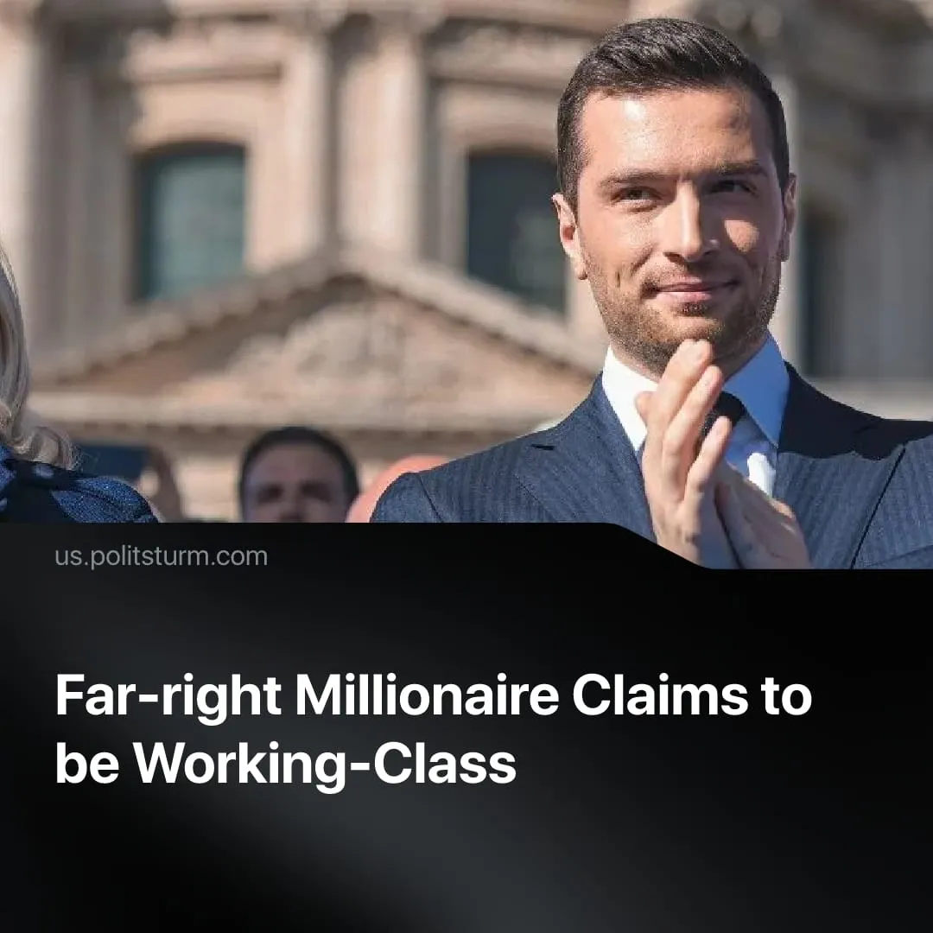

Original article
2026-08-15
2 min read

The chief of France’s far-right National Rally claims he’s working-class. His fortune is now in the millions, and he spends the equivalent of a French worker’s yearly salary in one night of partying with Trump Jr. and aristocrats.
Details. French far-right leader Jordan Bardella – right-hand man of presidential candidate Marine Le Pen – maintains his life is “profoundly ordinary”. He often highlights his origins in a poor, drug-ridden neighborhood of Paris. In an interview, Bardella declared to the workers:
Quote: “I am one of them: I grew up in public housing projects. [...] Just like millions of French people, I have known difficulties [...]”.
In reality, Bardella is a wealthy millionaire raised in privilege. He was educated in Catholic private schools. His father, a business owner, gifted him a personal car and private apartment in Paris by age 20. Bardella hasn’t worked a day in his life – outside politics.
► Despite a 70% absence, Bardella still collects a full €135,000 European Parliament salary every year, since 2019. His autobiography and manifesto were massively promoted by right-wing media mogul Vincent Bolloré, despite making a net loss on book sales. This allowed Bardella to collect €700,000 in royalties for the first book, and €250,000 for the second.
► In 2020, Bardella purchased his second property in Paris, a 60 m² flat in an expensive neighborhood, worth €370,000. In contrast, 90% of Parisian working-class households lack the income to buy an apartment and are forced to rent.
► Bardella failed to properly declare his fortune to tax offices, but is now estimated to be a millionaire. He faces multiple fraud investigations for embezzlement and falsifying records; attempting to get €240,000 worth of luxury purchases “reimbursed” by taxpayer campaign funds.
► The National Rally chief is a full member of bourgeois high society, spending summers in St. Tropez on the €3 million yacht of a right-wing TV host (employed by the same billionaire benefactor, Bolloré). Bardella maintains personal ties with the Le Pen family and rich neo-fascist businessmen named in the Panama Papers.
► The media glamourized Bardella’s relationship with a Bourbon Princess (descendant of historical French kings), including photos of the pair sipping champagne in a Monaco F1 Grand-Prix private lodge. Bardella later celebrated with Donald Trump Jr. at a VIP table costing €25,000 per night. Minimum wage workers in France make €21,000 per year.
Context. Controversial populists are increasingly widespread in bourgeois politics, a sign of the crisis of capitalism. In the USA, convicted felon millionaire Trump became president by declaring pro-worker and anti-war promises, which he immediately broke.
► Bardella’s boss, Le Pen, got legal permission to run for president in 2027, despite her criminal convictions for stealing taxpayer money. She is projected to win, beating every other candidate in polls.
► In France, the far-right votes in favour of the ultra-rich 86% of the time. Similarly, the majority of liberal President Macron’s cabinet ministers have been millionaires – thanks to his tax cuts, France’s 53 billionaires have doubled their wealth, owning more than half the population.
► Meanwhile, poverty in France hit the highest levels in recorded history. Since 2020, the amount of people who can’t afford to buy meat or heat their homes has doubled, and inflation is still accelerating. Bourgeois populists are advertised as “working-class” to appeal to workers’ resentment.

Original article

