Far-Right Convicted Criminal Projected to Win French Presidency
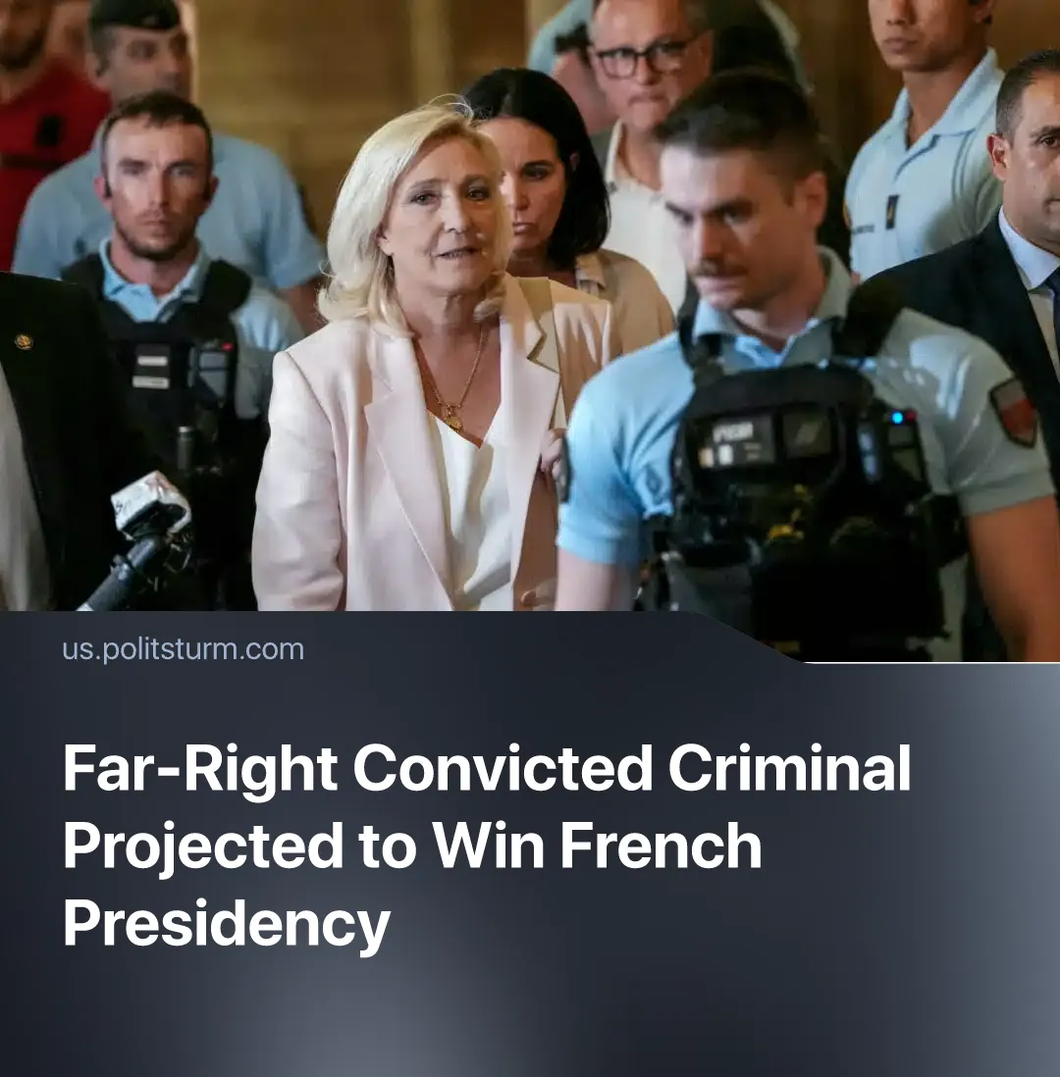

Original article
2026-07-22
2 min read

Marine Le Pen, leader of France’s far-right National Rally, announced her 2027 presidential campaign. She was previously sidelined from running due to being convicted of stealing taxpayer money.
Details. On July 7, French far-right leader Marine Le Pen of the National Rally announced that she will participate in the 2027 presidential election. Earlier that day, a French appeals court suspended the remaining 30 months of her disqualification, seeking a “proportional penalty” and to maintain "democratic principles”.
► Le Pen was convicted for misusing European Union funds in a fake jobs scam and was initially sentenced to four years in prison, 60-month disqualification and a huge fine. This penalty was later reduced to 45 months – 15 of which she has already served – and a year of wearing an electronic ankle monitor.
► In recent presidential election polls, about 36% will vote for Marine Le Pen in the first round, while no opponent surpassed 19%. In the run-off, Le Pen remains the projected winner against both Emmanuel Macron’s former prime ministers – Edouard Philippe and Gabriel Attal – and opportunist “leftist" Jean-Luc Mélenchon. Macron himself cannot run again due to a two-term limit.
Context. Fascization and sharpening inter-imperialist contradictions have led to the collapse of International norms and have shattered the image of "respectable” bourgeois officials. The current tendency lies in the promotion of controversial politicians.
► Donald Trump became US president despite being convicted on 34 felony counts of falsifying business records, leading an attempted coup after losing the 2020 election – charges dropped after his return to power – and close involvement with Epstein, including using the state to suppress publication of the files. Israeli Prime Minister Benjamin Netanyahu has delayed his corruption trial since 2020. British Prince Andrew faced uncharged pedophilia and Epstein-trafficking allegations, while former UK Prime Minister Keir Starmer promoted an Epstein associate to a top diplomatic post.
► Ongoing militarization and fascization under “liberal" President Macron have already laid the groundwork for France’s far-right rise. In 2024, the National Rally won a 31% majority of the French seats in the European Parliament and held a 34% polling lead for potential domestic legislative elections. In February of this year, French mainstream media called a slain fascist activist "a martyr”, and parliament held a minute of silence to honor him.
► In just two years, six French governments have collapsed, and Macron has replaced seven prime ministers during his term. Unpopular policies, worsening living conditions and police violence triggered numerous protests, strikes and riots. This ongoing political chaos is precisely what the National Rally seeks to exploit.

Original article

