Factory Workers Threatened With Firings as Deadly Tornado Approached
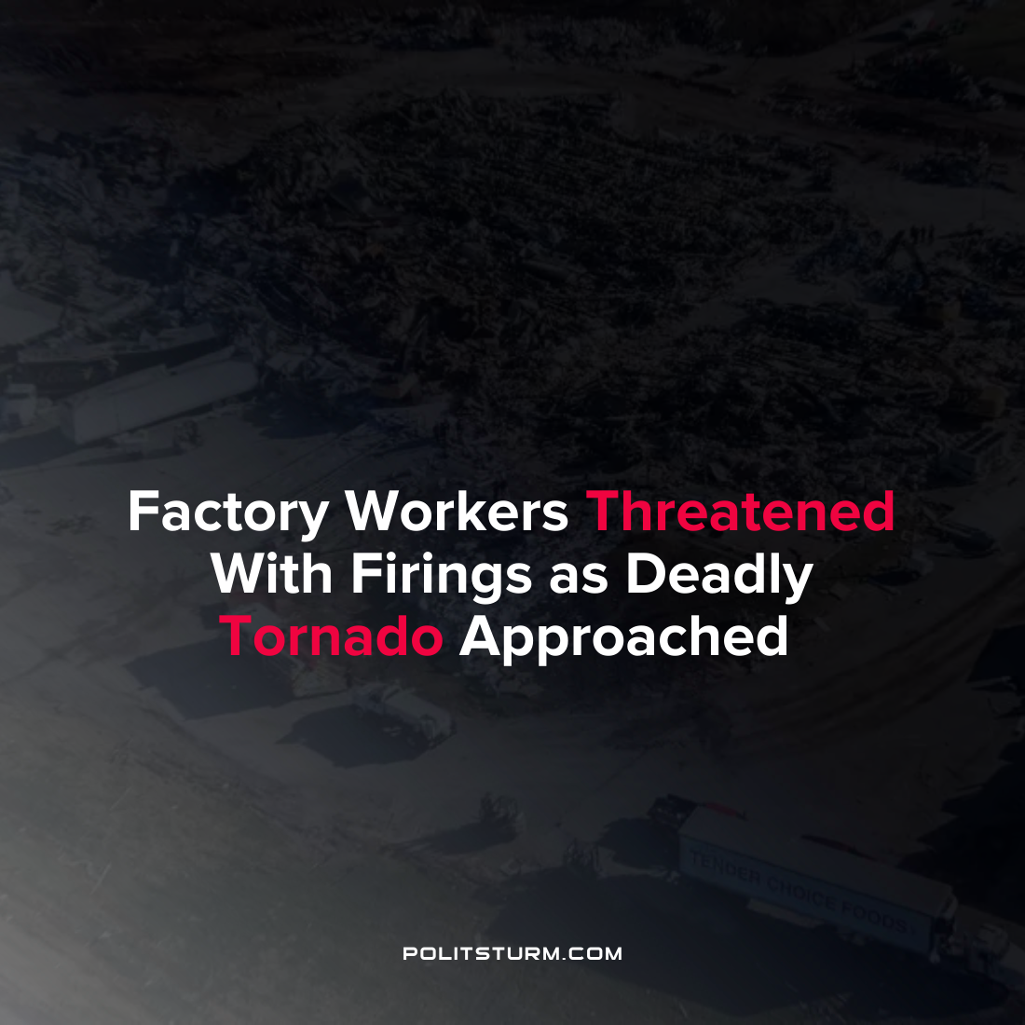

Original article
2021-12-13
1 min read

At least 8 people have tragically died in the Mayfield Consumer Products candle factory after a tornado destroyed the factory. Reports have emerged from the surviving workers that those who asked to leave were threatened with firings.
Initially workers were not allowed to leave the factory due to safety precautions. After a determination was made by management that the tornado was no longer a threat, workers were told to go back to work after congregating in hallways and bathrooms.
Company officials have denied the statements of their own workers who witnessed the events.
“It’s absolutely untrue…We’ve had a policy in place since Covid began. Employees can leave any time they want to leave and they can come back the next day”, said Bob Ferguson, a spokesperson for the company.
Workers in the factory continued to work and produce despite the obvious safety concerns caused by natural conditions. The workers feared for their wellbeing and were rebuffed by the management. The corporate executives and management acted in a manner that prioritized the maximization of profits above all else and then denied the accounts of their own workers. The unfortunate truth of the matter is that under the capitalist system the wellbeing and safety of the workers and all other concerns are subsumed by the profit motive.
Source: 1

Original article

