F.B.I Seized One Million Medical Equipment From a Brooklyn Hoarder
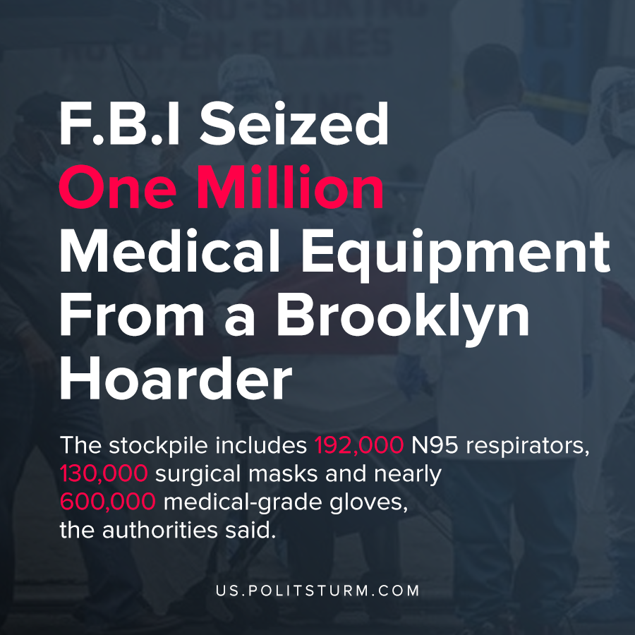

Original article
2020-04-06

The stockpile includes 192,000 N95 respirators, 130,000 surgical masks and nearly 600,000 medical-grade gloves, the authorities said.

Original article

