Europe’s Last Summer of Peace May Be Over, Claims Germany
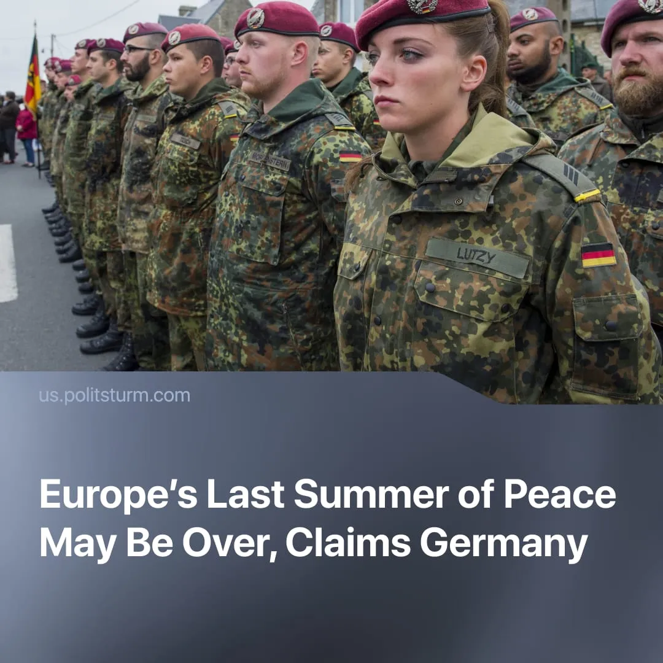

Original article
2025-11-27
1 min read

EU leaders are stirring up military hysteria, urging Europeans to prepare for war as early as next year.
Details. Across Europe, leaders now portray open conflict as imminent and unavoidable, and rearmament as an urgent necessity.
► Germany’s Defence Minister Boris Pistorius warned that Russia could regain full military capability by 2028 and that Europe may have already experienced its “last summer of peace.” He said decades of underinvestment had weakened NATO and stressed that Germany must accelerate mobilisation, recruitment, and procurement.
► Poland’s Chief of the General Staff, General Wiesław Kukuła, declared that Europe is already in a “pre-war period,” likening the situation to the eve of World War Two. He called for stronger deterrence, increased readiness, and coordinated mobilisation across NATO’s eastern flank.
► Sweden’s Defence Minister Pål Jonson argued that Europe must “toughen its response to Russia’s hybrid threats,” highlighting Moscow’s alleged escalating sabotage, drone activity, and pressure on critical infrastructure as reasons for a harder, coordinated “defence” posture.
► EU foreign policy chief Kaja Kallas stated that Europe must “prepare for war,” with EU institutions pushing long-term defence spending, rapid industrial expansion, and scaled procurement.
Context. EU military spending is projected to reach nearly €400 billion in 2025, marking the fastest rearmament cycle since the Cold War.
► These preparations come at a direct cost to ordinary people. Governments fund military expansion through higher taxes, new debt, and cuts to public services, shifting the burden onto workers both economically and through death in conflict, while defence firms secure long-term contracts and rising profits.
► Europe is not the only region acknowledging a pre-war environment. The United States has also stated openly that it is preparing for war.

Original article

