Europe’s Funding of Militarisation
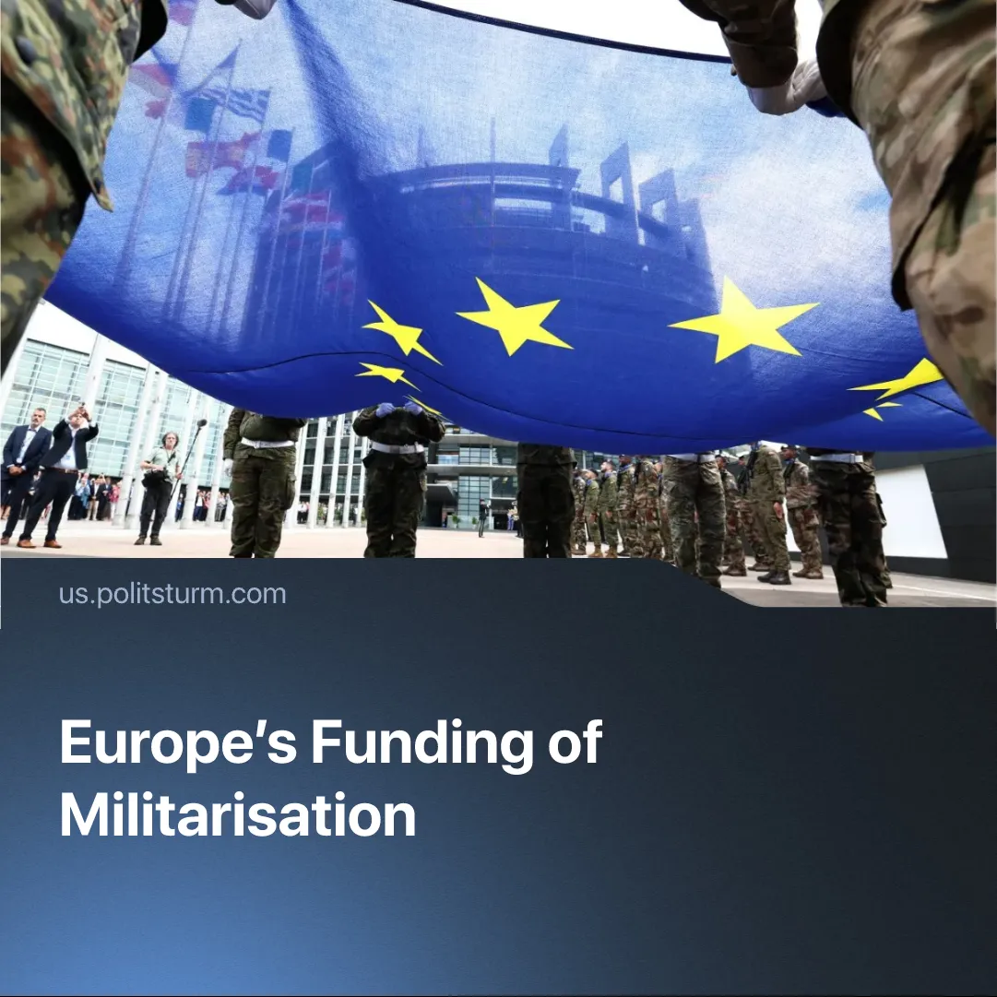

Original article
2025-09-03
2 min read

The EU's militarization program aimed to reduce its dependence on American weapons. Nevertheless, the European Union continues to import the majority of its weapons from the United States.
Details. This year has seen a number of European Union initiatives aimed at rearmament and strengthening its military capabilities. This activity peaked after Donald Trump's inauguration, when he prioritized the rearmament of the American army.
► On March 4th, 2025, European leaders endorsed a military plan called “Readiness 2030” to unlock a combined €800 billion ($866 billion). The plan was justified as a way to reduce dependency on US weapons and to achieve greater “strategic autonomy”. The target is to reach the sum by around 2030.
► Few months later, an initiative called “Security Action for Europe” (SAFE) was created within the “ReArm Europe” plan. The European Commission will raise loans on capital markets at lower interest rates, provided that at least two member states participate (Ukraine may also take part). These funds are then lent to EU member states to finance priority defence investments under favourable financial terms, including repayment periods of up to 45 years and grace periods of up to 10 years.
► Germany – the country with the strongest economy within the EU – plans to increase defence spending to 3.5% of GDP (equivalent to €162 billion) by 2029.
► French President Emmanuel Macron declared that the plan to double defence spending, originally set for 2030, will be brought forward to 2027. The previously planned €32 billion military budget will increase to €64 billion.
Context. Currently, the EU’s defence industry is decentralised, with numerous national suppliers producing in small volumes. Over 60% of defence imports by European NATO members come from the US.
► The EU remains heavily dependent on American energy, with 15% of its oil and 50% of its liquefied natural gas (LNG) imports coming from the US. In 2023, 58% of the EU's energy consumption was imported, recently agreeing to purchase $750 billion worth of US energy products — including LNG, oil, and nuclear fuel — by 2028. The deal also established a 15% tariff on most EU exports.
► Initial steps to consolidate European military mobilisation began with the introduction of the Permanent Structured Cooperation (PESCO) to stimulate joint military projects. Member states benefited from improved defence infrastructure and favourable investment schemes, with the initiative later expanding into broader frameworks in NATO and UN operations. Closely linked to this is the European Defence Fund (EDF), helping leading defence industries across Europe conduct joint research and development.
Important to Know. The United States opposes the EU's consolidation or greater strategic autonomy, benefiting from Europe remaining a subordinate market and military vassal. Trump has successfully shifted the burden of supporting Ukraine onto European countries, which have agreed to buy $40 billion worth of American weapons to transfer to Ukraine, whilst additionally covering transportation costs. This also allows the US to focus on what it considers its main threat, China.
► To tighten its grip, US officials and capitalists have backed pro-US far-right parties such as France’s National Rally and Germany’s AfD. Rising militarisation costs will deepen the EU crisis, turning workers’ anger against the current pro-EU governments and could boost these forces into power, ensuring Europe stays aligned with US interests.

Original article

