European States Fund Militarisation as Heatwave Kills Thousands
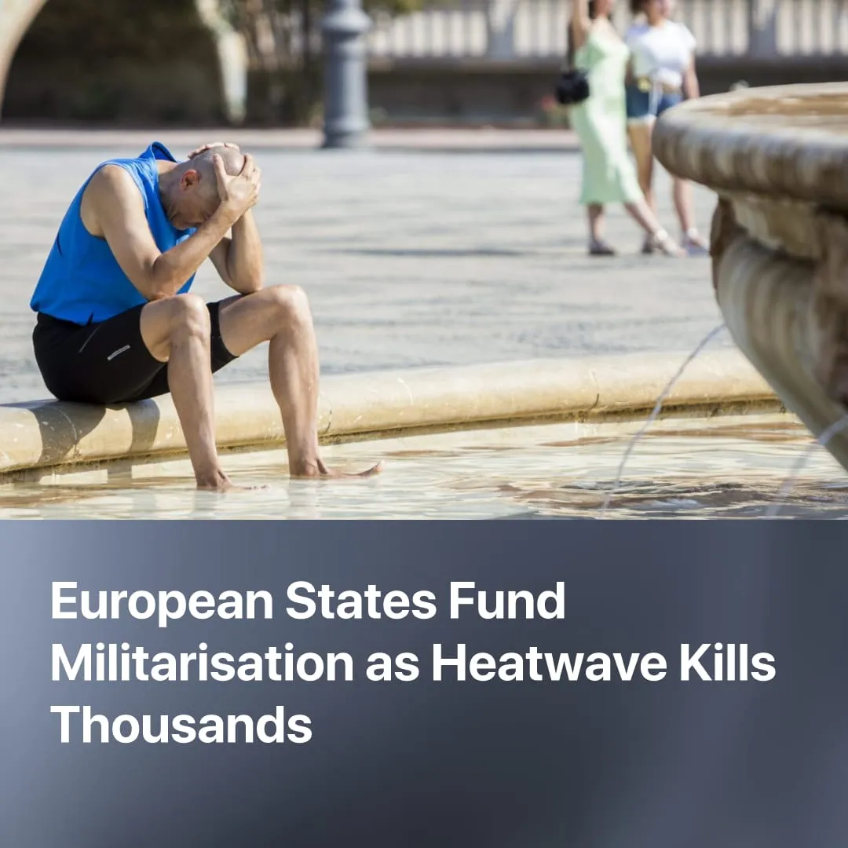

Original article
2026-07-11
2 min read

An estimated 20,000 people have died in Europe's worst heatwave in decades. EU states will spend €454 billion on militarisation in 2026, while committing just €15 billion a year to climate adaptation.
Details. Between June 22 and June 28, a historic heatwave swept across Europe. Preliminary estimates from climate scientists suggest over 20,000 heat-related deaths across the continent, though this figure has yet to be formally peer-reviewed.
► Confirmed official figures are already severe. France recorded 2,025 excess deaths, Belgium 1,200, the Netherlands 3,500, and Spain over 1,000. Health authorities warn that these numbers will rise as more regional data comes in.
► Despite temperatures soaring past 40° Celsius, state governments provided no structural relief, leaving citizens entirely dependent on passive warnings as fatalities at home spiked 91%.
► In the UK, authorities issued the second-ever red health alert for extreme temperatures, yet limited their response to standard public advisories on hydration and staying indoors, with no concrete emergency cooling measures implemented.
► This crisis is rapidly accelerating. Climate scientists explicitly warn that global weather will only grow more severe. Extreme heat has already killed over 200,000 Europeans over the past four years alone.
Context. Climate scientists explicitly warned state governments as early as 1988 that heatwaves of this intensity and frequency were coming, yet capitalist states systematically ignored them.
► Today, roughly 80% of European households lack adequate cooling, ageing rail networks buckle under the heat, and schools and public hospitals regularly report dangerous overheating that threatens vulnerable patients.
► The EU itself acknowledges it will need to invest €59-173 billion per year in climate adaptation until 2100 to protect agriculture, infrastructure, and ecosystems. Current committed spending stands at just €15-16 billion annually.
► These effects are not limited to Europe. Last month, heatwave temperatures in India hit 48°C. A recent demographic study confirmed that a five-day heatwave causes roughly 30,000 excess fatalities across the country, as millions of informal workers are forced to labour in deadly conditions with failing power grids cutting off any access to basic cooling.
Important to Know. Capitalist states are fundamentally incapable of planning for ecological crises because they exist to secure capitalist profits. Upgrading public infrastructure yields no immediate returns, so the ruling class does nothing. Instead, they pour billions into destructive fossil fuel industries because mass extraction remains competitive and highly profitable.
► This contrasts with the speed at which capitalist states mobilise to protect and expand their capital. During the 2020 pandemic financial crash, the European Central Bank printed over a trillion euros to rescue collapsing private markets. This massive bill was then entirely offloaded onto the working class through soaring inflation and brutal austerity cuts.
► The same logic applies to imperialist warfare, where governments redirect public wealth to the military while claiming they cannot afford climate infrastructure. EU states will spend an estimated €454 billion on militarisation in 2026 alone – just days after the deadly heatwave, the United Kingdom announced a further £15 billion surge in military spending.
► In contrast, the Soviet Union's consideration of nature naturally flowed from planned production. It established vast nature reserves as untouched scientific baselines to guide sustainable land use, launched large-scale afforestation projects, and minimised waste through the full use of materials – reusable packaging, glass bottle deposits, and paper recycling were standard practice.

Original article

