European Far-Right Demands “Antifa” Ban
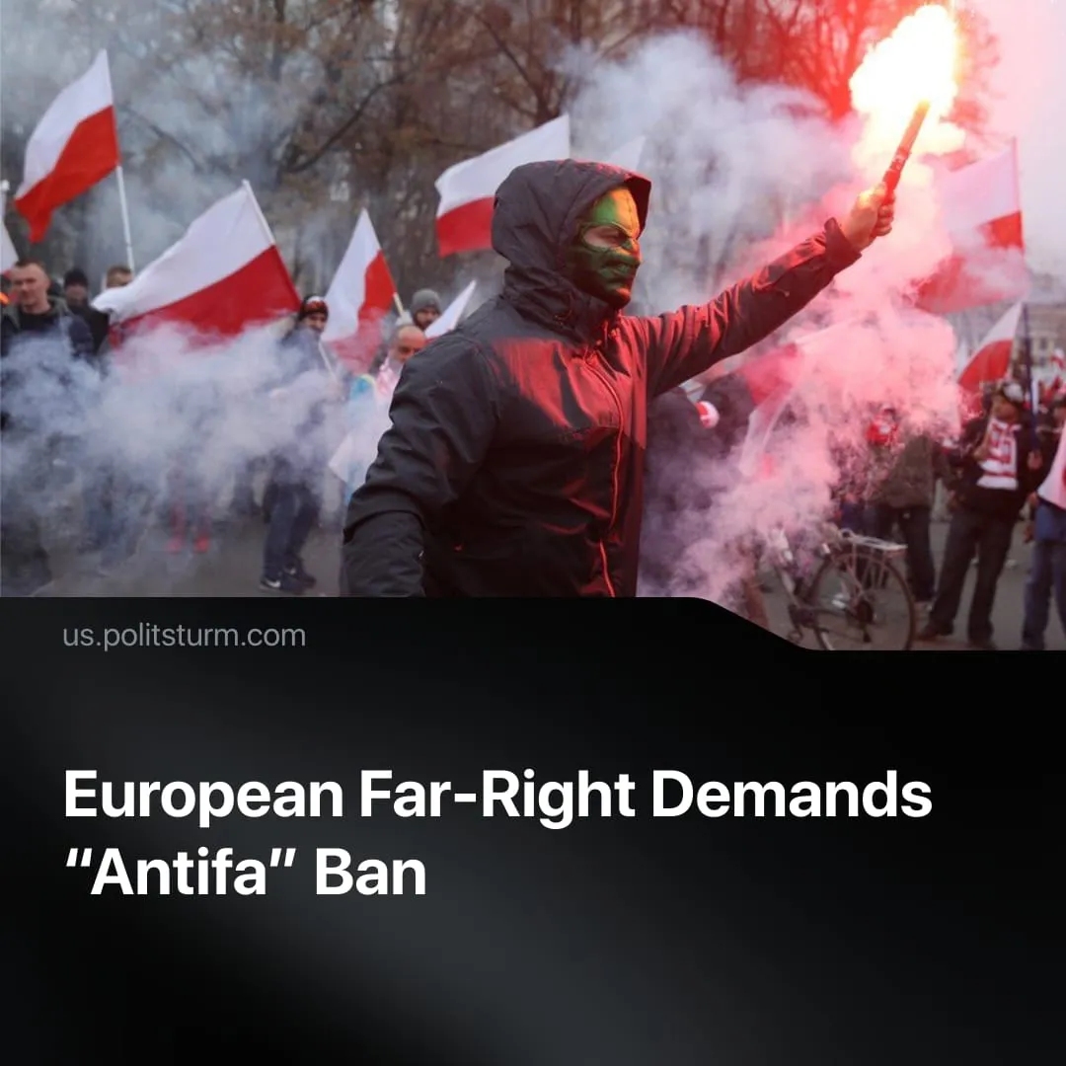

Original article
2025-10-13
1 min read

European far-right parties move to classify “Antifa” as terrorists, mirroring Trump’s policies in the US.
Details. Hungary’s right-wing Prime Minister Viktor Orbán announced plans to designate Antifa a terrorist organisation, declaring: “The time has come to classify organisations such as Antifa as terrorist groups, following the American model.”
► In the Netherlands, Geert Wilders’ far-right Party for Freedom (PVV), joined by two allied parties, submitted a parliamentary motion to ban Antifa, accusing it of “threatening politicians, disrupting meetings, intimidating students and journalists, and using violence.”
► In Poland, former Justice Minister Zbigniew Ziobro of the Law and Justice Party urged Prime Minister Donald Tusk to follow suit.
► In the European Parliament, the PVV tabled a question asking whether the EU Council would add Antifa and affiliated persons to the EU terrorist list.
► Far-right figureheads in other European countries have also praised the move. Former “English Defence League” leader Tommy Robinson called for the ban to be “implemented internationally.”
Context. These moves follow from Trump’s classification of “Antifa” as domestic terrorists. Since the collapse of the socialist bloc, the term has been used by loosely organised anarchist groups. However, it has been broadened by the right to encompass much of the left. In practice, it serves to criminalise communists — the only force that historically defeated fascism and challenged the capitalist system.
► Anti-communism has been rising across Europe — from Germany, where Soviet flags were banned during Victory Day, and France, where an anti-communist monument was recently unveiled, to more hardline measures such as in the Czech Republic, where recently support for communism has been criminalised by equating it with Nazism.
► The United States opposes any consolidation or move toward greater strategic autonomy within the EU, benefiting from Europe’s continued status as a subordinate market and military vassal. To ensure this, Trump’s administration has supported pro-US far-right groups across Europe.

Original article

