European Allies Issue Symbolic Sanctions on Israeli Settlers
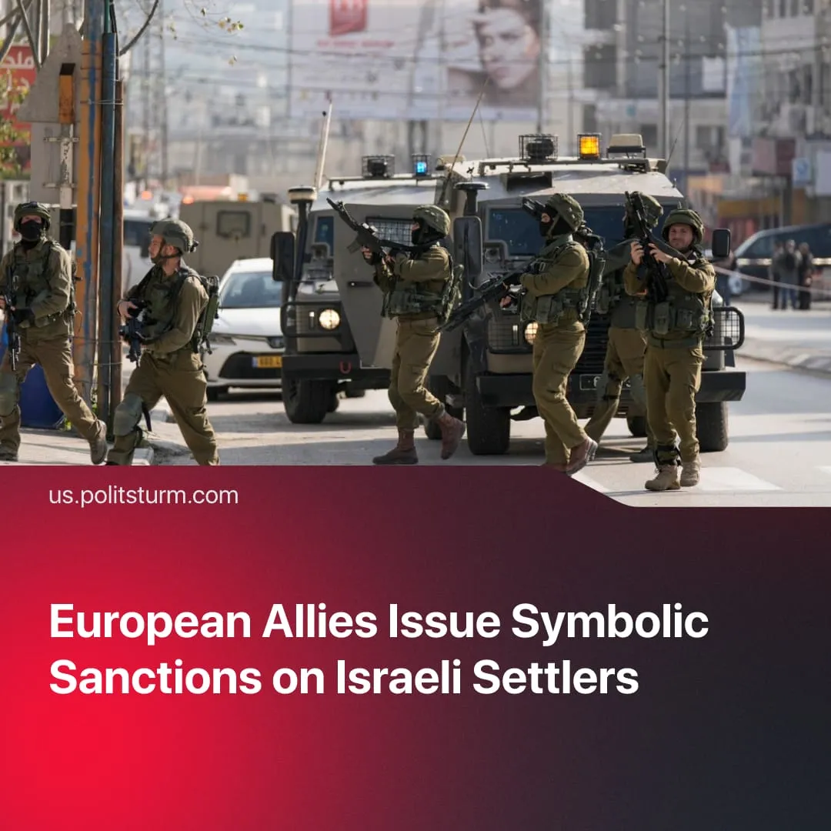

Original article
2026-09-26
2 min read

Western countries launch sanctions against West Bank settlers. Like last year's recognition of a Palestinian State, the move changes nothing materially and will not stop Israel's campaign.
Details. On 9 June, the UK, alongside France, Norway and Canada, imposed a new set of sanctions on Israeli extremist groups involved in financing and supporting violent acts in the Israeli-occupied West Bank.
► France banned the Israeli finance minister and four leaders of settler organisations, as well as 21 settlers, from entering the country. The UK's efforts were focused on disrupting financial flows supporting extremist organisations, which included a construction company whose resources were used to demolish Palestinian structures. Canada has prohibited another construction company and its owners from contacting banned groups.
► They also threatened Israel with additional measures if Israel doesn’t take action against the settlements. By the end of September, the UK, France, Canada, and Norway are also expected to impose a trade embargo on extremist settlement organisations
► Even so, settlements account for around 5–10% of Israel's GDP, and trade can be redirected to other countries, such as the US. According to reports, UK diplomats have told their US counterparts that the sanctions are largely symbolic – though the Foreign Minister denies this. This is confirmed by UK-Israel trade totalling $8.1 bn, while it is estimated that $51.4 m worth of goods were imported from the occupied territory in 2025 – around 0.68% of their total trade.
► The United States did not join the sanctions, stating that it would not act in the same way as the UK, stressing that Washington doesn’t want to see “anything destabilising”. Trump avoided condemning the sanctions and said that he would speak to both parties.
► In response, Israel bannеd some British politicians from entering the country, restricted or expelled British diplomats, and closed the British consulate in East Jerusalem. They condemned the sanctions as interference in Israeli affairs, threatened further retaliation, and called for an end to the UK's “occupation” of the Falklands, exploiting growing tensions between London and Washington.
Context. The Palestinian issue is of great significance to the electorate, making tougher policies on Israeli settlements politically useful given the negative attitudes towards Israel that prevail in the UK, France and Canada. This issue ultimately contributed to the former UK Prime Minister Keir Starmer's resignation, as his approval ratings dropped to an all-time low.
► Similar actions were taken last year when the EU recognised the Palestinian state. This symbolic move did not lead to any substantial material difference, and Israel was able to continue its operations in Gaza. In fact, financial and political support was given to Israel and the US during its conflict with Iran.
► The escalations in the West Bank, which led to the imposition of sanctions, were part of the Netanyahu government's E1 settlement plan, which involves the construction of 3,000 new homes in the area. Hamas' October 7 attack allowed the Israeli far-right to stir up nationalism and justify state approval of a massive increase in the number of settlements.

Original article

