EU to Buy US Weapons for Ukraine
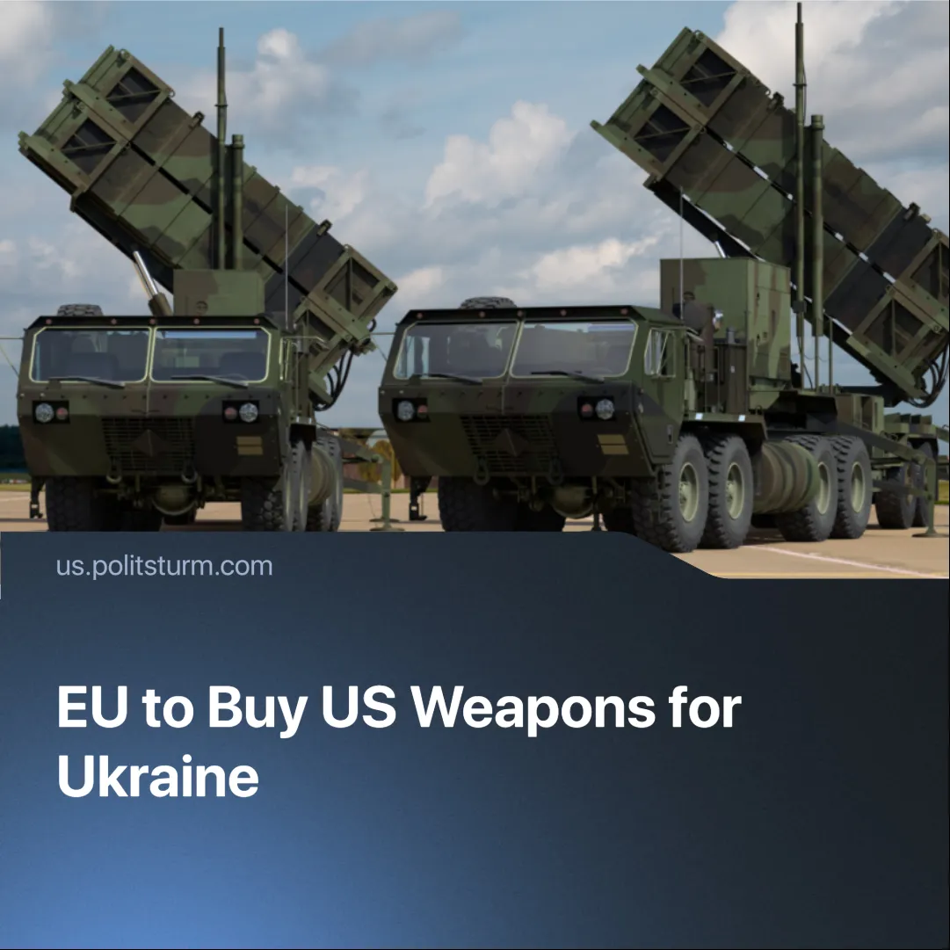

Original article
2025-07-25
1 min read

The US has forced NATO allies to purchase US weapons for Ukraine. While EU states accepted the deal, they urged Trump to “share the burden.”
Details. NATO members have agreed to spend at least €40 billion on US-made weapons — mainly advanced air defence systems such as Patriot missile batteries — which will be sent directly to Ukraine. Germany, Finland, Denmark, Sweden, Norway, the UK, the Netherlands, and Canada are backing the plan.
► Several EU officials have voiced concerns. EU foreign policy chief Kaja Kallas argued that “if Europe is going to pay for these weapons, then it’s European support, not American.” France, Italy, Hungary, Czechia, and Slovakia oppose the deal, citing economic strain and the risk of escalation. Macron’s government has reiterated calls to prioritise Europe’s own arms industry.
► Alternative proposals — such as sourcing from European manufacturers, focusing on drones and artillery shells, or using the European Peace Facility (EPF) — were discussed. Some were partially implemented, but US systems like Patriots and HIMARS were prioritised due to faster availability amid intensifying Russian missile strikes.
Context. While the deal apportions costs based on NATO members’ economic size, it does little to prevent Ukraine from sinking deeper into debt. Approximately 44% of Ukraine’s debt is already underwritten by European countries. Total debt now stands at 26% of GDP and is expected to reach 100% by the end of 2025.
► Trump has long used military aid as a bargaining tool. In 2019, he froze $400 million to pressure Ukraine into investigating Joe Biden. On 3 March 2025, he again temporarily paused all material aid, demanding immediate peace talks.
► In response, the EU unveiled a five-point plan in May 2025 to boost defence spending — including looser budget rules, expanding loans, and mobilisation of private capital.
► US-EU relations have worsened amid a tariff war, US pressure to raise military budgets, and Washington’s growing support for Europe’s pro-US far right. The deal to provide arms to Ukraine is a temporary necessity since the US failed to broker peace negotiations, and Europe can’t stand on its own.

Original article

