EU Resumes Condemnation of Israel’s Gaza Offensive
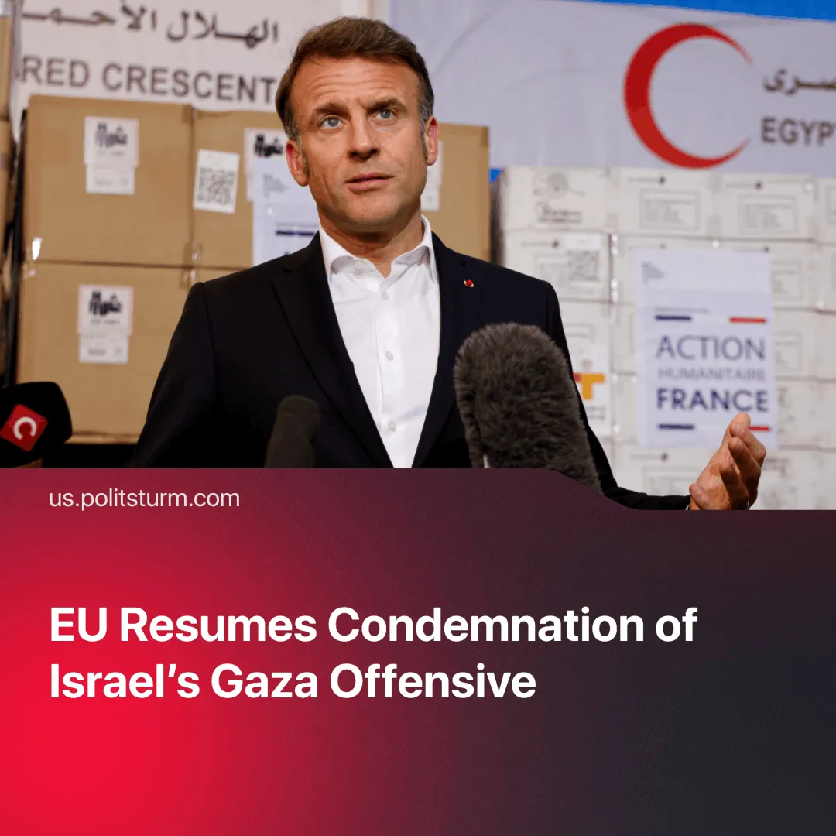

Original article
2025-07-28
2 min read

After backing Israel in the 12-day war with Iran, EU states have again condemned its Gaza offensive and signalled support for Palestinian statehood.
Details. The office of French President Emmanuel Macron has announced France would “formally vote in favour of recognising the State of Palestine” at the upcoming UN General Assembly.
► A coalition of 28 Western countries, including the UK, France, Canada, Australia, New Zealand and several EU states, issued a joint statement condemning Israel’s conduct in Gaza, denouncing the “inhumane killing” of over 800 civilians, particularly near aid distribution points.
► UK Foreign Secretary David Lammy said he was “appalled” and “sickened” by the ongoing humanitarian crisis and warned that further sanctions “may follow” if aid restrictions persist. Over 220 UK Members of Parliament signed a parliamentary letter urging the PM, Keir Starmer, to recognise Palestinian statehood.
► Israel’s Foreign Ministry stated that the joint condemnation by countries “fails to focus the pressure on Hamas and fails to recognise Hamas’s role and responsibility for the situation.”
► The United States did not join the statement, reaffirming its ironclad support for Israel and emphasising its right to self-defence.
Context. The European condemnation follows an earlier, short-lived shift toward sanctioning Israel and recognising Palestinian statehood, plans which were abruptly abandoned when Israel attacked Iran.
► The EU is Israel’s largest foreign investor, with over €72 billion in direct investment—most routed through the Netherlands, a key tax-haven and financial hub. The US is Israel’s main military sponsor, providing around $3.8 billion in annual aid and advanced weapons systems.
► Israel’s campaign in Gaza has produced catastrophic consequences: reported to be over 59,000 Palestinian deaths, widespread famine, and civilian massacres during aid deliveries—fueling public outrage and compelling capitalist states to issue symbolic protests.
Important to know. Now that the immediate threat of Iranian strikes on EU capital and infrastructure, which briefly aligned US and EU priorities, has subsided, European states can show support for Palestinian statehood to counterbalance US influence.
► The EU’s support currently remains symbolic. It has not severed investment ties with Israel or imposed meaningful sanctions. Backing Palestinian statehood serves to restore legitimacy at home, appeal to Arab states abroad, and position Europe as a “moderate” alternative to US dominance, without undermining Israeli capital.

Original article

