EU Pushes €90bn loan to Ukraine After Orbán Removed
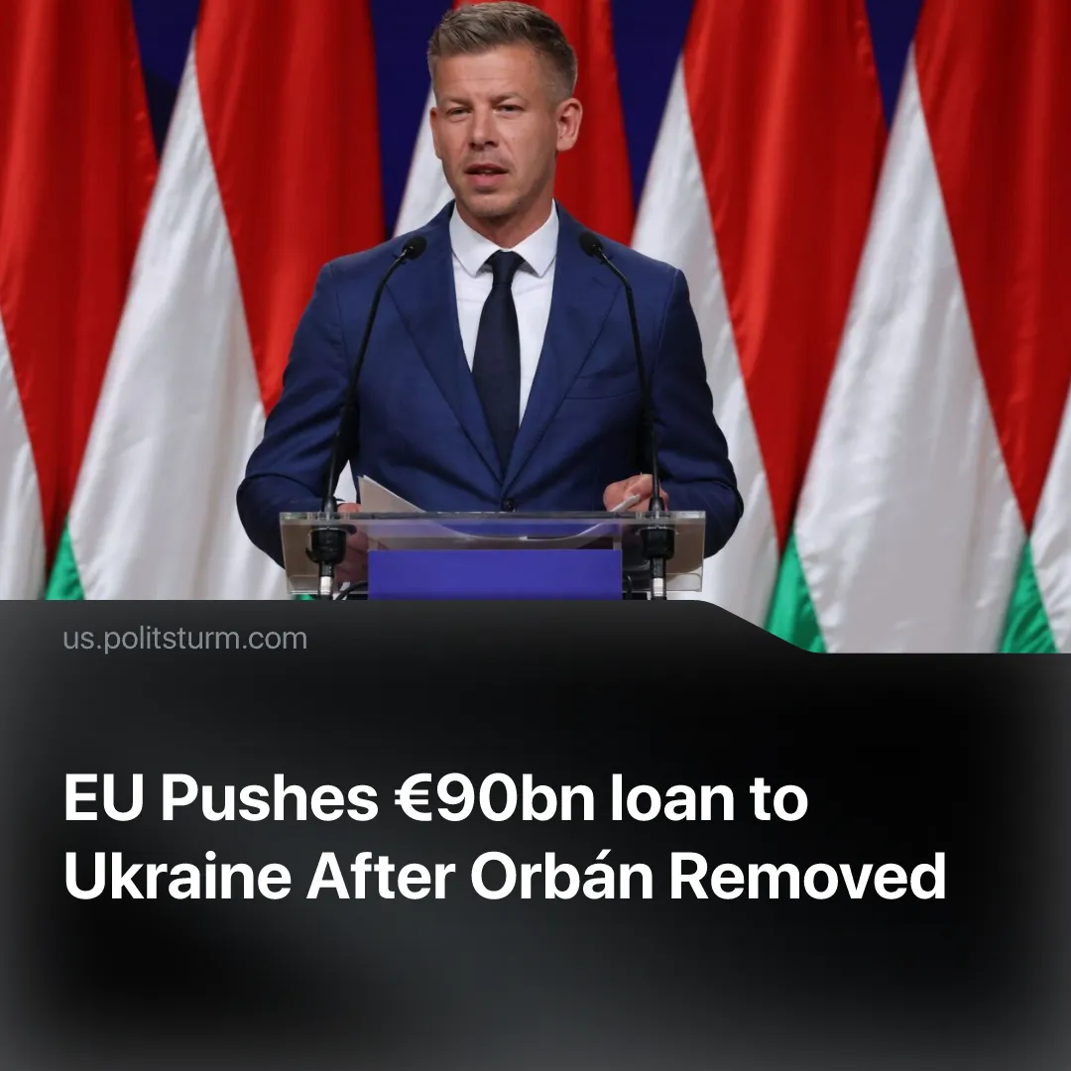

Original article
2026-04-20
1 min read

EU to pass €90bn loan for Ukraine after new pro-EU Hungarian leader elected.
Details. Following the defeat of the nationalist Hungarian Prime Minister, Viktor Orbán, the EU’s expansion chief, Marta Kos, stated this would clear the way for a previously blocked €90bn loan to Ukraine.
► The new pro-EU Prime Minister, Péter Magyar, has so far indicated his willingness to support the measure. Kos also stated that Magyar’s victory would “have a positive effect on [Ukraine’s] accession process” into the EU.
Context. Since Trump’s latest term, Europe has accelerated efforts to decouple from the US and assert its own imperialist power. Repeated calls for “strategic autonomy” have been made by the bloc’s most powerful states, France and Germany, while military spending has sharply increased.
► The US has promoted a strategy of supporting European far-right parties as a means of fragmenting EU unity and maintaining its dependence. Orbán’s nationalist government was the primary example of this, with JD Vance visiting Hungary to promote Orbán a week before the election.
► One of the EU’s primary concerns is the “SMO” in Ukraine, which it continues to support through loans. A €90bn loan was blocked in March by Hungary, with Orbán justifying the veto by citing a dispute over a pipeline damaged by the conflict, which carries Russian oil through Ukraine to Hungary and Slovakia.
► The rise of Magyar indicates a shift in Hungarian capital towards the EU, while still using the same methods. Magyar was part of Orbán’s Fidesz network for nearly two decades before leaving in 2024, serving as a diplomat to the EU, stating he was inspired by Orbán’s anti-communism during his youth. His campaign mainly emphasised anti-corruption efforts, rebuilding institutional trust, and improving cooperation with the EU.

Original article

