EU Military Spending Three Times Larger Than What is Needed for Climate Change
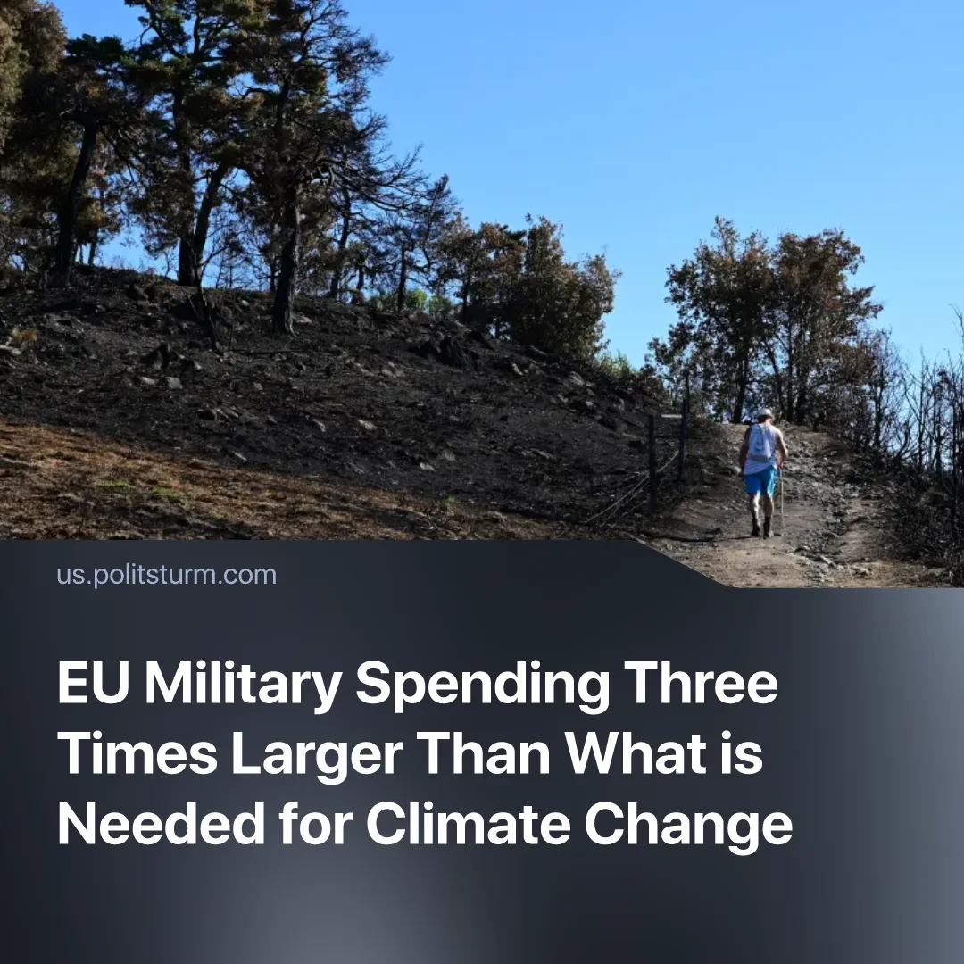

Original article
2026-08-20
1 min read

The EU needs to spend up to 137 billion Euros per year on climate change adaptation. In 2025 it invested only 16 billion on this, but invested 450 billion on militarisation in 2026.
Details. An EU report stated that, due to global warming, the bloc must annually invest up to a maximum of €137 billion until 2050 in upgrading its agriculture, energy, and transport sector to withstand the effects of climate change. It also states that from 2051–2100, this annual climate adaptation investment could need to rise to €173 billion.
► The same report estimates that in 2025, the EU spent just €16 billion on climate change adaptations. If this spending does not increase, it means the bloc is up to €120 billion short of its investment requirements.
► This is different from spending on climate change mitigation (reducing further intensification of climate change), which the EU states that, in total, it has spent over €550 billion from 2021 to 2025. Much of the strategy behind this spending is on making green energy more profitable and attractive to capitalists.
►In just 2026, EU countries are estimated to spend collectively more than €450 billion on their militaries; in 2014, one of its lowest points, they spent €195 billion – still higher than what is needed for climate change adaptation. The bloc has been consistently increasing its military spending over the past decade.
Context. During the recent heatwave, thousands of excess deaths were recorded in Europe due to the extreme heat. At the same time, the ongoing wildfires are breaking records for the total area burnt. Furthermore, due to the droughts and severe heat, Europe is facing far lower crop yields, driving up food prices, and straining public infrastructure.
► To justify its ballooning military spending, European media is drumming up war hysteria and portraying war with Russia as an inevitable event. In 2025, Germany’s Defence Minister claimed that Europe had seen its “last summer of peace”, insinuating a war with Russia could’ve started in early 2026. The EU has repeatedly painted Russia as a naturally aggressive country.

Original article

