On the Growth of Militarism in the European Union
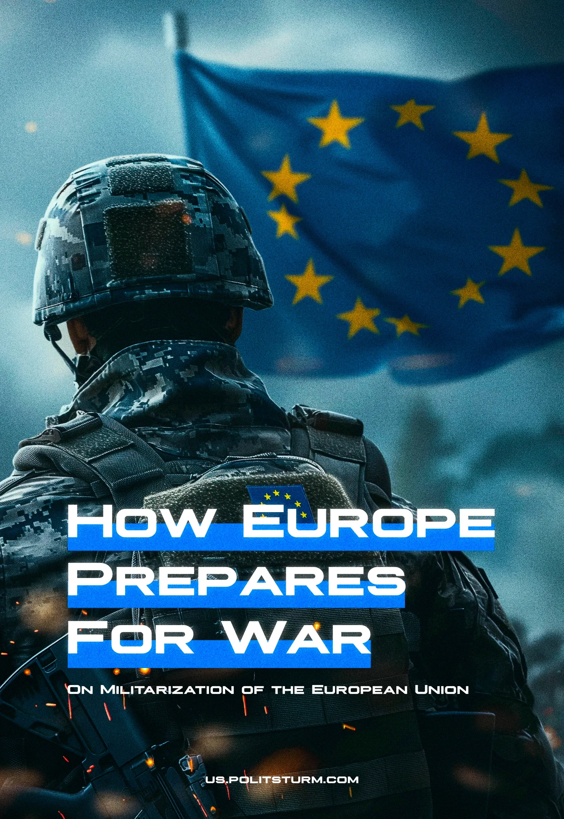

Original article
2024-05-10
10 min read

The growth of the frequency and intensity of military conflicts has grown in recent years. Along with this is the rise of militaristic and chauvinistic rhetoric by the leaders of the capitalist world accompanied by growth in their military investments. In this piece, we will examine the growth of such rhetoric, investments and industry across the EU, especially since we previously wrote about this.

The growth of military spending
Combined EU member spending has been growing rapidly for the last 8 years in a row. In 2021 it surpassed the €200 billion mark and reached €214 billion [1] and in 2022 (the latest published figures as of now) it ballooned to €240 billion [2]. From 2021 to 2022, the biggest increases were by Sweden (30.1%), Luxembourg (27.9%), Lithuania (27.6%), Spain (19.3%), Belgium (14.8%) and Greece (13.3%). In addition, notably, a record number of these investments, €250 million worth across 46 projects, are now being managed by the combined European Defence Agency (EDA).
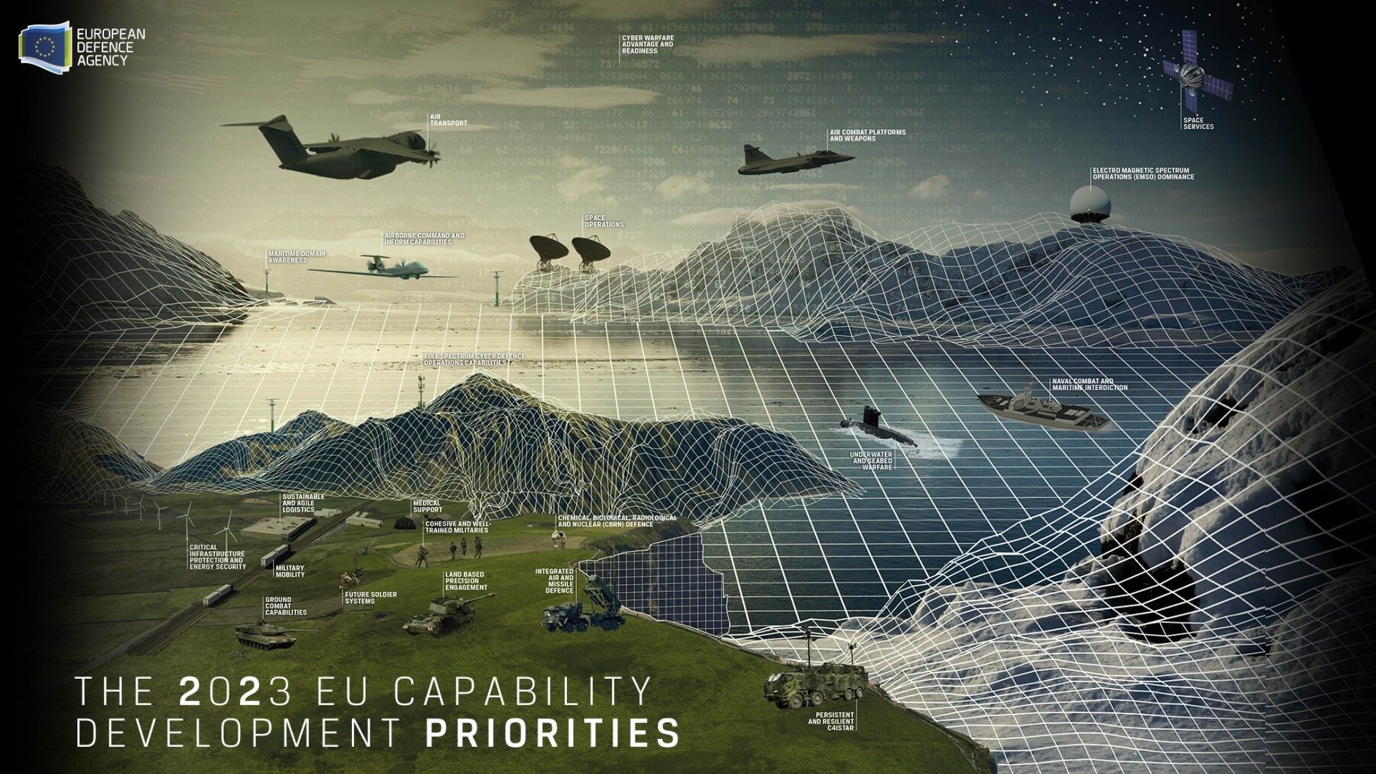
So, as can be seen, it is not just the raw amount of money being spent on European militaries, but there is also an increased degree of centralisation and coordination in said spending. This is further demonstrated by the first-ever combined European Defence Industrial Strategy (EDIS) formulated and released this year, setting the direction for European military spending for the next 10 years [3]. The objective of this strategic initiative is to prepare the bloc for war. It aims to do so by encouraging EU domestic arms procurement. From February 2022 to June 2023, 78% of EU member states arms acquisitions originated outside of the EU [4]. The EDIS aims to encourage member states to acquire 40% of total arms from within the EU by 2030.
Furthermore, the European Defence Industry Programme (EDIP) regulation was also announced in March 2024. This programme will allocate €1.5 billion from the EU budget and facilitate greater cooperation in scaling up EU member states’ production of arms, from development to maintenance. The European Parliament has also backed a plan to establish a €100 billion defence fund and called on the European Investment Bank (EIB) to liberalise its lending criteria for this endeavour [5].
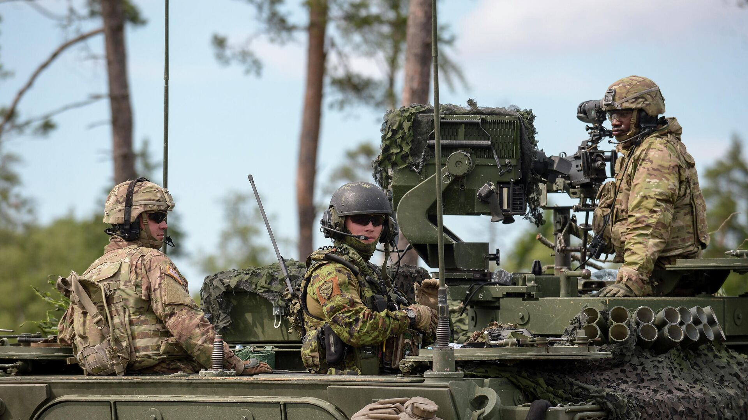
While no longer in the EU, the UK’s military spending is the highest in Europe at £52.8 billion in 2022, or 2.3% of GDP [6][7], confirming our previous thesis that the UK left the EU not to escape from the bloc’s increased militarisation, anti-democratic laws and enforced privatisation, but to push these things further than the rest of the EU.

Why is this happening?
The reason given by EU officials [8], the European monopoly press [9] and indeed many ordinary EU citizens is that the increased European militarisation is in response to Russian actions in Ukraine. On the surface it might appear as so, however, we will advance a different thesis.
The obvious rebuttal to the argument that EU militarisation is solely in response to Russia’s recent escalation of the Ukraine conflict neglects the fact that European military spending has been consistently increasing for the past 8 years as mentioned previously.
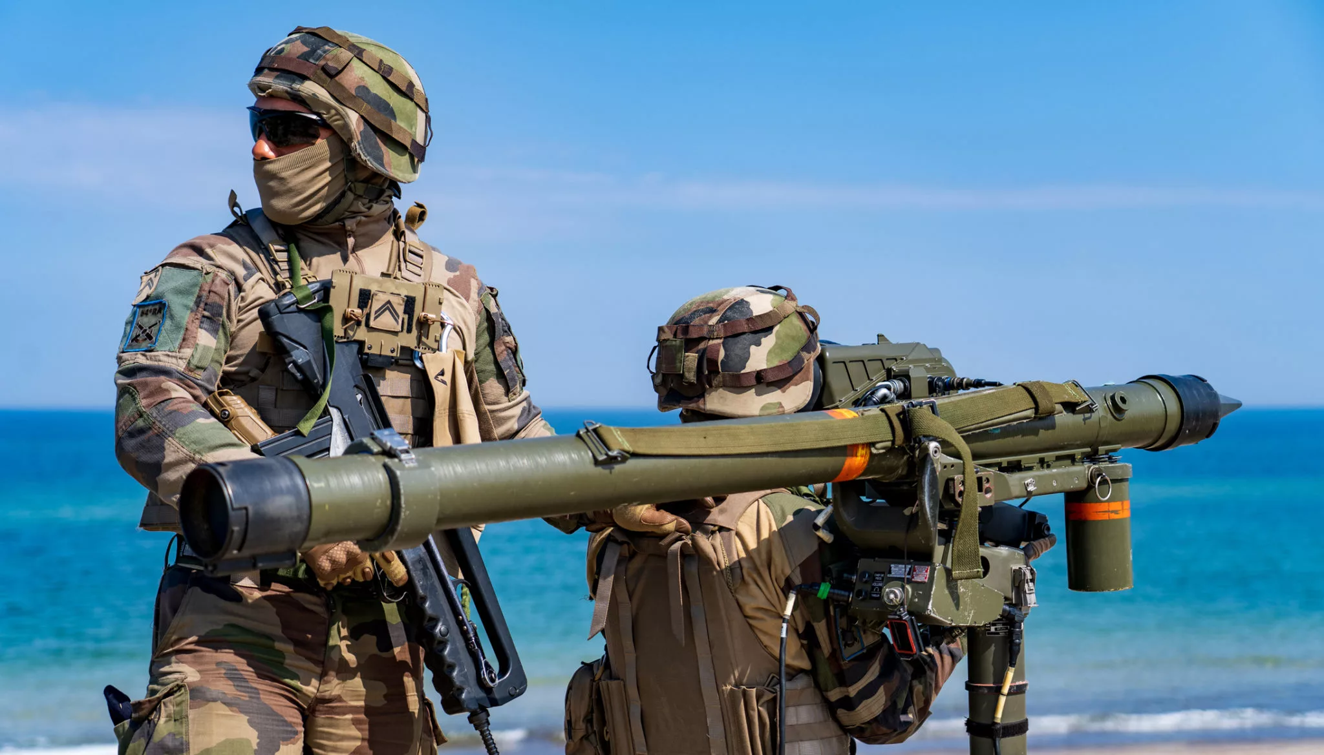
However, while this disproves the claims of EU officials, it doesn’t explain the cause. Reality of life under capitalism teaches us not to believe their words, but to look for the real essence why.
“Capital flows into those branches of economy in which the rate of profit is highest. You will never compel a capitalist to incur loss to himself and agree to a lower rate of profit for the sake of satisfying the needs of the people. Without getting rid of the capitalists, without abolishing the principle of private property in the means of production, it is impossible to create planned economy.” – Stalin, An interview with H.G. Wells.
In the imperialist stage of the world capitalist system, dominated by transnational monopolies, there is a constant drive to divide and re-divide global markets, resources, and labour. This pursuit of profit through imperialist expansion mirrors the conditions that led to the First World War. Lenin's analysis of imperialism as the highest stage of capitalism underscores this reality:
“Imperialism has grown from an embryo into the predominant system; capitalist monopolies occupy first place in economics and politics; the division of the world has been completed; on the other hand, instead of the undivided monopoly of Great Britain, we see a few imperialist powers contending for the right to share in this monopoly”. – Lenin, Imperialism, the Highest Stage of Capitalism.
Following the overthrow of Soviet Power, previously inaccessible markets and resources became available for capitalist exploitation. This has led to a relatively peaceful, (yet still devastating workers of former Soviet and dependant countries) expansion of capital. With capitalist social relations prevailing globally and feudal relations largely dissolved, the division of the world is again now complete.
As the world faces an economic crisis, imperialist powers are drawing lines to vie for the re-division of resources, potentially leading to another world war. Recognizing their individual weakness against American and Chinese capital, EU member states seek to strengthen their bloc. In essence, increased military spending is not about defending liberty, but about preparing for profit-driven wars that exploit millions of workers, reminiscent of the conditions that sparked World War I.
And the military monopolies are themselves involved in this process. The largest 15 European arms manufacturers enjoyed a combined profit of €17.6 billion in 2022, a 14.3% increase from the previous year in real terms [10]. While thousands die, and millions are displaced the biggest and most predatory capitalists rake in the big bucks.
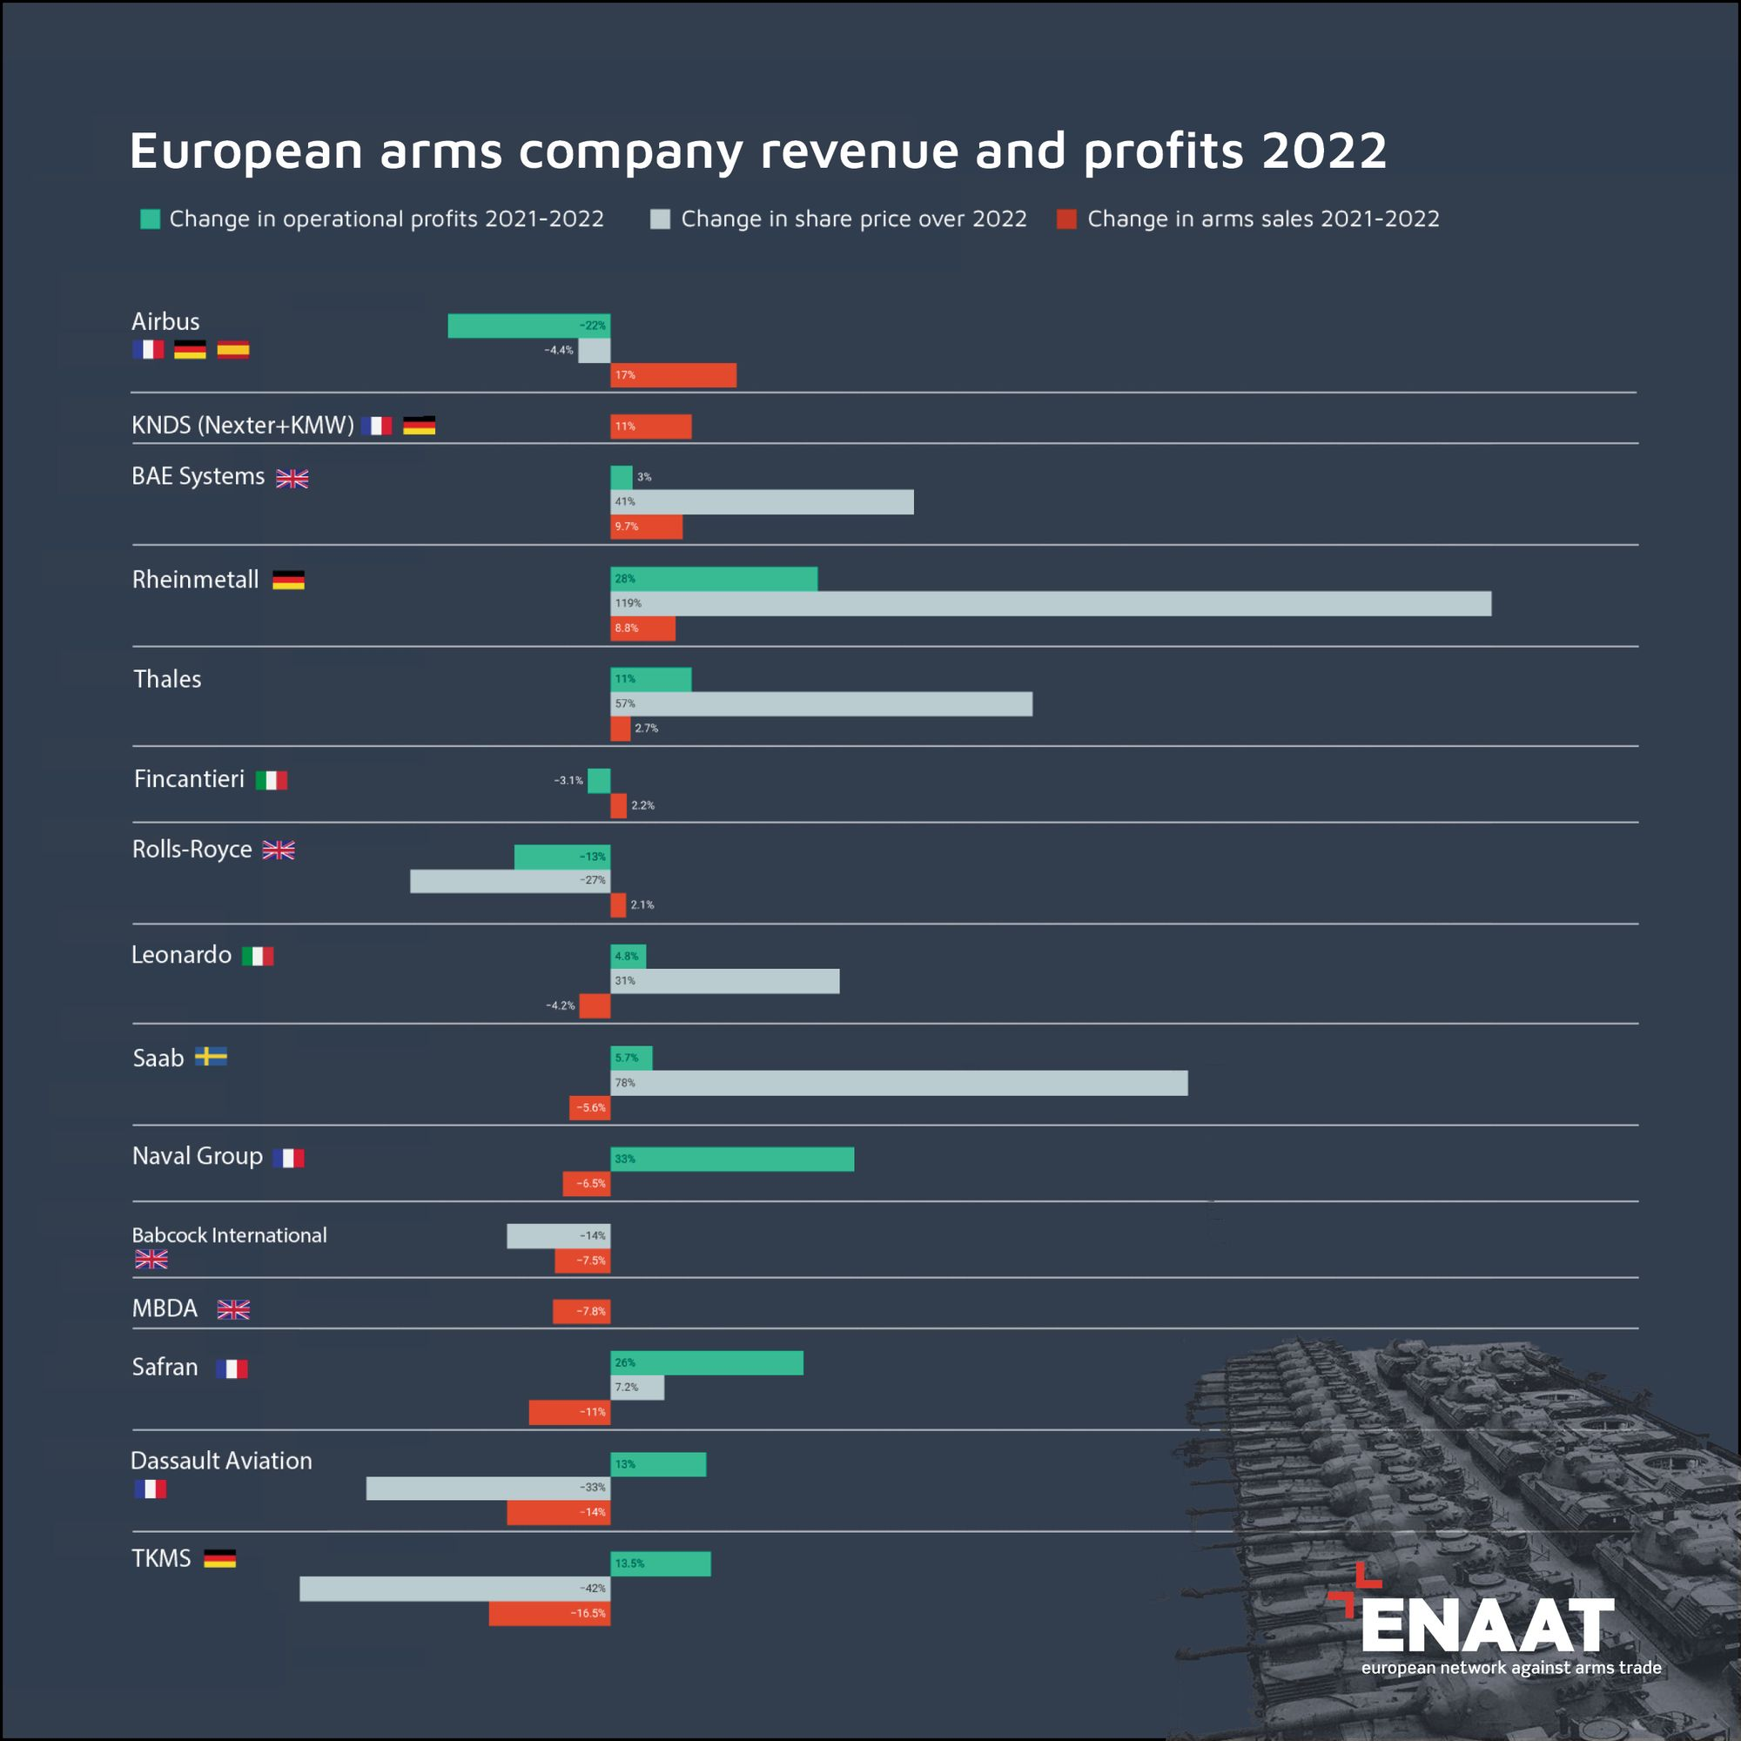
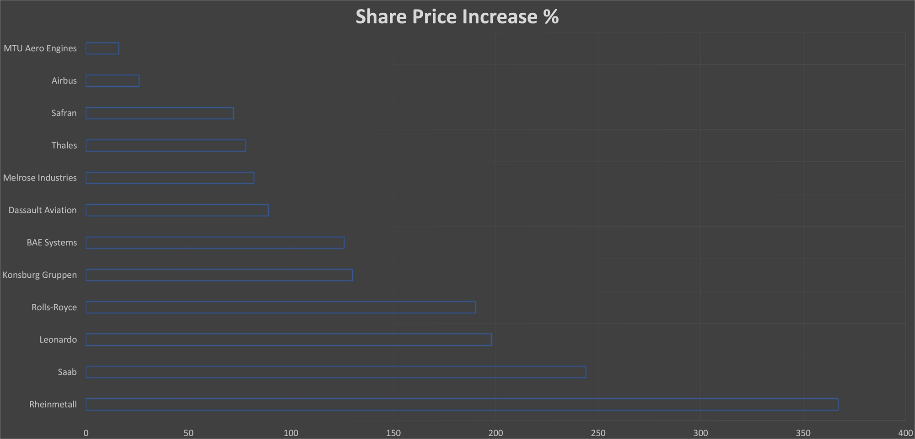
Share price increases of major European Arms manufacturers from the start of 2022 to the start of 2024 [11]

Who will pay for European Militarisation?
While depleted stocks from arms sent to Ukraine have continued to spur European arms production to a greater degree, it’s a self-sustaining beast as capitalists expect a return on their investment. Profits continue to be made by the cannibalistic sacrifice of human life. Every state professes to act in defence of the nation or the interests of the nation. However, they purposefully mystify the interests of the ruling class as the interests of the whole nation.
As European militarisation gains momentum, it's important to consider who bears the financial burden of this arms race. As it is funded from national state and EU budget, taxpayers, predominantly working individuals, foot the bill for the expansion of military capabilities. This substantial investment in defence infrastructure and weaponry diverts resources away from essential social services and infrastructure projects desperately needed by ordinary citizens who are pushed into poverty in an increasing number.
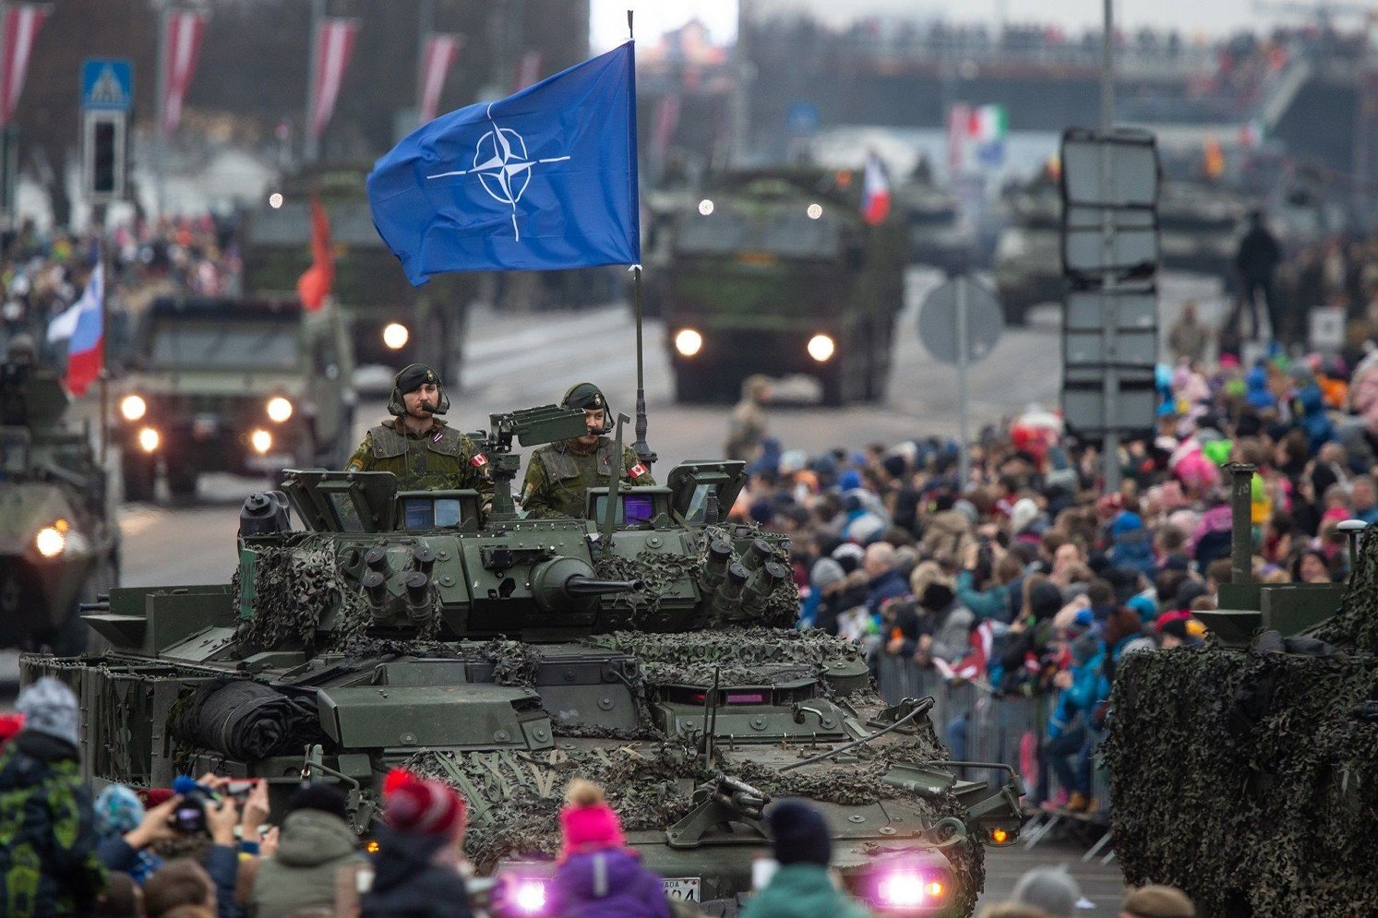
Despite the rhetoric of defending national interests, the true beneficiaries of this militarisation are the ruling capitalist class and the arms manufacturers who profit from the perpetuation of conflict. The contradiction is stark: while the ruling elite reap immense profits from warfare, they simultaneously propagate austerity measures and austerity policies that exacerbate social inequality and hardship for the masses.
This exploitation and manipulation of national interests to serve the ruling class's agenda underscores the fundamental antagonism between labour and capital. As long as capital persists, the interests of capital will continue to clash with those of the working class, perpetuating a cycle of exploitation and conflict.

What can we do to oppose this?
So, to summarise, war is not an anomaly under capitalism, but its inner nature – cutthroat competition – taken to its logical conclusion. As such it is an inevitability that the biggest corporations with the means to do so (and the states that act in their interest) will chose violence and war in order to achieve their aims, if necessary and possible, or other methods if they work better.
As a result, it is futile for the rise of militarism in one rival capitalist country or bloc to supposedly be opposed by the rise of militarism in another, as the same root causes actually drive them both.
Capitalism has triumphed worldwide, yet the poverty that liberal ideologists said would disappear with the “End of History” is still with us and instead increases, while inequality grows within and between nations. Young people, who were promised flexible, innovative, cool jobs, are left out in the cold: unemployed, underemployed, overworked, and with rising bank debts. Now many of them are earmarked by the ruling class to kill and be killed in another imperialist war for the re-division of the world.
The solution is for workers in all countries to establish power in their own hands, expropriating the capitalists whose collective action leads to war (and poverty, and crises) – establishing socialism. When socialism has achieved victory on a world scale and class distinctions are abolished worldwide (everyone has equal opportunity to work the socially owned means of production) will wars between humans become a relic of our barbarous class-divided prehistory.
We need Communist Parties to lead their workers towards this destiny. However, in the majority of countries, the work of founding a real Communist Party has yet to be completed. We are involved in this work. Join us if you wish to contribute
Sources:
[1] https://eda.europa.eu/news-and-events/news/2022/12/08/european-defence-spending-surpasses-200-billion-for-first-time-driven-by-record-defence-investments-in-2021#
[2] https://eda.europa.eu/news-and-events/news/2023/11/30/record-high-european-defence-spending-boosted-by-procurement-of-new-equipment
[3] https://commission.europa.eu/news/first-ever-european-defence-industrial-strategy-enhance-europes-readiness-and-security-2024-03-05_en
[4] https://www.europarl.europa.eu/RegData/etudes/ATAG/2024/760362/EPRS_ATA(2024)760362_EN.pdf
[5] https://www.europarl.europa.eu/doceo/document/TA-9-2024-0107_EN.html
[6] https://www.msn.com/en-gb/money/other/uk-beats-europe-as-defence-spending-exceeds-the-end-of-cold-war-full-list-of-countries/ar-AA1nqiYs
[7] https://assets.publishing.service.gov.uk/media/660d4b5197e60600112b2218/MOD_Defence_in_Numbers_2023.pdf
[8] https://www.ft.com/content/0c0482f3-ee5f-42f8-9469-7f82c4ad4c17
[9] https://www.euronews.com/2023/04/24/europes-military-spending-soars-fuelled-by-ukraine-war
[10] https://aoav.org.uk/2023/european-arms-industry-profits-amid-ukraine-invasion/
[11] https://www.ft.com/content/e9939f2b-6454-4be8-b99d-05023f635e87

Original article

