EU Militarisation Accelerated Throughout 2025
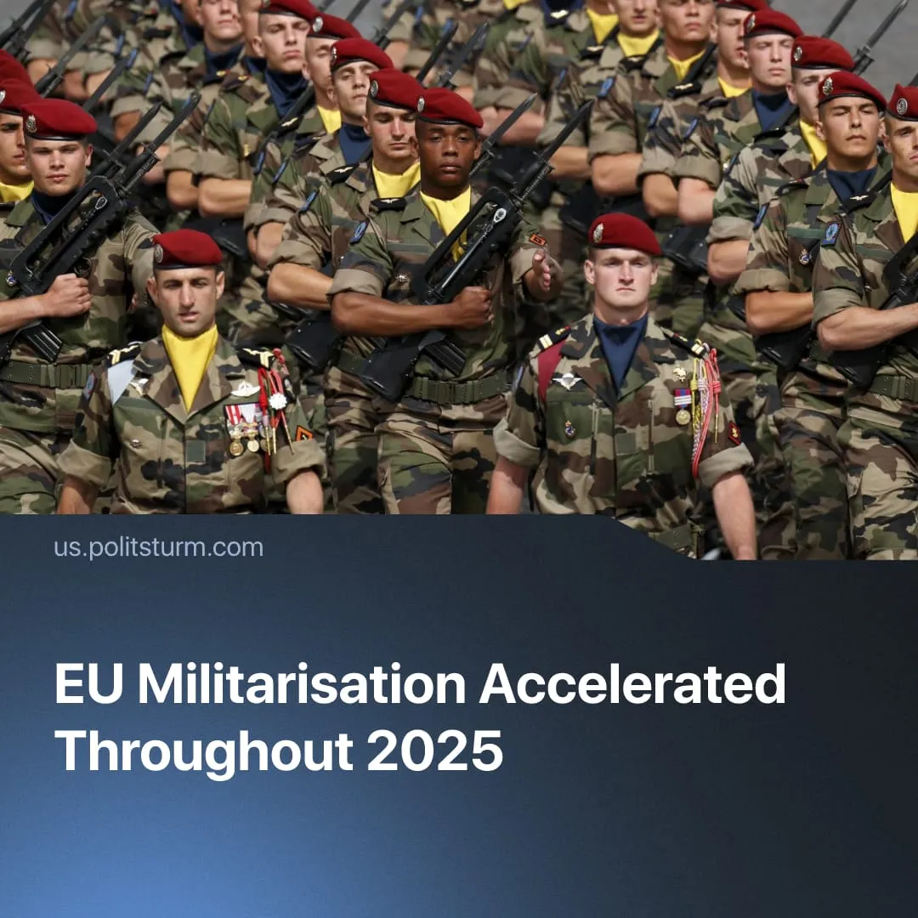

Original article
2025-12-20
2 min read

EU leadership pumped Europe with war hysteria throughout 2025. This increased profits for large companies and deepened the impoverishment of workers.
Details. At the start of the year, Trump’s intensified tariff threats and public pressure on Ukraine to accept negotiations exposed Europe’s dependence, pushing EU leaders to accelerate militarisation under the banner of “strategic autonomy.” Incidents such as the public humiliation of Zelenskyy were used to argue that Europe must prepare to fight alone.
► Throughout the year, EU officials consistently elevated the threat of conflict with Russia, presenting Ukraine as a warning of what awaits Europe without rapid rearmament. This narrative was reinforced by repeated, media-driven “drone incursion” scares, airspace violations, intelligence leaks, and warnings of sabotage, aiming to keep populations in a permanent state of emergency.
► “Defence budgets” surged across the bloc, with combined military spending projected at around €400 billion, alongside over €177.5 billion already spent on Ukraine. Programmes such as “Readiness 2030” and the SAFE mechanism were fast-tracked to enable rapid procurement, joint arms production, and the expansion of military infrastructure.
► While arms manufacturers and defence contractors recorded soaring profits through contracts and market speculation, workers faced worsening austerity, cuts to healthcare and social services, wage pressure, and moves towards conscription and compulsory service.
Context. EU militarisation did not begin in 2025, nor did the constant invocation of war threats. Programmes such as PESCO (launched in 2017), the European Defence Fund (ongoing), EDIS (2023), and EDIP (2024) established the institutional and financial framework for coordinated militarisation, allowing rapid expansion once political conditions aligned.
► In 2025, as inter-imperialist tensions rose, the United States, United Kingdom, China, Russia, Iran, Middle Eastern states, India, and Southeast Asian countries all expanded military spending and invoked external threats to justify rearmament.
Important to Know. The militarisation of 2025 is not a break from the existing order but a direct expression of it. As the economic crisis deepens and Inter-imperialist rivalry sharpens, rearmament accelerates as capitalist states prepare to redivide markets, resources, and spheres of influence through force.
► War preparations will further exacerbate worsening conditions already faced by workers, including worsening austerity, rising living costs, job insecurity and the erosion of social protections, while also bringing the threat of conscription, mass displacement and death – sharpening class antagonisms across Europe.
► To maintain control under these conditions, capitalists are increasingly relying on far-right forces to discipline labour and suppress dissent. This trend is already visible across Europe.
► Rising reformist and social-democratic “workers’ parties” in France and Germany have already shown what they offer workers by responding to conscription with rhetorical criticism, jokes, or calls for minor concessions to make conflict more attractive. They aid imperialist policy while diverting workers toward false solutions.
► The situation highlights the urgent necessity for communists to organise, prepare for intensified repression, and advance a genuinely internationalist response to imperialist war. This requires strengthening organisational work between genuine communists and intensifying the struggle against opportunism on both the left and the right.
We are already doing this work. Support and join us.

Original article

