EU Ignores 85th Anniversary of Hitler’s Invasion That Killed 27 Million
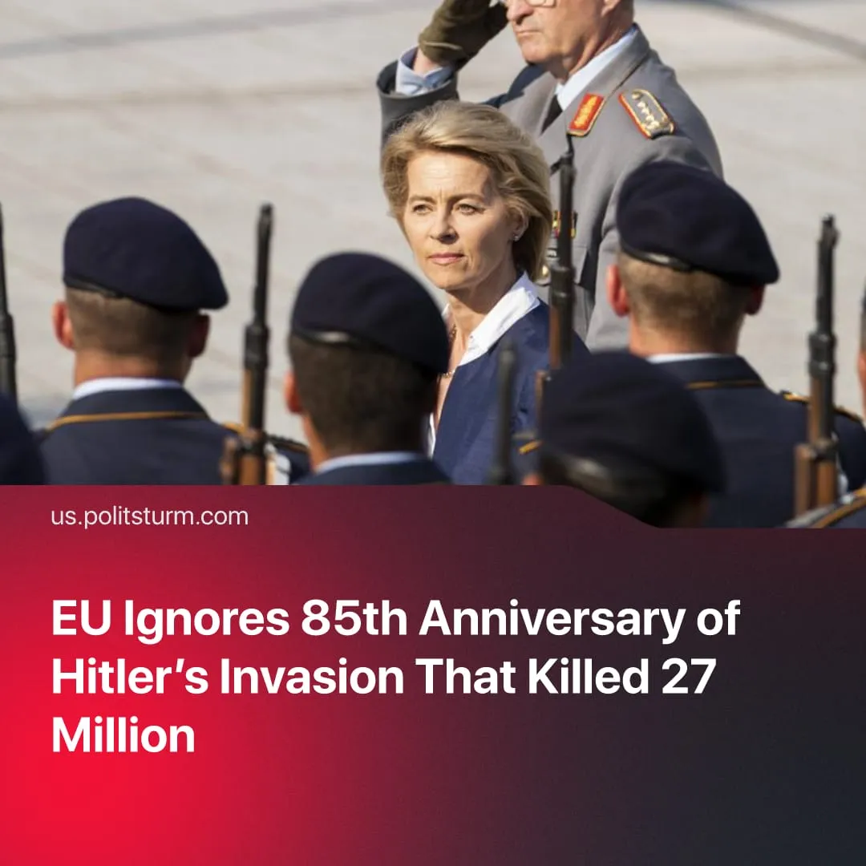

Original article
2026-06-22
1 min read

85 years ago, Germany justified its invasion of the USSR by claiming 'Soviet aggression'. The EU marked the anniversary with silence, yet has repeatedly pushed the same narrative.
Details. June 22 marks the 85th anniversary of Operation Barbarossa, when more than 3.8 million Axis troops crossed the Soviet border in the largest military invasion in history. Even after the attack began, Nazi Germany justified the invasion by the need for 'preemptive defense' against the alleged Soviet attack on Germany.
► Neither the European Commission, European Council, European Parliament, nor leading EU officials such as Kaja Kallas or Ursula von der Leyen appear to have issued statements commemorating the date. Similar silence was observed even among EU member states that invaded the USSR alongside Nazi Germany, including Italy, Hungary, Romania, Slovakia and Finland. Major Western media coverage of the anniversary was likewise limited, with only one major newspaper reporting on the date.
► EU High Representative Kaja Kallas has repeatedly implied the USSR was "naturally aggressive", directly echoing Nazi propaganda, which framed the invasion of the Soviet Union as saving European civilisation from Bolshevism.
Context. The Great Patriotic War of the Soviet Union against the German-Fascist invaders is the most significant part of World War 2. Nazi Germany's war of extermination against the Soviet Union claimed more than 27 million Soviet lives and left 1,710 towns and over 70,000 villages destroyed.
► The Red Army ultimately inflicted around 76% of Germany's military losses, helped liberate much of Europe from Nazi occupation, and won the war by taking Berlin in May 1945.
► Since 1964 the EU has marked May 9 as "Europe Day", replacing Soviet Victory Day and preventing communist celebration of the day. The EU also marks August 23 as "Black Ribbon Day," falsely equating fascism and socialism by commemorating "victims of all totalitarian and authoritarian regimes."

Original article

