EU Extends Private Message Monitoring
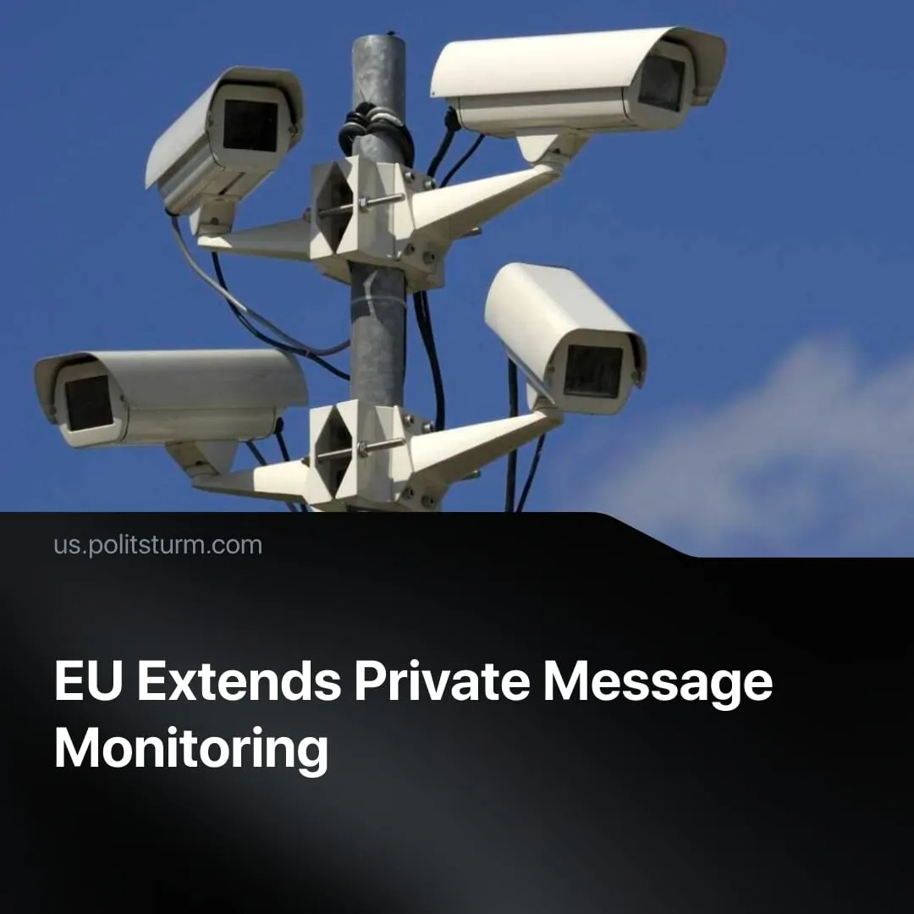

Original article
2026-07-23
1 min read

The EU passed a bill allowing mass surveillance of private messages under the cover of child protection. This infrastructure will be inherited by the far right.
Details. The European Union extended Chat Control 1.0 until 2028. The law permits tech companies to scan private messaging networks and hand over user data, chat logs, and account information to state authorities without a warrant. Officially justified as child protection, the measure opens the door to monitoring political opinion.
► The extension was forced through a procedural loophole right before the summer recess, allowing a 47% minority to override the 53% majority of voting deputies who opposed it. Major conservative, social democratic, and far-right factions united to pass it, politicians claiming to oppose the measure opportunistically used public anger for votes without offering real resistance.
► Negotiations for a permanent expansion resume in September, aiming to make client-side scanning mandatory across all devices, effectively destroying end-to-end encryption and subjecting every private conversation to state surveillance.
Context. European governments are expanding police and surveillance powers as the economic crisis deepens and inter-imperialist conflict approaches, running parallel to the growth of far-right parties across the continent. Just as capitalist governments in the 1930s built secret police networks during a crisis, today they are constructing a digital surveillance apparatus to monitor and control the working class.
► Child protection is the stated justification for Chat Control, but European states are expanding surveillance across the board regardless of pretext. Germany's expanded Federal Police Act authorises live facial recognition, automated data analysis, and state spyware to intercept encrypted communications. France normalised AI surveillance during the Olympics, while Poland deployed military-grade spyware against domestic political opponents.
► The pattern of masking unpopular measures behind acceptable justifications runs throughout European policy. Germany's conscription bill was marketed as voluntary, the fine print authorises a mandatory draft without declaring a state of emergency.

Original article

