EU Chief Repeats Claim That USSR Was Naturally Aggressive
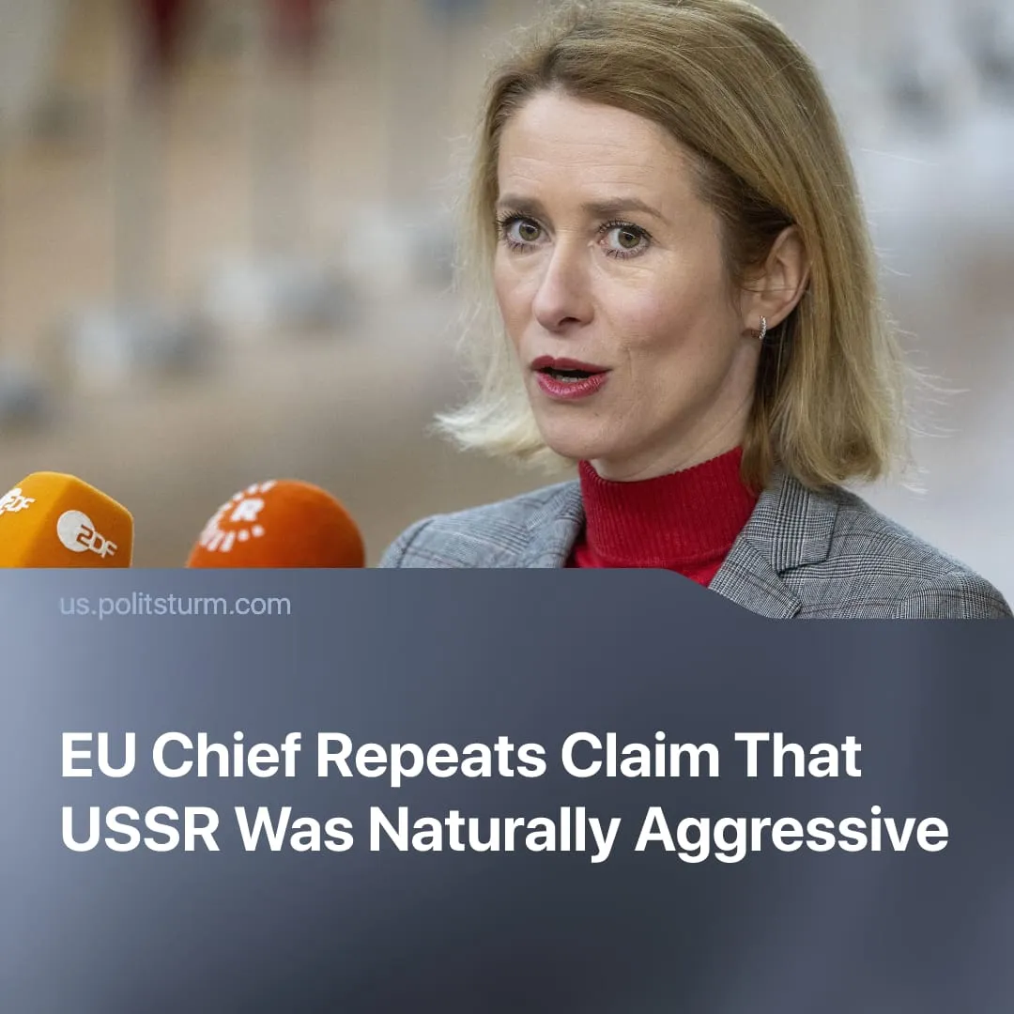

Original article
2026-04-04
1 min read

Once again, the Soviet Union is implied as naturally aggressive by the EU foreign policy chief in an attempt to refocus international attention on Russia’s SMO.
Details. EU High Representative Kaja Kallas recently delivered a speech in Zürich, where she repeated her claim that “Russia has attacked at least 19 countries. I'm not counting those in Africa. [...] Some as many as three or four times. And none of these countries have ever attacked Russia.”
► The first part of this quote was stated almost verbatim during Trump’s attempt to negotiate a 20-point peace plan last year, which included a number of concessions to Russia that went against the EU’s own imperialist interests.
► She went on to say that Russia has a “very clear negotiating tactic: [...] First, you demand something that has never been yours, [...] then you present ultimatums and use force. And then there will always be people in the West who offer you something you didn’t have before.”
Context. As we have previously explained, this narrative deliberately conflates the USSR with modern capitalist Russia, presenting both as historically “aggressive” to erase their fundamentally different class character. In reality, the USSR, as the first workers’ state, adopted a defensive foreign policy shaped by repeated invasions, capitalist and fascist encirclement, and sustained counter-revolutionary intervention.
► International attention has shifted towards the US-Iran conflict. Both imperialist powers have clashed over diverging interests, with the US retracting increasing levels of support from Ukraine and the EU resisting giving full backing to the campaign against Iran.
► The EU is reaffirming where its main imperialist interests lie and that it is unwilling to offer any major concessions in peace negotiations with Russia. As the US reconsiders its NATO membership, a rapidly remilitarising Europe is attempting to consolidate its position and send a “hardline” message to the Kremlin.

Original article

