EU Electoral Bans Reveal Deepening Imperialist Resolve
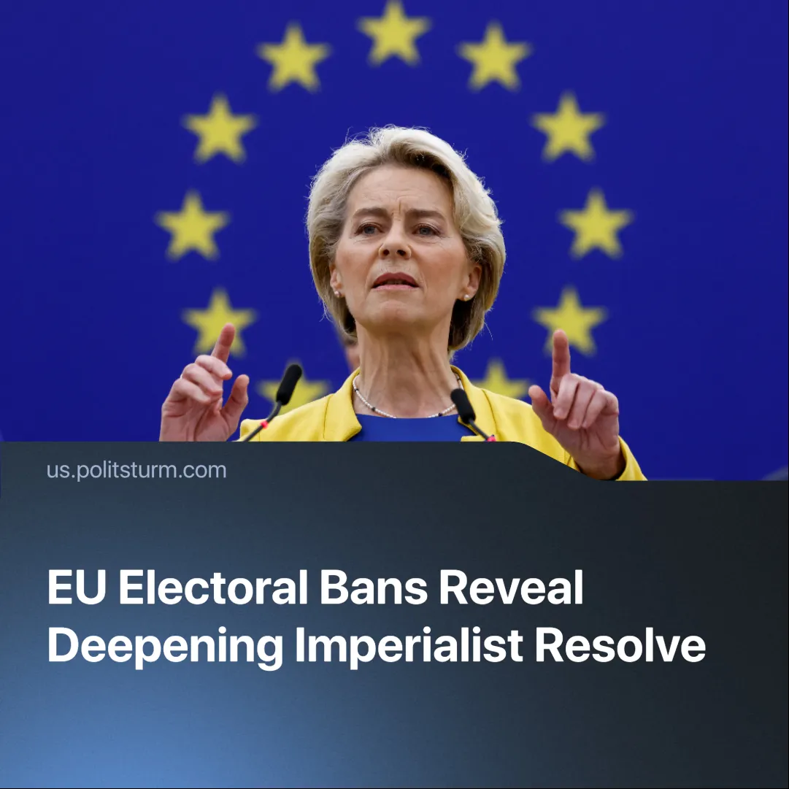

Original article
2025-04-11
2 min read

The European Union has taken increasingly bold steps to suppress political forces that conflict with its interests. It has barred individuals from elections, overturned results in Romania, and signaled a willingness to do the same in central countries like Germany.
Details. Romania's electoral commission banned an anti-NATO and anti-EU candidate, Calin Georgescu, as well as Diana Șoșoacă, from taking part in the country's May elections, citing alleged Russian interference.
► The November 2024 elections were cancelled two days before the second round in December and rescheduled for May because of these allegations. There is strong evidence of foreign interference. However, the sudden moves to ban these candidates have led to violent protests in the country.
► In France, far-right candidate Marine Le Pen has been found guilty of embezzlement and barred from the 2027 elections, in addition to being sentenced to wear an electronic tag. But she is an exception—similar embezzlement is widespread in the EU, yet it rarely results in prosecution.
► Former European Commissioner Thierry Breton told French television that if the German AfD party wins the elections in Germany, they could also be annulled by the European Union, "as they did in Romania".
Context. Tensions between the imperialist powers have increased as the USA has stepped up its trade war against other countries in an attempt to reassert its own position and prepare for an inevitable armed conflict. The EU, made up of many different national states, is increasingly concerned about possible fragmentation that threatens its ability to defend the bloc's interests and compete with other powers.
► Romania is especially important to the EU—bordering Ukraine, hosting key NATO operations, and serving as a major route for Ukrainian grain exports.
► The EU is facing economic stagnation, states are pushing through austerity measures to protect profits, and living conditions for workers continue to deteriorate. As a result, EU states are seeing the rise of far-right parties.
► In Germany, the Christian Democratic Union (CDU) won the recent elections but didn't get enough votes to form a majority. The alliance between the CDU, the Social Democratic Party (SPD) and the Greens to form a government is facing instability and tensions due to conflicting interests. This provides further opportunities for the growth of the far-right Alternative for Germany (AfD).
Important to Know. Far from being a "defence of democracy", these bans show how the EU is consolidating its power and ready to eliminate political risks—left or right—that could threaten its ability to defend the bloc's interests and compete with other powers.
► Many of these far-right parties have expressed anti-EU views and threaten the bloc's ability to assert itself as an imperialist power amid growing tensions between the major powers (China, the US, Russia, etc.).
► As US-EU relations deteriorate amid an escalating trade war, American capital has a direct interest in these parties gaining ground. Their rise would weaken the rival bloc and push individual EU states toward dependency on the US, aligning them more closely with American imperialist objectives.
► The US's interest in these parties can be seen in Trump's demand for France to release Le Pen and in US billionaire Elon Musk's defence of Georgescu, as well as his urging Germans to vote for the AfD.
Conclusion. Far from being a moral defence or attack on democratic values, the EU's move to curb internal opposition is a logical step toward unifying its economic interests—bringing its currency, regulatory standards, military coordination, and ideological framework into alignment—amid growing tensions between the imperialist powers. The EU wants to strengthen its internal cohesion and discipline to be able to compete with the US and China for the redivision of the world and to increase its market share and influence.

Original article

