Escalation. Israel and Iran
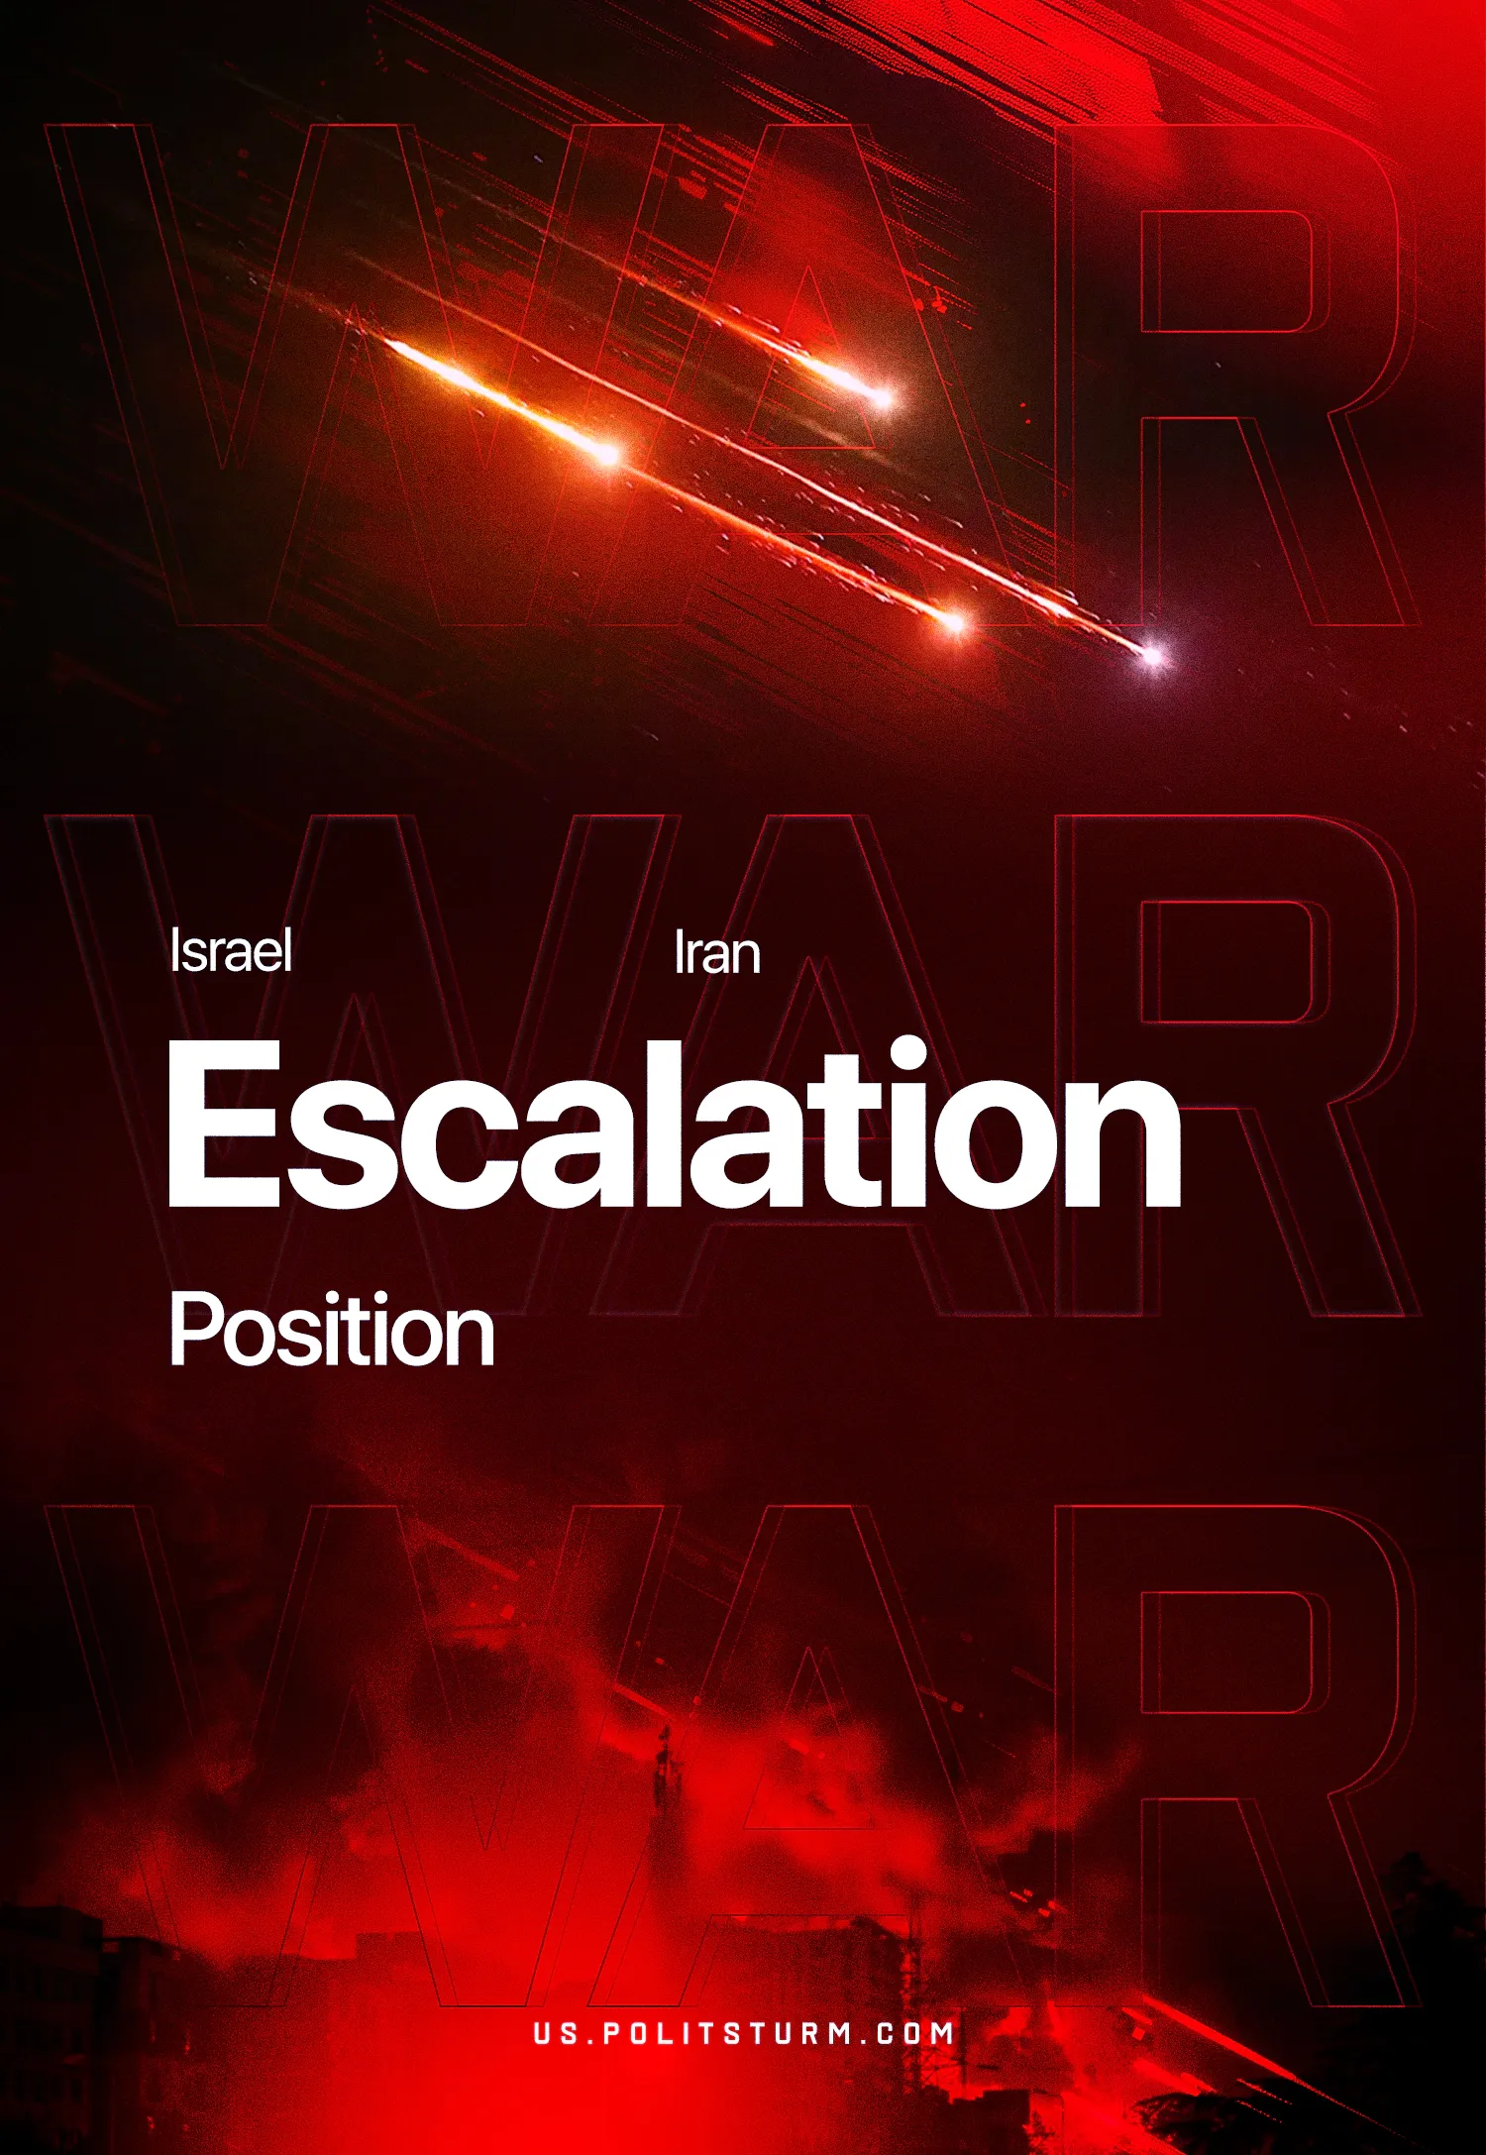

Original article
2025-06-17
5 min read

On June 13, Israel carried out strikes on strategic targets in Iran, including a uranium enrichment plant and a nuclear facility in Natanz.
Targets of the attacks also included missile infrastructure and senior military leadership. In response, Iran launched an operation against Israel, firing hundreds of ballistic missiles. The United States is increasing its military presence in the region.
On June 15, Iran announced its willingness to enter into an agreement.
On June 17, U.S. President Trump stated that he expects “complete surrender” from Iran. At present, hostilities continue: Israel and Iran are exchanging missile and drone strikes.
What is important to know?
1. Both sides are states ruled by the dictatorship of capital. Neither Israeli nor Iranian capitalists are allies of the working people of Israel or Iran.The escalation of the conflict in the Middle East represents an intensification of the struggle among regional imperialists, supported by the major imperialist blocs led by the United States and China.
2. The U.S. leadership was aware of the planned strikes and supported Israel. Since his inauguration, Trump has allocated hundreds of billions of dollars to support Israel. The U.S. President has repeatedly declared that it is unacceptable for Iran to develop nuclear weapons.
Information about the promotion of a military solution by U.S. leaders regularly appeared in the media. In the weeks leading up to the escalation, media reported preparations for strikes on Iran. Just days before it began, Trump spoke of the "excessive aggressiveness" of the Iranian leadership, after which the U.S. began evacuating diplomatic personnel from Iraq, which borders Iran.
During the hostilities, many members of the Iranian side involved in nuclear negotiations were killed. Trump explained their deaths as a result of Iran's refusal to make concessions and warned against retaliatory actions. In subsequent statements, the U.S. President rejected negotiations until Iran surrenders. The United States is currently continuing to concentrate forces in the Middle East.
3. Israel acts as the strike force of Western imperialism. European Union countries, which had recently threatened sanctions against Israel, immediately backed their ally. The U.S. uses Israel to apply intense pressure on Iran’s leadership.The ruling regime in Israel, which initiated the escalation, pursues the following objectives:
– Suppression of Iran’s nuclear potential and overall weakening of Iran;
– Strengthening military leadership in the region;
– Internal political consolidation and further incitement of nationalism and chauvinism (initiated after the Hamas attack on October 7, 2023), to obscure the crisis and deceive workers;
– Demonstration of the strength of the Western imperialist bloc led by the United States.
4. Iran’s public statements about readiness for negotiations after Israeli strikes indicate the political weakness of the Iranian capitalists, regardless of how events develop. Strikes on key facilities and losses in leadership undermine the stability of the Iranian bourgeoisie and its theocratic superstructure.
This will intensify internal contradictions, worsen the socio-economic crisis, and lead to heightened class struggle. It is possible that, in the face of defeat, the Iranian regime will attempt to covertly and rapidly develop nuclear technology as its last guarantee of survival.
5. Israel’s actions have demonstrated high effectiveness and serve as an example for the global bourgeoisie. Previously, Israel consistently eliminated or weakened other Iranian proxy forces in the region — Hamas and its allies in Gaza, Hezbollah in Lebanon, and the Houthis in Yemen.
Israel also conducted operations in Syria targeting Iranian forces and their allies. These actions contributed to the collapse of the Assad regime and the installation of a pro-Turkish government.As a result, Israel gained freedom of action in the region and justification for territorial expansion. Amid the growing crisis and the redrawing of the world order, other imperialists will strive to replicate this experience. In the near future, we can expect the further reactivation of old conflicts and the emergence of new ones.
6. All key capitalist powers are accelerating militarization, fascization, reforming military alliances, and intensifying pressure on the working class. The increasing number of open military confrontations in recent years confirms that the period of relative capitalist stabilization has ended. The illusions of the “age of global democracy” and the “end of history” have finally dissipated.
The UN Charter has once again been cast aside. The organization is increasingly turning into a formal structure incapable of restraining the aggression of major capitalist powers. Like the League of Nations before it, the UN is losing all influence, and its resolutions are ignored when they contradict imperialist interests.
7. The threat of nuclear catastrophe presents a particular danger. Nuclear escalation is becoming part of the political agenda of the capitalists, and only the organized working class can change the situation.
8. Under conditions of increasing reaction, militarization, and fascization, the communist movement in all countries faces urgent tasks:
– To prepare theoretically grounded and organized cadres;
– To build modern, resilient, and disciplined structures capable of operating under complex political conditions and fulfilling the role of the vanguard;
– To develop systematic work for the dissemination of Marxism-Leninism among workers;
– To adapt tactics based on a concrete Marxist analysis of the current stage of the capitalist system;
– To firmly resist all forms of opportunism and uphold a clear Marxist-Leninist line.
Despite the weakness of the modern workers' and communist movement and the strengthening of reaction, communists must already be preparing for future developments and consistently rebuilding the movement.
Imperialism is driving the world toward a new world war. The only way out is socialism.

Original article

