India Spends More on Interest Payments than Defense or Any Other Expenditure
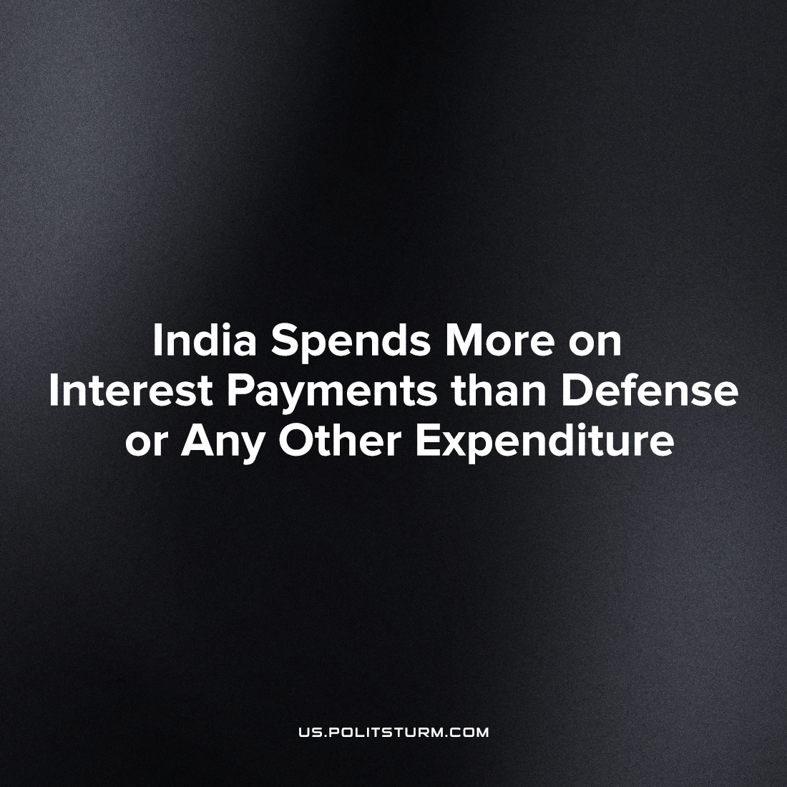

Original article
2023-05-26
2 min read

On 31st March 2023, the Ministry of Finance of India announced that the total amount of the Central Government debt is estimated at about 1,769.4 billion dollars. While this is little changed since 2022, outstanding Indian debt has surged by 2.5 times under the BJP's fascistic government and its liberalizing reforms.
The toll from this record-high debt is in enormous interest payments made from public funds to Indian and the International capitalists. Looking at the 2022 budget we can see almost 20% of tax money is spent on the interest payments, the single largest expenditure, greater than subsidies ( 7%), pensions ( 4%) and centrally sponsored schemes (9% ) combined.
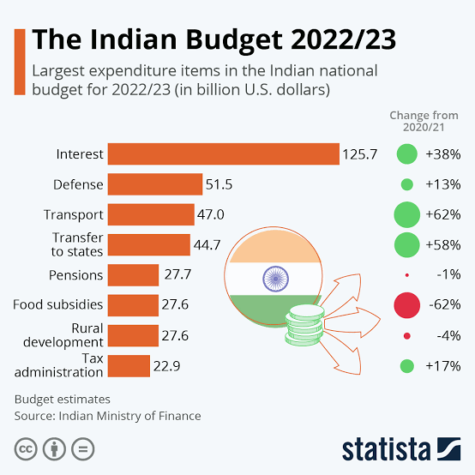
As usual the capitalist government has declared that debt is of “no concern” and “it's for the growth”, In truth, loans and interest serve as means to further maximize profits for the capitalists.
This comes at increased suffering and austerity of workers, while the capitalists profit from the public funds. The government is drastically reducing subsidies for essential needs like food, fertilizer, and petroleum. The food and fertilizer subsidy, which greatly benefits 800 million impoverished workers and peasants, is being slashed by 3.7 trillion rupees ($44.6 billion), a 3 times more than previous years cuts of 1 trillion rupees ( around $12 billion) that already surpassed the overall subsidy reduction in percentage terms.
The fact is that the debt crisis acts as a chance for the capitalists and their puppets in the parliament to enrich themselves while gaslighting workers, so they can reduce social welfare, defund our schools and hospitals, and cut pension plans.
Meanwhile international capital uses it as a tool to further their interests in India and use our country as a pawn in their own international imperialist geopolitics and wargames. No matter which government is in power.
The fact of the matter is that it is capitalism because of which we are nothing but debt slaves to the national and international capital, while they continue to exploit our workers and undermine our national sovereignty. Under capitalism, our nation and its workers have no freedom. Capitalists continue to profit from the debt while it's the workers who pay the brunt of this in the form of tax extraction by the state and in the form of reduced workers’ benefits. Under capitalism workers are destined to lose no matter who is in power, in the end all these bourgeois parties are pawns of these same capitalists and imperialists who exploit our workers.
India can only be liberated from the chains of capitalist-imposed debt servitude through the unwavering efforts of a genuine revolutionary, class-conscious communist party. The struggle is not solely for socialism, but also the genuine emancipation of our nation. The workers truly have nothing to lose but their chains, and to become masters of their own destiny.
Sources: 1, 2, 3
Source of debt increasing under BJP
Source of subsidies cuts (2022)
Source of subsidy cuts (2023)

Original article

