Ernst Thalmann on the Class Struggle
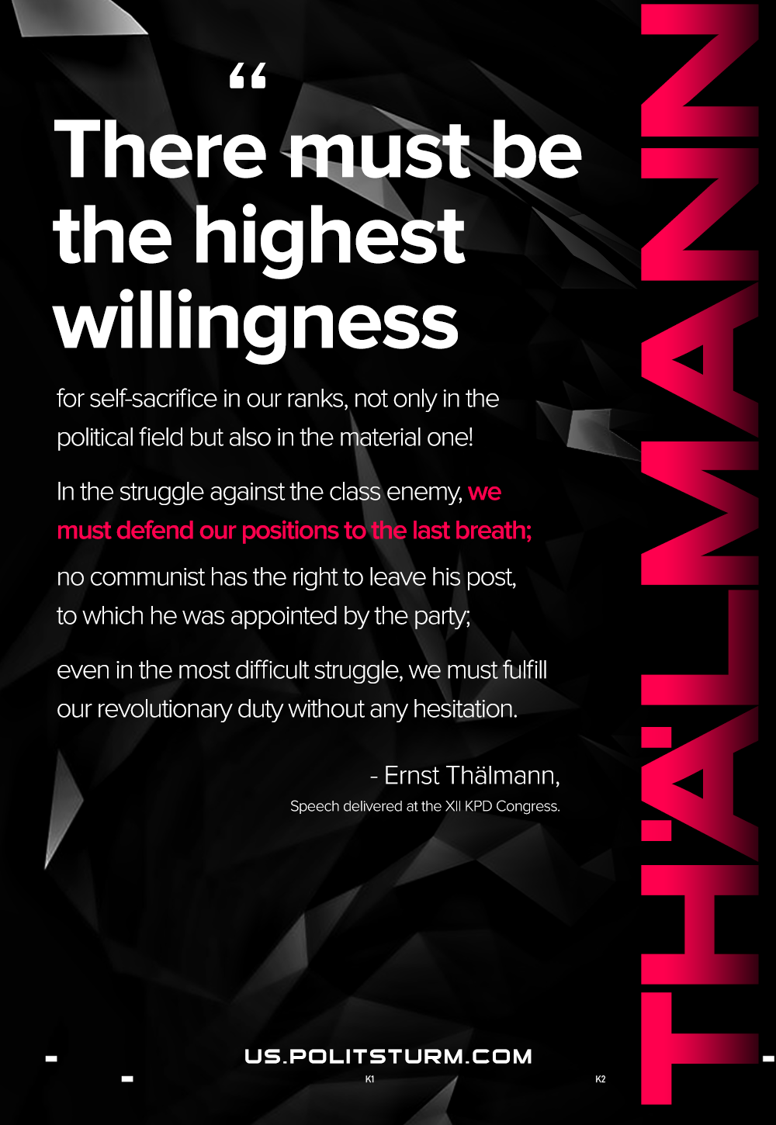

Original article
2020-11-16

There must be the highest willingness for self-sacrifice in our ranks, not only in the political field, but also in the material one. In the struggle against the class enemy, we must defend our positions to the last breath; no communist has the right to leave his post, to which he was appointed by the party; even in the most difficult struggle, we must fulfill our revolutionary duty without any hesitation.
E.Thalmann, Speech at the 12th CPG Congress.

Original article

