Ernst Thälmann on Fighting Opportunism
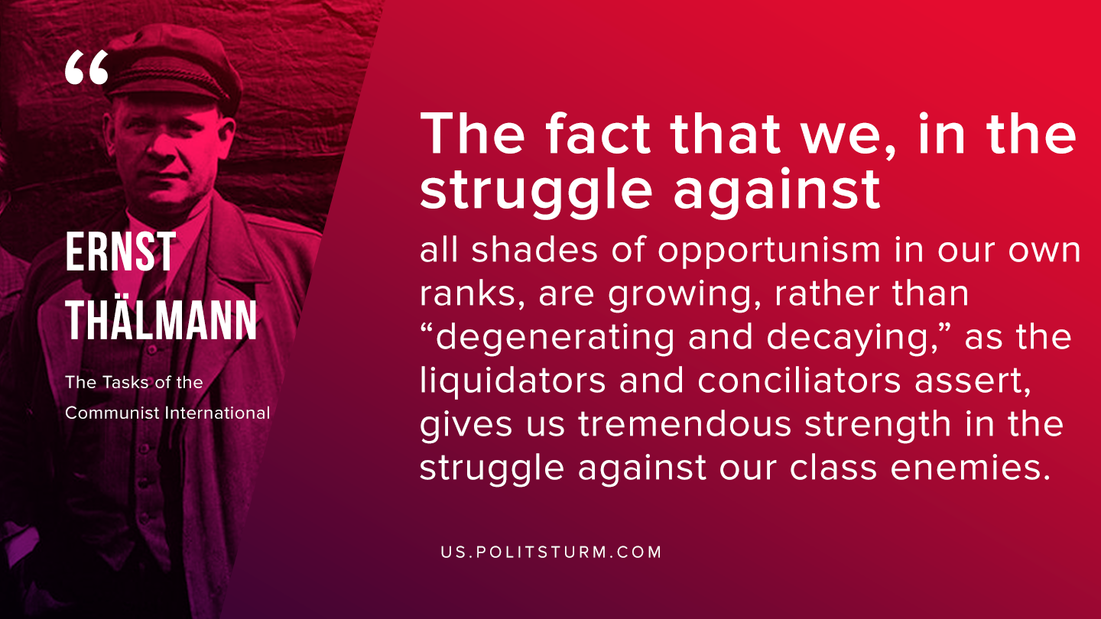

Original article
2019-12-04

The fact that we, in the struggle against all shades of opportunism in our own ranks, are growing, rather than “degenerating and decaying”, as the liquidators and conciliators assert, gives us tremendous strength in the struggle against our class enemies.
Ernst Thälmann, “The Tasks of the Communist International”

Original article

